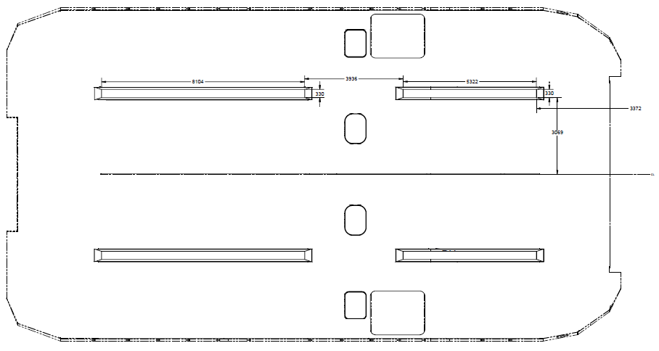
(26’ 7”)
(17’ 51/2”)
(12’ 11”)
(13”)
CL Fwd
(10’ 1”)
(11’ 3/4”)

