
554 Old Spanish Trail
Slidell, LA 70458
Phone: 985-649-5832
Fax: 985-641-5950
dammonengineering.com
info@dammonengineering.com

March 7, 2019

Merlin DeCorte, PLA
Specialty Pools & Outdoor Living, LLC
1701 Belle Chasse Hwy.
Gretna, Louisiana 70056
Office: (504) 596 - 6343
Cell: (504) 874 - 2198

RE: Stone Bridge Manor Pool

We have reviewed the piling capacity test report from Stratum Engineering, dated Feb 25, 2019. No additional piles will be required.

Some adjustments to the plan have been made:

- The maximum pool depth has been revised from 6ft depth to 5 ft maximum depth.
- The pool sidewall, near the piling that was tested, must be constructed directly over the piles as shown on detail #3 of the attached drawing An additional #4 rebar has been added along this same sidewall to be placed directly on top of each pile for the entire length of the sidewall.
- An additional #4 rebar has been added in the middle of the pool floor between the two piles that have the greatest distance between them. See attached.
- All of the pool sidewalls have been revised to show a single mat of re-bars, when the backfill on the sides of the pool is filled with River Sand for a thickness of 2ft.
- A general note has been added that all piles shall have a minimum of one #4 bars directly on top of the pile in each direction connecting with another pile.

If you have any questions please contact me.

Thank You,

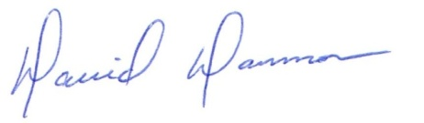
David Dammon
President
Dammon Engineering, Inc.
(985) 649-5832

