May 12, 2017
Dr. Jimmy Guidry,
State Health Officer

RE: Request for Variance of Required Continuous Decking and Access Step
Project Name: Wax Museum Condos

Mr. Guidry,
Please grant a variance to the requirement for continuous decking as detailed in LAC 51 XXIV, Swimming Pools, paragraph 323 F. The minimum continuous, unobstructed deck width for a class C pool, including the coping, shall be a minimum of 4 feet. In addition we request a variance from placing a step up to the pool.
- This pool is being constructed in a location that is open to fresh air however it is horizontally constrained by existing structure.
- This pool is very similar to a typical hot tub/spa that does not require step(s).

We are attempting to create a safe and healthy environment for all in this condominium and to conform to the Louisiana State Code as close as possible. We feel this is a common sense approach given the boundaries of the existing site.
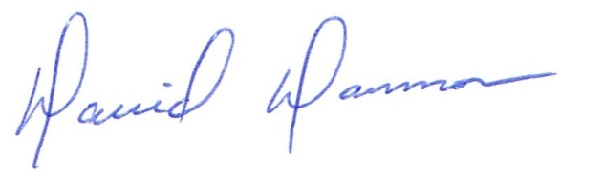
David Dammon
President
Dammon Engineering, Inc.
(985) 649-5832

