Covenant Baptist Church
Directory of Community services Guide to COMMUNITY ORGANIZATIONS Fall 2009

Community Service Organizations



Baptist Ministries
Baptist Friendship House
813 Elysian Fields Ave.
New Orleans, LA. 70117
504-949-4469 kbennettbfh@aol.com

Brantley Baptist Center
201 Magazine
New Orleans, LA. 70130
504-786-6122 tpitman@namb.net

Carver Baptist Center
3701 Annunciation
New Orleans, LA. 7011
504-897-2434 jhfannin@juno.com

Louisiana Baptist Children’s Home P.O. Box 4196
Monroe, LA. 71211
318-343-2244

Samaritan’s Purse
P.O. Box 3000
Boone, NC. 28607
800-353-5949

WMU
wmustore.com
Fax: 205-995-4840
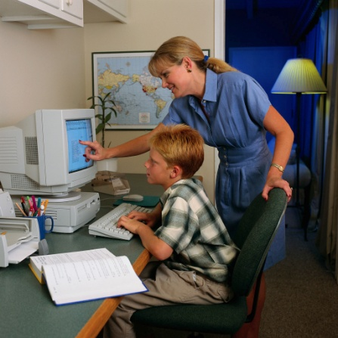

Helping others
Caring Center 1020 Stadium
Slidell, LA.
646-1368

Community Christian Concern
P.O. Box 3125
2228 Second Street
Slidell, La. 70458
985-646-0357

Global Maritime Ministries, INC.
P.O. Box 750787
New Orleans, LA. 70115
3635 Tchoupitoulas
504-895-2028
800-413-4762

Home of Grace
www.homeofgrace.org

Pregnancy Help Center
1327 Englewood
Slidell, LA. 70458
985-643-4357

Gladney Center for Adoption
800-452-3639

Rachel Sims Mission
729 Second Street
New Orleans, LA. 70130
504-891-2578

Safe Harbor
P.O. Box 28
Slidell, LA. 70459
985-643-0496

Sellers Maternity Home
Rt. 3 Box 10
Tallulah, LA. 701282
800-859-0046

Camps
Ridgecrest (Lifeway Conf. Center)
P.O. Box 28
Ridgecrest, NC. 28770
800-588-7222

Living Waters Baptist Assembly
21230 Living Waters Rd.
Loranger, LA. 70446
985-345-1831 or House 985-345-8153
LWSEBA@juno.com Fax: 345-8153

Tall Timbers
318-445-6797

Other
Baptist Book Store
3901 Gentilly Blvd.
New Orleans, LA. 70126
504-282-2626
Nashville-800-233-1123

Infobaptistmessage.com

International Mission Board
P.O. Box 6767
Richmond, VA. 23230
800-999-3113 or 804-353-0151
Prayerline 800-395-7729

Baptist Book Store
3901 Gentilly Blvd.
New Orleans, LA. 70126
504-282-2626
Nashville-800-233-1123

Northshore Baptist Assoc.
11411 McLaughlin Ln.
Hammond, LA. 70403
225-567-5086
Fax: 225-567-5148 bmo@I-55.com

North American Mission Board
4200 North Point Parkway
Alpharetta, GA. 30022-4176
800-634-2462- www.namb.net
770-410-6000 770-790-8980

N.O. Baptist Theological Seminary
3939 Gentilly Blvd.
New Orleans, LA. 70126
800-662-8701

Lifeway
800-458-2772 (literature)

Louisiana Baptist Convention
P.O. Box 311
Alexandria, LA. 71309
800-622-6549
www.lbc.org/calendar

LA. College Pineville
800-4871906

