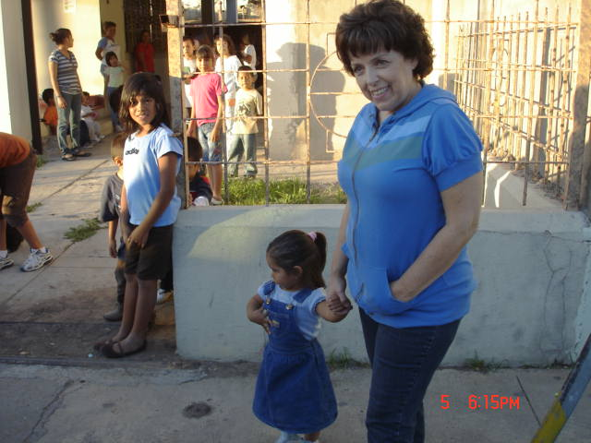

Mexico Mission Trip

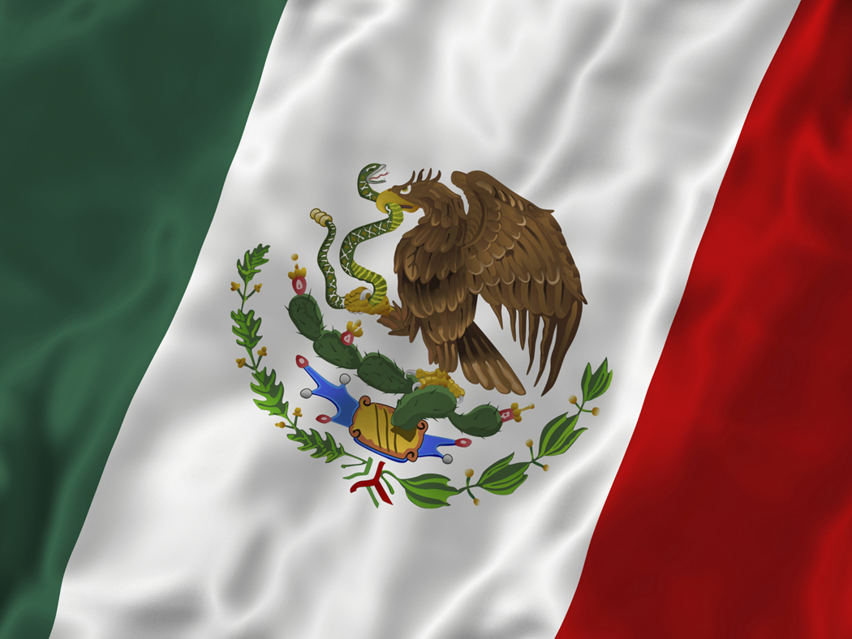

February 14 through 20th

COST $125.00 EACH PERSON

HRDM, inc
Founder/president
Karen Salinas

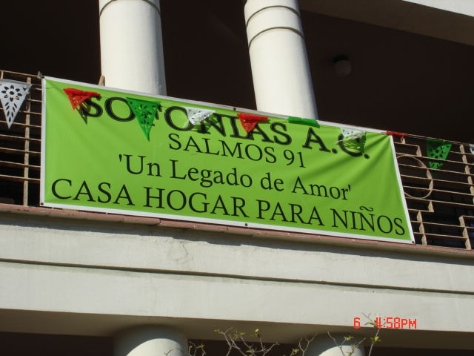

This is a joint trip with Calvary Baptist Church, Thompson Road Baptist Church and Covenant Baptist Church. We will be working at the orphanage and The Colonies.
For information contact Kirt Dammon
985-290-3888

A PASSPORT IS REQUIRED
HRDM
A Legacy of Love
P.O. Box 633
Laredo, Texas, 78042
Cell:956-251-2347
Email: isaiah443@yahoo.com
Web: www.cowboyfellowship.org/hrdm

WE ARE ALWAYS IN NEED OF SHAMPOO, LAUNDRY DETERGENT, DEODORANT, SUAVITEL, DISHWASHING LIQUID, GARBAGE BAGS, TOILET PAPER, PAPER TOWELS......
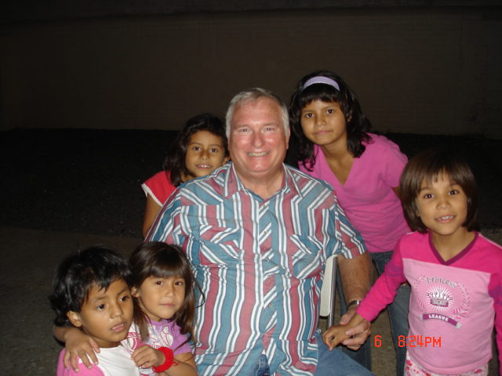

Where do the children come from? At times the children are placed by the D.I.F. (Department of Family Integrity) others hear about our home through word of mouth, families with little or no income or resources to care for a child, some are abandoned or abused. Our home is open to help all of God's little ones who need our love and compassion.
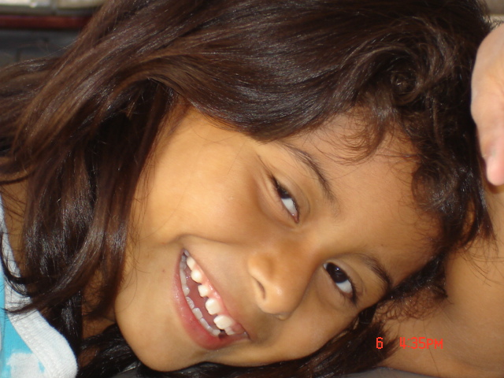
How do we donate?
R: Monetary donations can be made out to: HRDM, Inc. PO Box 633 Laredo TX 78042, and sent through Operation Christian Love Pearsall Texas. For further information please contact Kent McCary in Dilley Texas at 830-965-2913.
Pkgs. can be mailed to: K. Salinas c/o Leyendecker Lumber 303 Flecha Lane Laredo Texas 78045

Convenant Baptist Church
890 Robert Road
Slidell, LA. 70458
985-643-9438

Obtaining A Passport
Apply in Person (minors under 16 & 17 different requirements)
- Complete Form DS-11
- Submit evidence of US Citizenship
- Present Identification
- Submit a Photocopy of yourself
- Fees (Abt. $125)
- Web site http://travel.state.gov/passport/passport_1738.html
PLACES TO OBTAIN A PASSPORT
Slidell Post Office & Main Post Offices in Covington, Mandeville, Bay St. Louis, MS

YOU MUST APPLY IN PERSON IF:
- You are applying for your first U.S. passport or
- You are under age 16 or
- Your previous U.S. passport was issued when you were under age 16 or
- Your previous U.S. passport was lost, stolen, or damaged or
- Your previous U.S. passport was issued more than 15 years ago or
- Your name has changed since your U.S. passport was issued and you are unable to legally document your name change

Primary Evidence of U.S. Citizenship (One of the following):
Previously issued, undamaged U.S. Passport
Certified birth certificate issued by the city, county or state*
Consular Report of Birth Abroad or Certification of Birth
Naturalization Certificate
Certificate of Citizenship

Processing Time
ROUTINE SERVICE | As of ( Saturday November 7, 2009 ), we are processing routine applications in approximately 4-6 weeks from the time of application.
EXPEDITED SERVICE* | As of ( Saturday November 7, 2009 ), we are processing requests for expedited service, that include overnight delivery to and from the Passport Agency, about 2-3 weeks door-to-door*.

