
554 Old Spanish Trail
Slidell, LA 70458
Phone: 985-649-5832
www.dammonengineering.com
info@dammonengineering.com

CAMP VILLERE
NEW HOME CONSTRUCTION
State Project: LA14-A-037
Engineer’s Project: 2210
Bi-Weekly Construction Meeting Minutes

May 23, 2017
9:00 a.m.

Attendees:
James Downing, LANG - Operations
Gerald J. Leonick, Camp Villere
Charles Crawford, Grillot Construction
David Dammon, Dammon Engineering, Inc

Minutes:
- Meeting opened with a discussion about the project’s percentage of completion. The project is now 48% complete. The mechanical and electrical rough-ins are almost complete and the plumbing should start tomorrow. The exterior siding is progressing. The exterior walls should be insulated starting next week.

- A discussion was held concerning the color choice of kitchen counter top and the splash guard behind range. The samples were taken to review the choices.

- The exterior siding cementitious trim that has been installed does not have a finished edge. The edges will be skim coated to provide a finished edge before paint is applied.

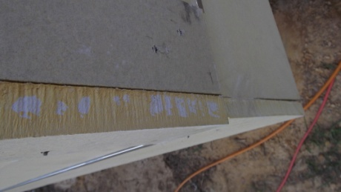

- A site visit was performed to view the construction progress. The area around the residence will need additional site work to give the residence a yard that does not pond.

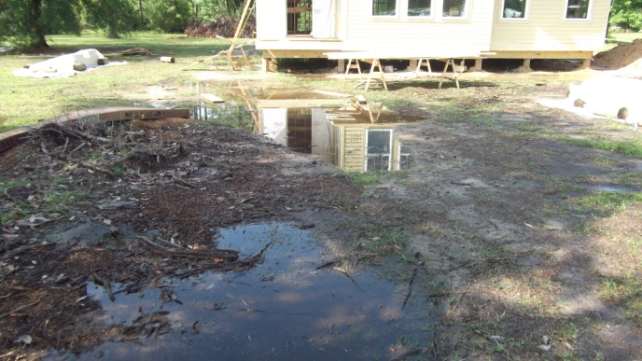
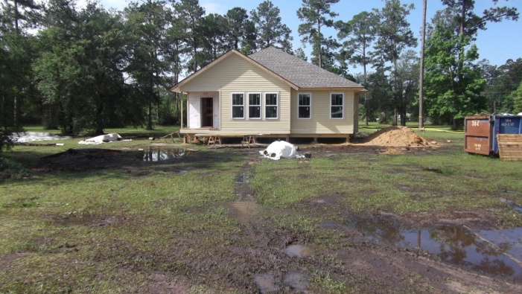

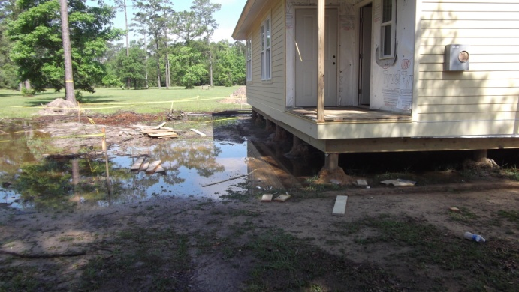
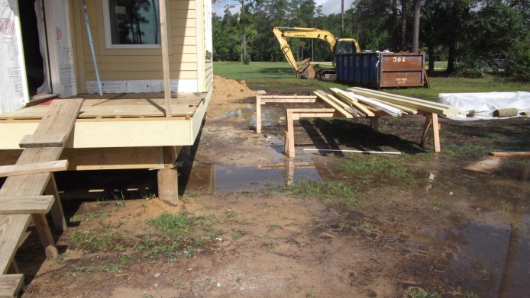

- Next scheduled meeting is 6/6/2017 at 9 am (0900).

