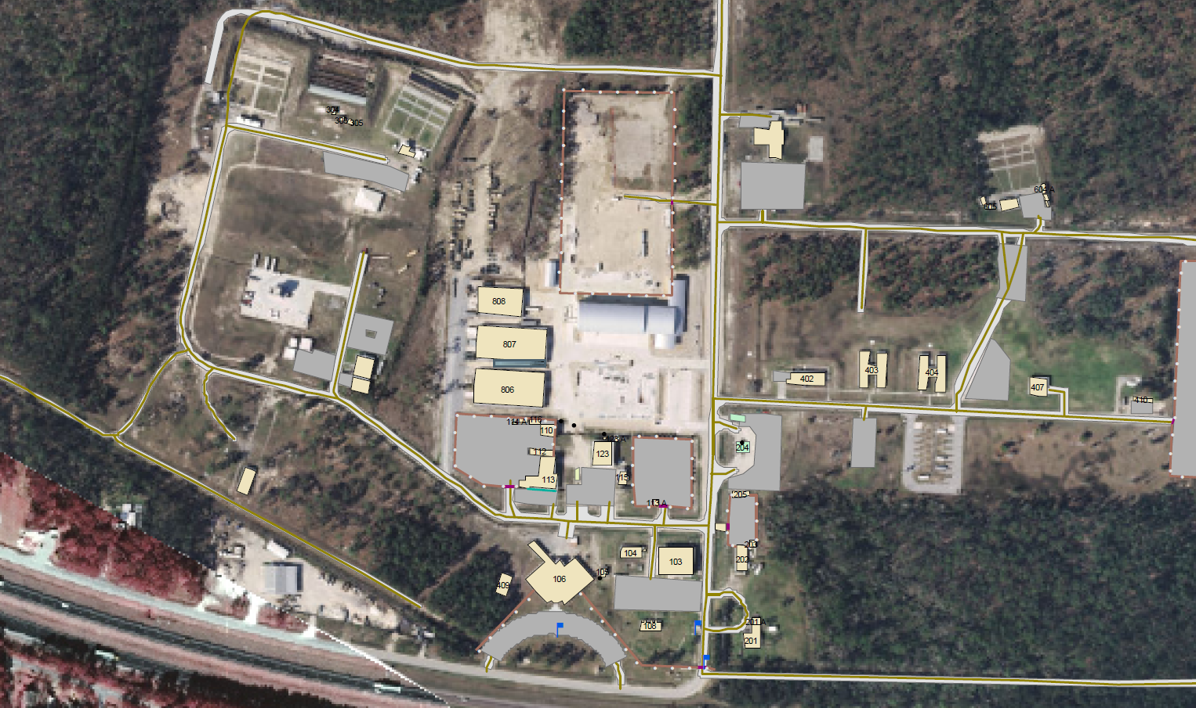
Proposed Site for Post Commander’s House
Front Gate
Post Cmdr House

