
554 Old Spanish Trail
Slidell, LA 70458
Phone: 985-649-5832
dammonengineering.com
info@dammonengineering.com

February 22, 2024

Jonathan M. Trahan, P.E
Fourrier & de Abreu Engineers, LLC
Project Engineer

Re: Cell X Mundy Landfill

Mr. Trahan,

Thank you for considering Dammon Engineering. We are pleased to propose our services for the subject project.
Our understanding is that this agreement is for the electrical for 2 pump locations in Cell X. We anticipate that it will take 15 hours @ $135/hr.

Also, if selected, we can provide Pump design. We anticipate that this will take 7 hours @ $135/hr.

Please note these hours do not reflect time for Site Visits nor do they reflect time for submittal reviews.

Sincerely,

If you have any questions, please contact me.

Thank You,

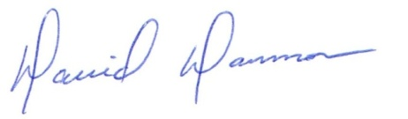
David Dammon
President

