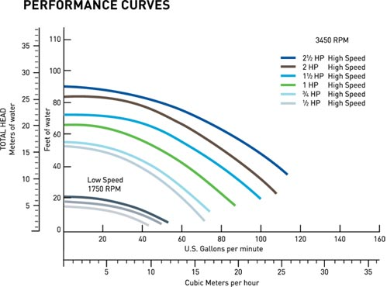

Pentair SuperFlo .5HP Standard Efficiency Pool Pump 115-230V | 340036

Typically ships same business day

