- How many new members have we installed?
Kathy Lowery, Michele Blanchard-Airey, Jeanette Sanford, John Remond, Cherelle Fakhruddin, Jason Butler

- If you haven’t yet, please say hello to our Foreign Exchange Student from Tawain, her name is Lili. We are looking for host families for next year. If you would like to host a Foreign Exchange Student please contact Ron Davis.

- Our club has another international project and donated $500 to help fund a potable water storage tank for the Mexican village (700 population) of Puerto Lobos. There are several Rotary clubs teaming with local Mexican Rotary clubs to fund the $60,000 project.

- Your Public Relations Committee has gathered the names of a number of civic organizations. We are in the process of contacting them to provide them with a Rotarian Guest Speaker at their functions. Our club has Guest Speakers every week and we want let these organizations know that we would like to present Rotary and how our club has benefited the city of Slidell. If you would like to be a Guest Speaker please contact Don Bryan.

- We have gained two new major donors to the Rotary Foundation. Please join in to congratulate Brenda and John Case as new major donors. Also Don and Debra Bryan are officially Bequest Society members, as is Ken Thompson.

- Salmen High School hosted the District Interact Conference “Light Up Interact”. There were 150 Interact Students that signed up for the conference.

- Year to date our club has a 58.85 % membership attendance at our weekly meetings.


- Our club is collecting new socks and shoes for “Shoes for Orphan Souls” again this year. If you have not been able to contribute shoes yet we are still collecting shoes to send to the Orphans. If you would like you could also donate money and we will purchase socks and shoes. These shoes are part of the largest humanitarian aid projects sponsored by Buckner International, a global Christian ministry dedicated to transforming the lives of vulnerable children, families and elders. According to the Buckner Shoes for Orphan Soul’s website, a pair of simple shoes can go a long way to preventing disease from hookworms and other parasites, as well as protect feet from injury. In many communities, they allow children to attend school who would not have been eligible due to lacking of the required footwear.

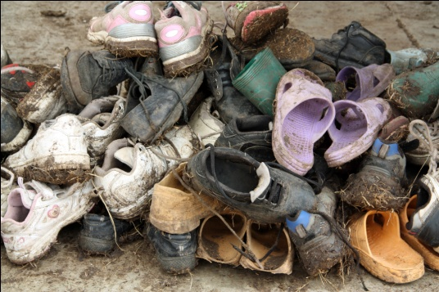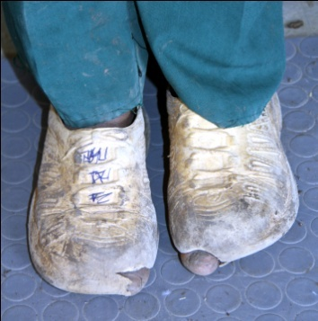

The donations will be distributed overseas, as well as in the United States, to vulnerable children and orphans. Since 1999, more than 2.5 million pairs of new shoes have been distributed to children in 74 countries.

Rotary International District 6840, made up of Louisiana and Mississippi chapters, last year collected 1,494 pairs of shoes and 1,390 pairs of socks for distribution. Buy a new pair of shoes and socks. Sneakers and athletic shoes are best. The greatest need is for sizes Youth 1 - Adult 7. Bring these new socks and shoes to our regular meeting.

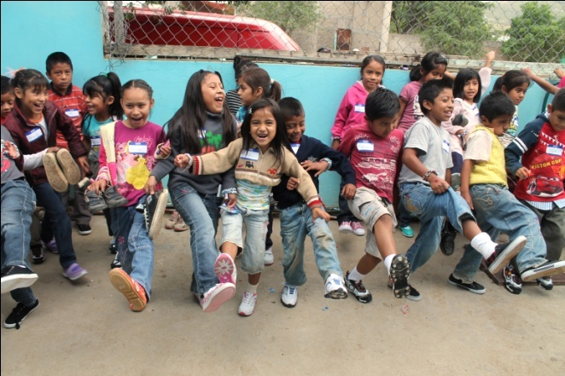
You can find information about Shoes for Orphan Souls at www.buckner.org/shoes.

Donations can be dropped off at the First Pentecostal Church at 388 Robert Blvd in Slidell (985) 643-8760, or the Edward Jones office at 2170 Hwy 190 West Suite 135 Slidell (985) 781-7683, or the Dammon Engineering office at 554 Old Spanish Trail in Slidell (985) 649-5832.

- We had 3 of our members attend President-Elect Training Seminar (PETS) the past quarter. Please join in to thank Rene Arcemont, Barbara Doyle (Our President Elect), and Dr. Joan Archer for attending.
