Overview

Simply the Most Economical Way to Heat Pools and Spas
Heat your pool with an environmentally friendly heat pump. Pentair’s UltraTemp heat pump uses an ozone-friendly refrigerant and has a 100% pure titanium heat exchanger that assures corrosion-free performance for extra-long life.

- LCD control board displays an intuitive, menu-driven readout with easy to follow, full-word messages—no more codes
- AutoSet (time clock override) feature monitors water temperature and turns the water circulation pump on and off as needed to maintain desired pool temperatures
- Automatic defrost feature senses refrigerant temperature and prevents UltraTemp from freezing, allowing the heat pump to operate at even lower temperatures
- Compatible with all automated control packages
- Long-life, corrosion-resistant plastic composite cabinet stands up to severe climates and pool chemicals
- Emerson Copeland Scroll Compressor on 60-Hz, single-phase models
- ETL listed for safe operation
- Thermostatic Expansion Valve (TXV) controls refrigerant flow for optimum efficiency and BTU output over a wider operating range
- Highest efficiency available—meets or exceeds existing codes and standards
- BTU and efficiency performance independently certified by the Air-Conditioning, Heating and Refrigeration Institute (AHRI)
Product Resources

Product Features
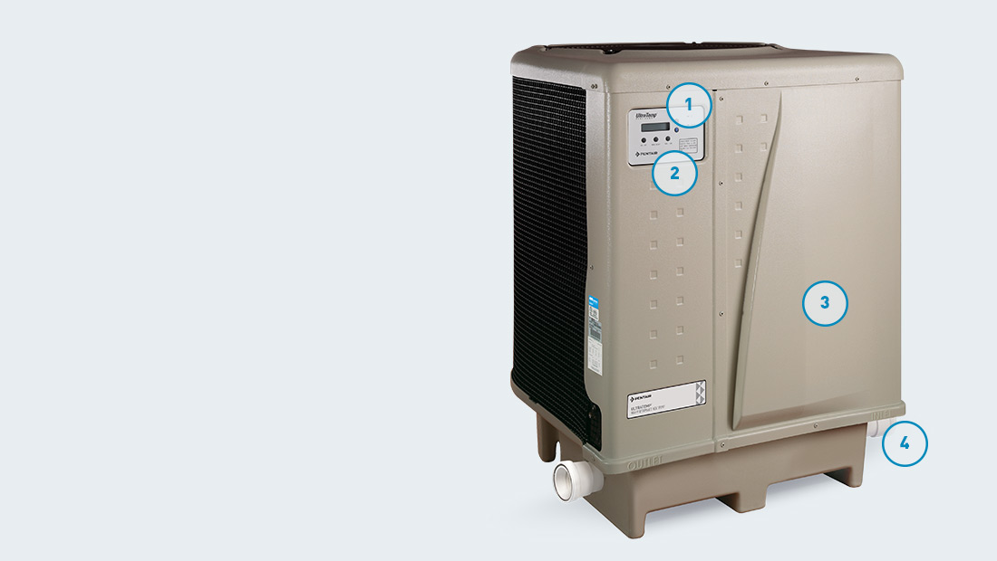

Product Components
- Digital controls with dual thermostats offer precise temperature control for pool/spa combinations and avoid overheating and energy waste
- Self-diagnostic controls monitor and troubleshoot heat pump operations to ensure safer, dependable operation
- Long-life, corrosion-resistant composite cabinet retains a like-new appearance for years
- 2" plumbing connections for easy installation



Energy Conscious
The UltraTemp heat pump provides digital controls with dual thermostats to offer precise temperature control for pool/spa combinations. This way, you can avoid overheating and energy waste.


AutoSet™ Temperature Control
This standard feature monitors water temperature and turns the pump on and off as needed, overriding the time clock to maintain desired temperature. It’s the ultimate in convenient, hands-free comfort control.
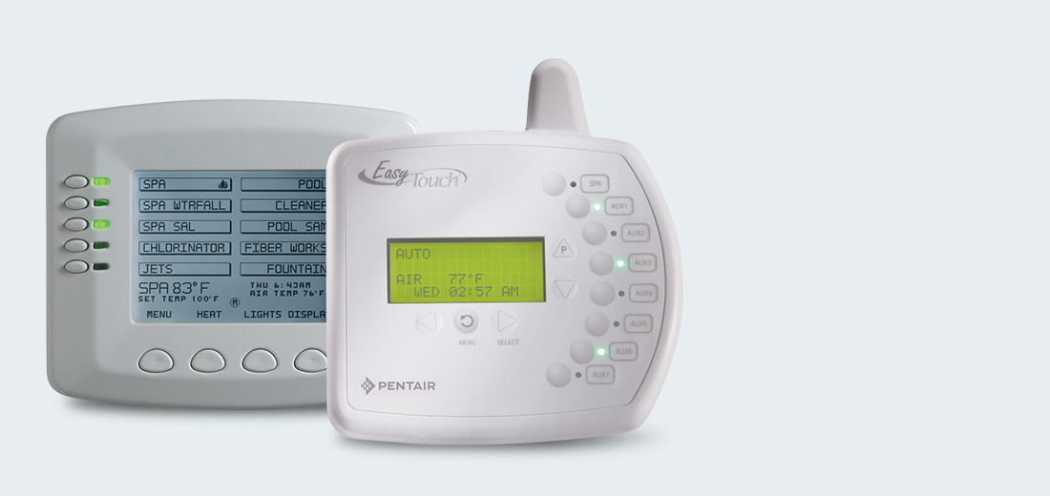

Automation Compatible
The UltraTemp heat pump is the perfect companion to IntelliTouch® or EasyTouch® Control Systems. All heat pump instructions and displays can be transferred to a centralized control system that manages all your pool/spa operations and poolscape features.
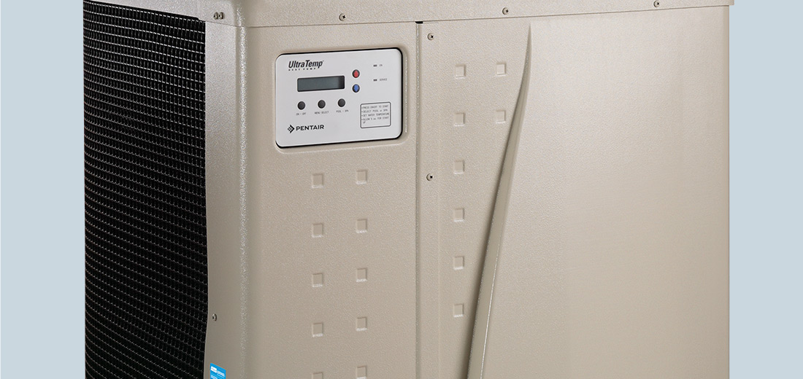

Easy, Dependable Operation
UltraTemp’s LCD control board displays an intuitive, menu-driven readout with easy to follow, full word messages—no codes to memorize. Its self-diagnostic software continuously monitors the system for peak performance. And, the heat pump’s ETL listing is your assurance of safer, dependable operation.

