554 Old Spanish Trail
Slidell, LA 70458
Phone: 985-649-5832
Fax: 985-641-5950
dammonengineering.com
dammoneng@bellsouth.net

February 7, 2014

Mr. Sammy Mannino
St. Tammany Parish School Board
Supervisor of Construction
321 North Theard St.
Covington, LA 70433-2835

RE: Slidell Junior High School Roof Replacement – STPSB # 1321

Mr. Mannino,

Dammon Engineering is pleased to have been selected to provide Architect and Engineering services for the design of roof repair work to be performed on the Slidell Junior High School Roof of Buildings A, B & C and Canopy as identified on the attached roof plan.

After visiting the site, assessing the condition of the existing roof and considering the School Board's plans, we have determined that the following work should be performed under this contract:

- Remove all existing modified bitumen roofing systems to existing structural deck along with aluminum flashing and replace with SBS Modified Bitumen roofing membrane system with minimum 2” polyisocyanurate insulation. Tapered perlite insulation is to be installed where existing roof structure is not sloped to promote positive drainage. All existing non-functioning roof penetrations/vents remain and flash.
- Remove and replace all existing gutters and downspouts with pre-finished metal gutters and downspouts.
- The existing canopy facing Fourth Street is to prepare the existing modified bitumen cap sheet and aluminum flashing as required by manufacturer to receive a new elastomeric coating.

Our estimate for the Construction Cost for the above work is $305,000.00.

Once we receive a contract from the school board, we'll begin work on the design package.

If you have any questions, please feel free to call.

Sincerely,
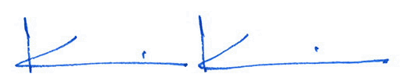

Kevin J. Kinchen, NCARB
Chief Architect

Cc: Cameron Tipton

