May 19, 2014

Bill Picket
Fischer's Inc.
11668 Chef Menteur Hwy.
New Orleans, LA 70129

RE: STPSB Project No. 1321
Slidell Jr. High - Reroofing of Old Sixth Grade Wing

Dear Mr. Picket,

In accordance with the provisions of the contract’s general conditions, you are hereby notified to commence work on the subject contract on or before May 28, 2014 and are to fully complete the work in sixty (60) consecutive calendar days in accordance with your contract dated 11 April, 2014 subject to adjustments of the Contract Time. Contractor shall be assessed Liquidated Damages in the sum of seven hundred fifty dollars ($750.00) per day which the work is not complete beginning with the first day beyond the completion time stated above for each phase of work.
Sincerely,
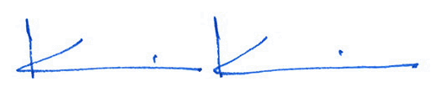

Kevin J. Kinchen, NCARB
Chief Architect
Dammon Engineering, Inc.

cc: Sammy Maninno, STPSB

