 | Submittal

Prepared For:  Wisnor & Associates | Date: December 05, 2022  Job Name:  Boyett Jr High School
_____________________________________________________________________________________________

Trane U.S. Inc. is pleased to provide the following submittal for your review and approval.

Product Summary
Qty | Product
2 | PREC
1 | Split System Air Conditioning Units (Small)

_____________________________________________________________________________________________

Kimberly Fricke  Trane U.S. Inc.  4013 N Interstate 10 Service Rd W  Metairie, LA 70002  Office Phone: (504) 733-6789 | The attached information describes the equipment we propose to furnish for this project and is submitted for your approval.  Submittal acceptance and return is a critical step, so please ensure submittals are returned with approval to release to production within 14 days of submittal date.  Product performance and submittal data is valid for a period of 6 months from the date of submittal generation. If six months or more has elapsed between submittal generation and equipment release, the product performance and submittal data will need to be verified. It is the customer’s responsibility to obtain such verification.

Table of Contents
Product Summary 1
PREC (Item A1) 3
Tag Data 3
Product Data 3
Performance Data 4
Mechanical Specifications 6
Dimensional Drawings 8
Weight, Clearance & Rigging 12
Accessory 13
Split System Air Conditioning Units (Small) (Item B1) 14
Tag Data 14
Product Data 14
Performance Data 15
Mechanical Specifications 16
Dimensional Drawings 17
Weight, Clearance & Rigging 21
Field Installed Options - Part/Order Number Summary 22
PREC 22
Split System Air Conditioning Units (Small) 22

Tag Data - PREC (Qty: 2)
Item | Tag(s) | Qty | Description | Model Number
A1 | RTU-1,  RTU-2 | 2 | 6- 25 Ton PKGD Precedent Unitary Rooftop | TSJ180A3S00**000000000000000000000000000

Product Data - PREC
Item: A1 Qty: 2 Tag(s): RTU-1, RTU-2
DX Cooling
Standard Efficiency
R-410A
15 Ton
208-230/60/3
Symbio 700
Motorized outside damper 0-50% (Field Installed)
Horizontal Conversion Panel (Field Installed)

Performance Data - 6- 25 Ton PKGD Precedent Unitary Rooftops (PREC)
Tags | RTU-1,  RTU-2
Cooling Entering Dry Bulb (F) | 80.00
Cooling Entering Wet Bulb (F) | 67.00
Summer Ambient (F) | 95.00
Entering Dry Bulb (in HGRH) (F) | 73.00
Entering Wet Bulb (in HGRH) (F) | 64.00
Ambient (In HGRH) (F) | 75.00
Design Airflow (cfm) | 6000
Airflow Application | Horizontal
Design ESP (in H2O) | 0.500
Fan Pressurized (in H2O) | 0.540
Design ESP + Component SP (in H2O) | 0.500
Elevation (ft) | 0.00
Gross Total Capacity (MBh) | 188.59
Gross Sensible Capacity (MBh) | 146.26
Gross Latent Capacity (MBh) | 42.34
Net Total Capacity (MBh) | 184.56
Net Sensible Capacity (MBh) | 142.22
Net Sensible Heat Ratio (%) | 77.00
Coil LAT DB (F) | 57.09
Coil LAT WB (F) | 56.80
Cooling Leaving Unit Dry Bulb (F) | 58.20
Cooling Leaving Unit WB (F) | 57.24
Fan Motor Heat (MBh) | 4.03
Dew Point Temperature (F) | 56.64
Refrigerant charge (HFC-410A) - Ckt 1 (lb) | 14.5
Saturated Discharge Temperature (F) | 121.42
Saturated Suction Temperature (F) | 51.15
Heat Static Pressure Adj (in H2O) | 0.000
Component SP Add (in H2O) | 0.000
Max Available ESP (in H2O) | 2.000
Supply Motor Horsepower (hp) | 3.100
Supply Operating Horsepower (hp) | 1.280
Supply RPM (rpm) | 1003
Compressor Power (kW) | 12.86
System Power (kW) | 16.96
EER @ AHRI (Number) | 11.00
IEER @ AHRI (Number) | 14.20
MCA (A) | 78.00
MOP (A) | 100.00
Compressor 1 RLA (A) | 30.90
Compressor 2 RLA (A) | 16.40
Condenser Fan FLA (A) | 2.30
Evaporator Fan FLA (A) | 8.80
Height (ft) | 4.92
Width (ft) | 7.25
Length (ft) | 10.25
Approx Configured Weight (lb) | 1820.0
Approx Installed Weight (lb) | 1820.0
Corner weight A (lb) | 611.0
Corner Weight B (lb) | 447.0
Corner Weight C (lb) | 322.0
Corner Weight D (lb) | 440.0
Center of Gravity - Length (ft) | 4.33
Center of Gravity - Width (ft) | 3.00
Ducted Discharge - 63 Hz (dB) | 80
Ducted Discharge - 125 Hz (dB) | 79
Ducted Discharge - 250 Hz (dB) | 73
Ducted Discharge - 500 Hz (dB) | 67
Ducted Discharge - 1 kHz (dB) | 62
Ducted Discharge - 2 kHz (dB) | 57
Ducted Discharge - 4 kHz (dB) | 55
Ducted Discharge - 8 kHz (dB) | 53
Ducted Inlet - 63 Hz (dB) | 81
Ducted Inlet - 125 Hz (dB) | 74
Ducted Inlet - 250 Hz (dB) | 69
Ducted Inlet - 500 Hz (dB) | 62
Ducted Inlet - 1 kHz (dB) | 56
Ducted Inlet - 2 kHz (dB) | 55
Ducted Inlet - 4 kHz (dB) | 56
Ducted Inlet - 8 kHz (dB) | 52
Outdoor Noise - 63 Hz (dB) | 84
Outdoor Noise - 125 Hz (dB) | 91
Outdoor Noise - 250 Hz (dB) | 95
Outdoor Noise - 500 Hz (dB) | 93
Outdoor Noise - 1 kHz (dB) | 89
Outdoor Noise - 2 kHz (dB) | 85
Outdoor Noise - 4 kHz (dB) | 82
Outdoor Noise - 8 kHz (dB) | 76
Acoustic Footnote 1 | Ducted Discharge and Ducted Inlet Sound in accordance with AHRI 260-2017
Acoustic Footnote 2 | Outdoor Sound in accordance with AHRI 370-2015
Heat pump heating ambient temperature (F) | 47.00
Heat pump heating ambient relative humid (%) | 70.00
Supply Fan Count (Number) | 2.00

Mechanical Specifications - PREC
Item: A1 Qty: 2 Tag(s): RTU-1, RTU-2

General
- Packaged rooftop units cooling, heating capacities, and efficiencies are AHRI Certified within scope of AHRI Standard 210-240 for 6 to 25 Tons and ANSIZ21.47 and 10 CFR Part 431 pertaining to Commercial Warm Air Furnaces (all gas heating units).
-Convertible airflow.
-Symbio controls operating range is from 0-125 from factory; if designing for cooling mode operation below 40 deg F ambient temp, add low ambient kit to assure continuous and reliable operation.
-Factory assembled, internally wired, fully charged with R-410A, and 100 percent run tested to check cooling operation, fan and blower rotation, and control sequence before leaving the factory.
-Colored and numbered wiring internal to the unit for simplified identification.
-Units cULus listed and labeled, classified in accordance for Central Cooling Air Conditioners.

Casing
-Zinc coated, heavy gauge, galvanized steel.
-Weather resistant pre-painted metal with galvanized substrate.
-Meets ASTM B117, 672 hour salt spray test.
-Removable single side maintenance access panels.
-Lifting handles in maintenance access panels (can be removed and reinstalled by removing fasteners while providing a water and air tight seal).
-Exposed vertical panels and top covers in the indoor air section insulated with a cleanable foil-faced, fire-retardant permanent, odorless glass fiber material.
-Base pan shall have no penetrations within the perimeter of the curb other than the raised 1 inch high downflow supply/return openings to provide an added water integrity precaution, if the condensate drain backs up.
-Base of the unit insulated with 1/8 inch, foil-faced, closed-cell insulation.
-Unit base provisions for forklift and/or crane lifting on three sides of unit.

Hail Guards
-Provides condenser coil protection.

Microchannel Coils
-Optimal heat transfer performance due to flat, streamlined tubes with small ports, and metallurgical tube-to-fin bond.
-Reduce system refrigerant charge by up to 50% leading to better compressor reliability.
-Compact all-aluminum microchannel coils reduce the unit weight.
-Recyclable all aluminum coils All aluminium construction minimizes galvanic corrosion.
-Strong aluminum brazed structure provides better fin protection.
-Flat streamlined tubes more dust resistant and easy to clean.
-Coils leak tested at the factory to ensure the pressure integrity.

Compressors
-All units have direct-drive, hermetic, scroll type compressors with centrifugal type oil pumps.
-Suction gas-cooled motor with voltage utilization range of plus or minus 10 percent of unit nameplate voltage.
-Internal overloads standard with scroll compressors.
-Crankcase heaters are standard on all compressors.
-All units have dual compressors.
-Three stages of cooling available on 6 to 17.5 tons units and four stages of cooling available on 20 and 25 tons units.

Filters
Two inch standard filters shall be factory supplied on all units.

Frostat
-Utilized as a safety device.
-Opens to prevent freezing temperatures on evaporator coil.
-Temperature will need to rise to 50°F before closing.
-Utilized in low airflow or high outside air applications (cooling only).

Motorized Outside Air Damper
-Once set, when indoor fan starts, outdoor air dampers shall open to set position.
-When indoor fan shuts down, damper shall close to the full closed position.

Dimensional Drawings - PREC
Item: A1 Qty: 2 Tag(s): RTU-1, RTU-2

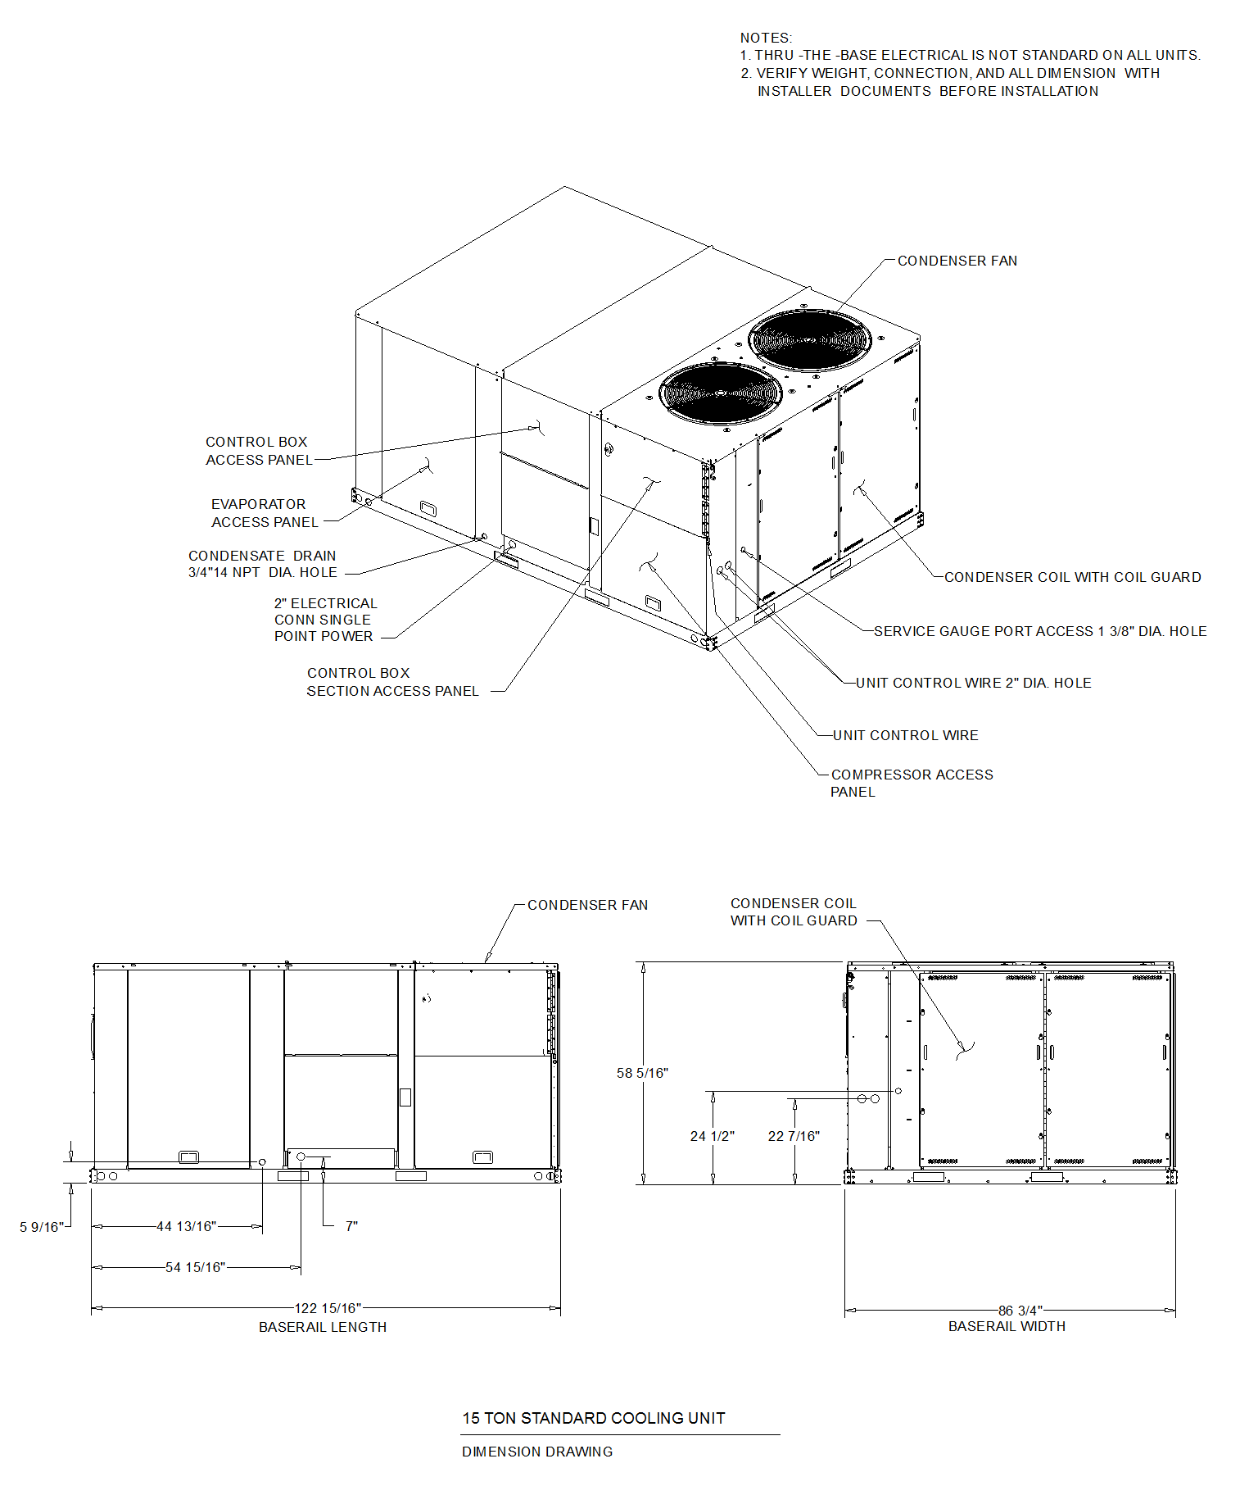
Dimensional Drawings - PREC
Item: A1 Qty: 2 Tag(s): RTU-1, RTU-2

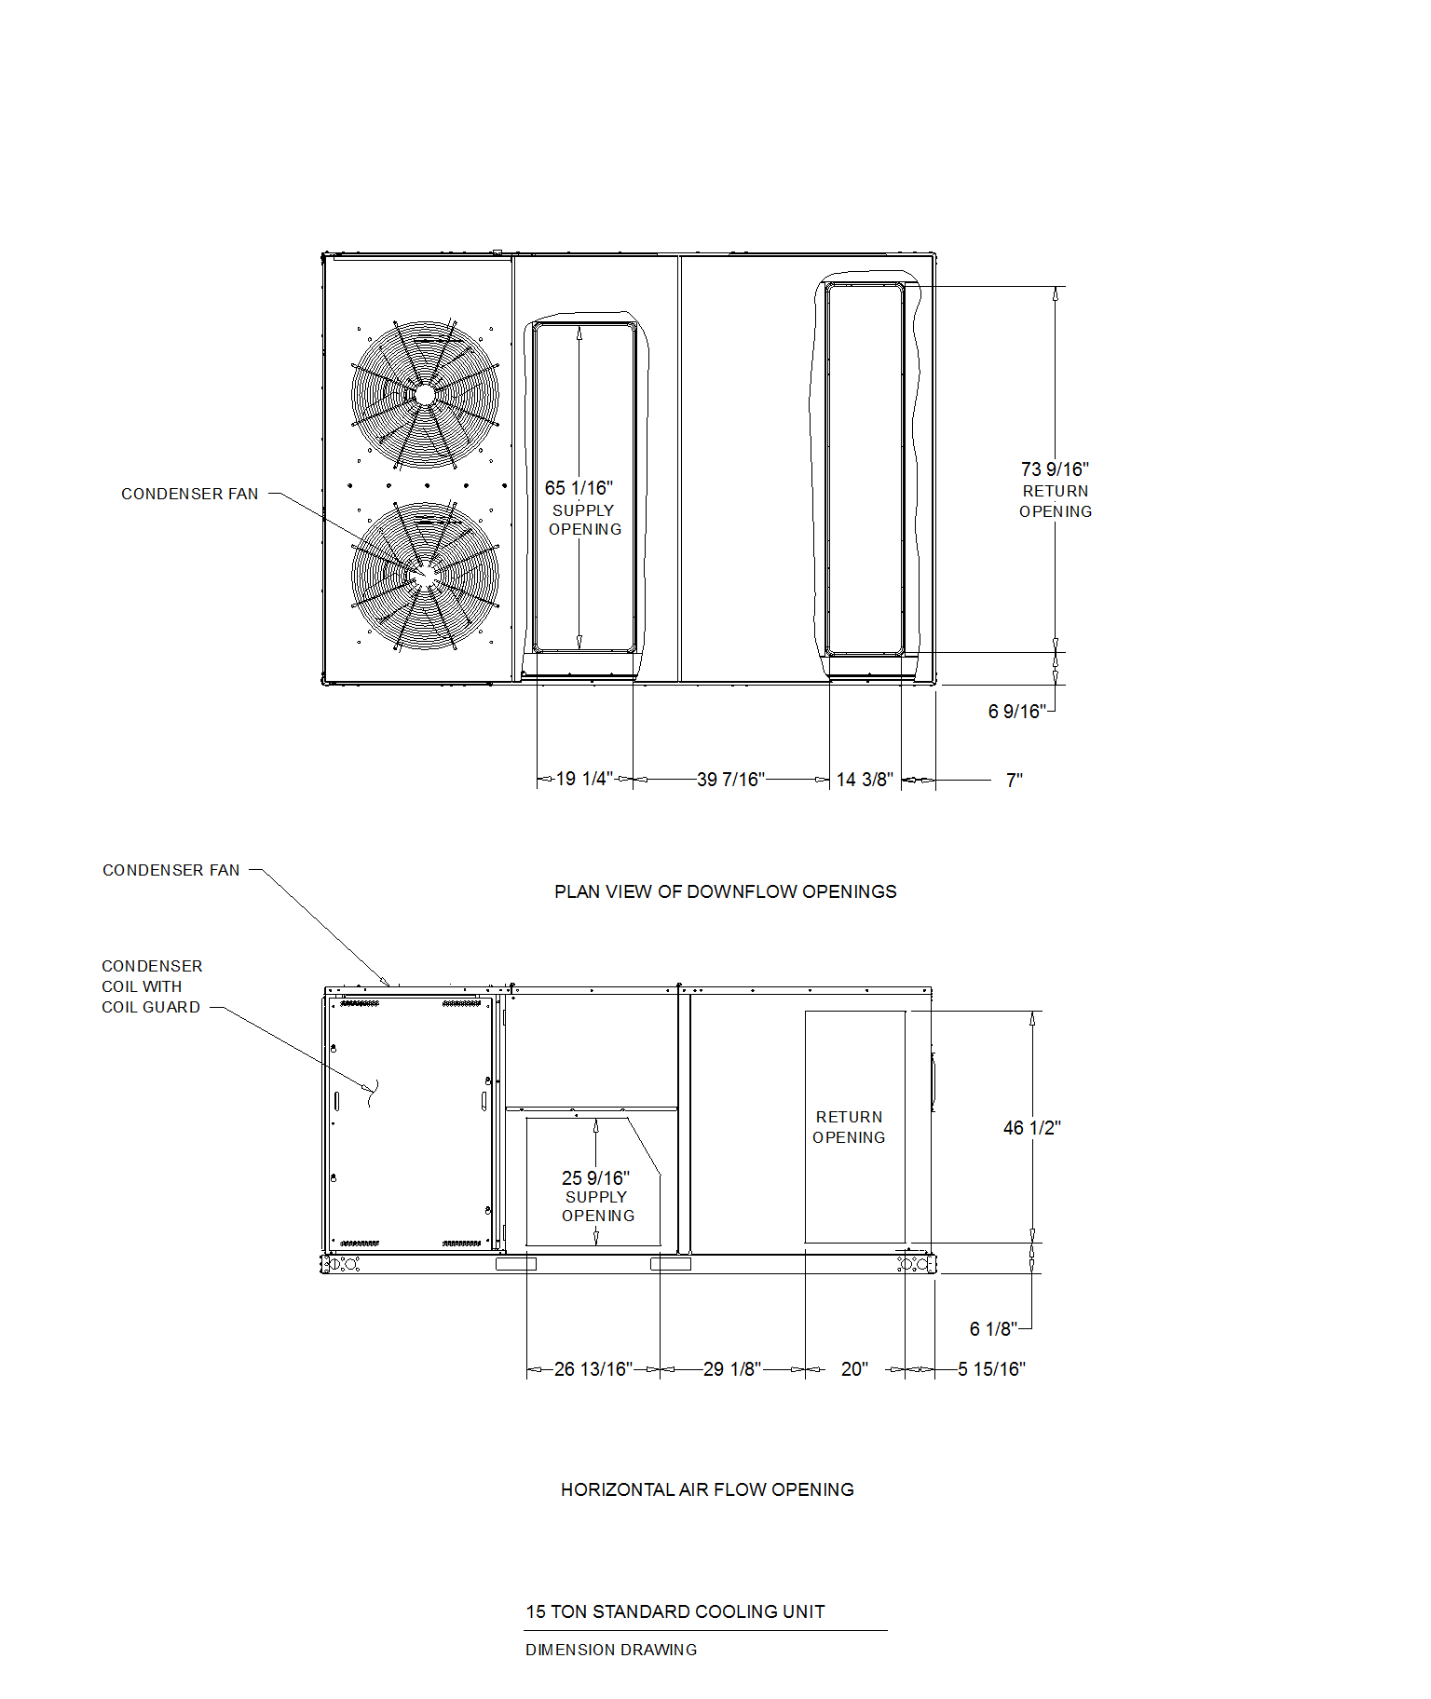
Dimensional Drawings - PREC
Item: A1 Qty: 2 Tag(s): RTU-1, RTU-2

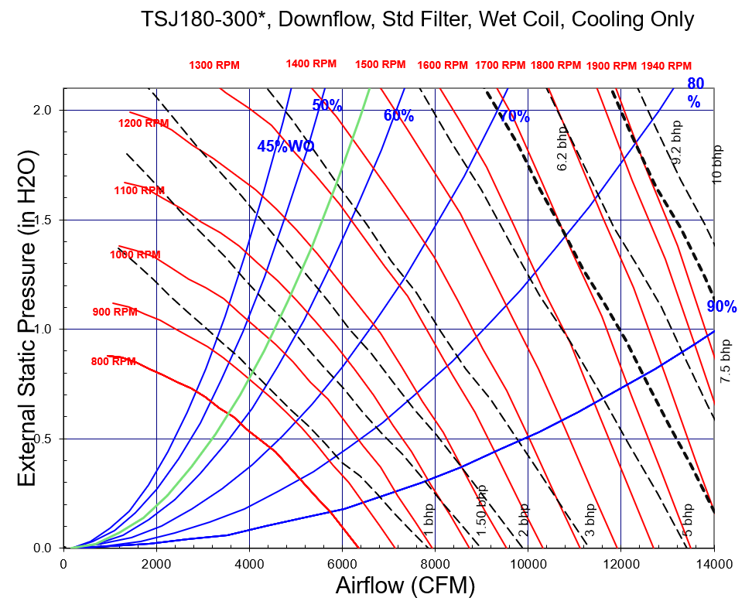
Note: Fan Curves are for TSJ/WSJ units. For YSJ units, add additional static pressure for Gas Heat Exchanger (ref. RT-PRC098*, table 47)

Dimensional Drawings - PREC
Item: A1 Qty: 2 Tag(s): RTU-1, RTU-2

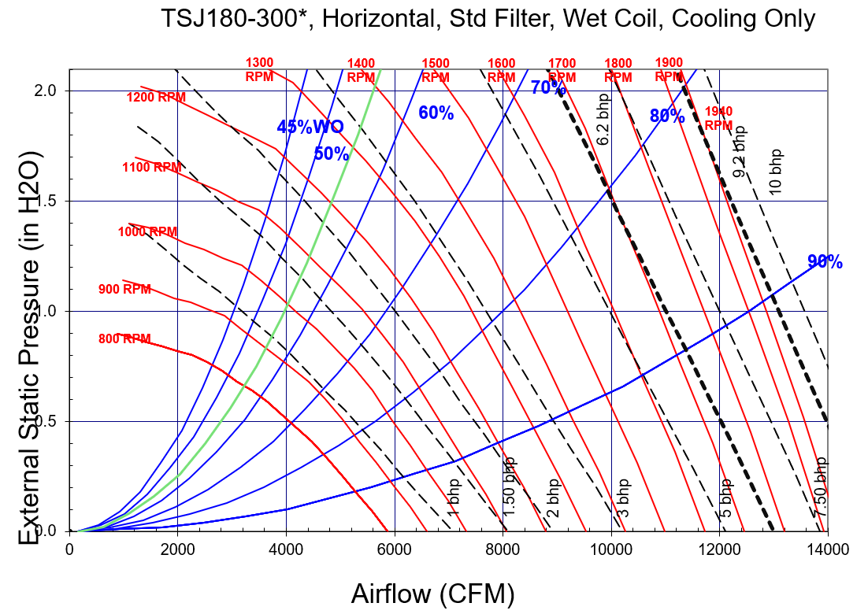
Note: Fan Curves are for TSJ/WSJ units. For YSJ units, add additional static pressure for Gas Heat Exchanger (ref. RT-PRC098*, table 47)
Weight, Clearance & Rigging - PREC
Item: A1 Qty: 2 Tag(s): RTU-1, RTU-2

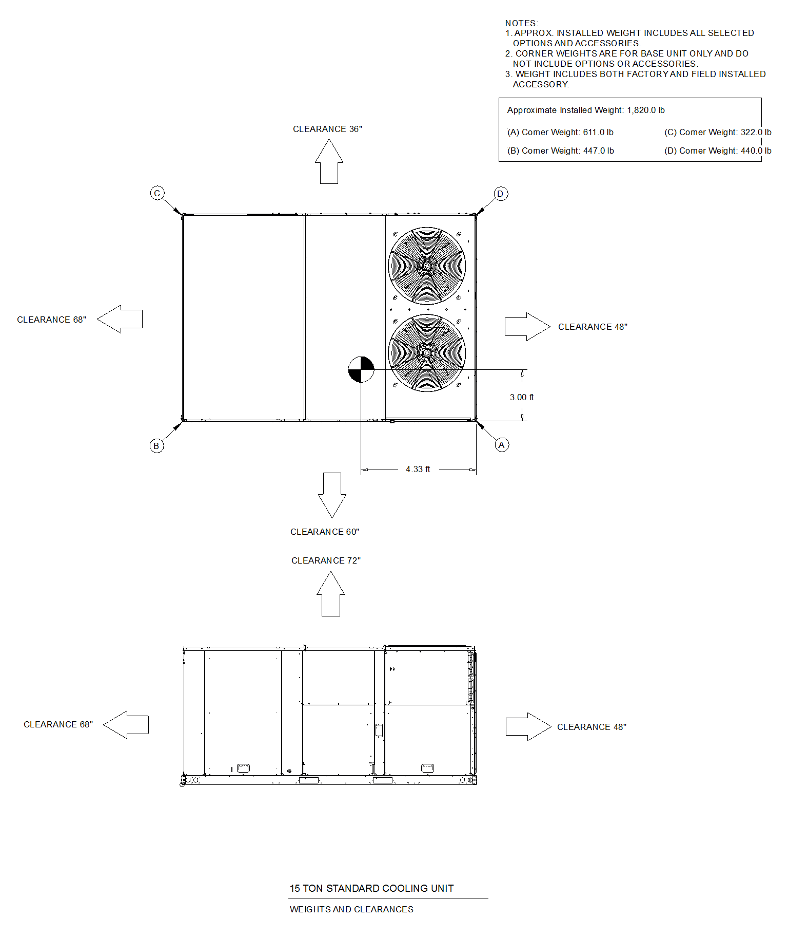
Accessory - PREC
Item: A1 Qty: 2 Tag(s): RTU-1, RTU-2

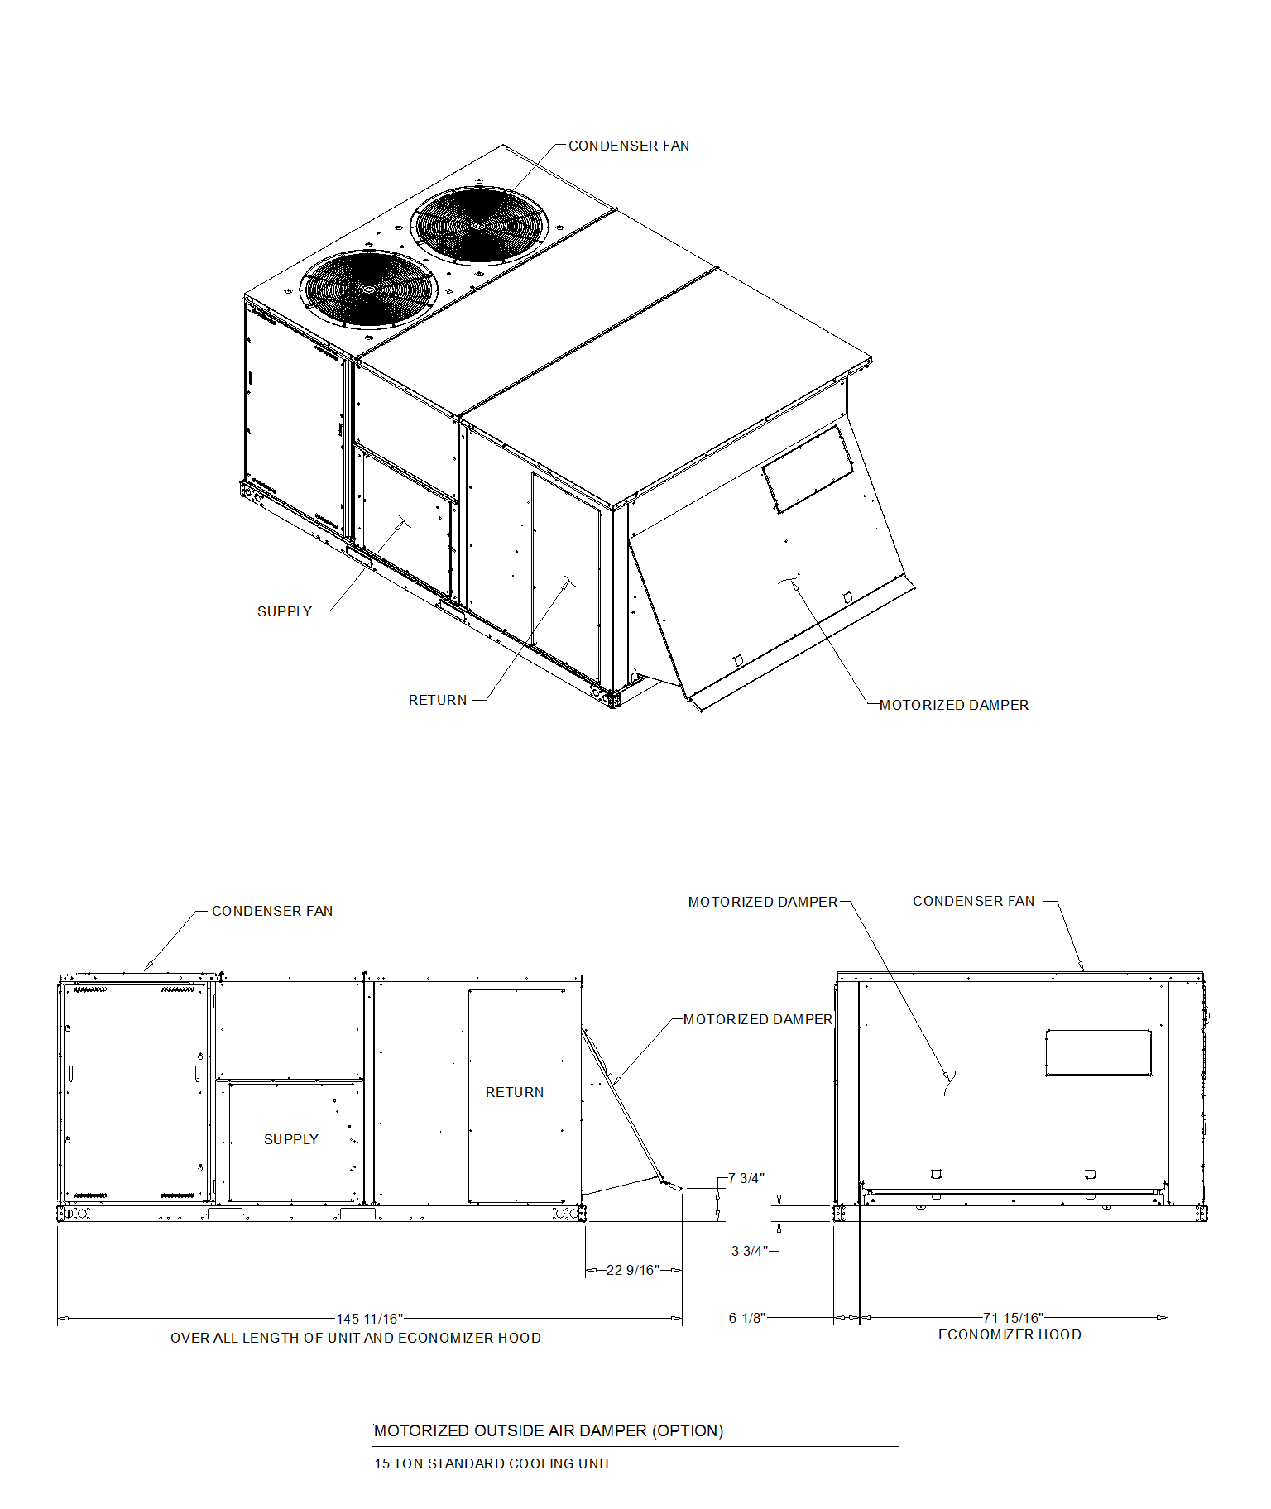

Tag Data - Split System Air Conditioning Units (Small) (Qty: 1)
Item | Tag(s) | Qty | Description | Model Number
B1 | AHU CU-1 | 1 | 1.5 - 5 Ton Unitary Split Systems (SSC) | 4TTR4060N10000*00000*TEM4B0C60S51S*********000**0000*0***000000000000000000000*0**0

Product Data - Split System Air Conditioning Units (Small)
Item: B1 Qty: 1 Tag(s): AHU CU-1
Split System Cooling Outdoor Unit
5 Ton Nominal Cooling Capacity
Major Design Sequence N
200 - 230 Volt 1 Phase 60 Hertz
Low cost
Multi-poise 4-way
Better, Retail replacement Mid EFF
Footprint - C
5 Ton air handler
Std Efficiency
5.0 ton airflow
208-230/1/60
Standard Coil
Brazed
7.21/9.60 kW Htr w/Ckt Brk 208/240/1 (Field Installed)

Performance Data - 1.5 - 5 Ton Unitary Split Systems (SSC)
Tags | AHU CU-1
Design clg EDB (F) | 80.00
Design clg EWB (F) | 67.00
Cooling outdoor DB (F) | 95.00
Cooling EDB (F) | 80.00
Cooling EWB (F) | 67.00
Capacity @ AHRI (Btuh) | 56000.00
Elevation (ft) | 0.00
Clg net total capacity (Btuh) | 58446.00
Clg net sensible capacity (Btuh) | 44191.00
Clg net latent capacity (Btuh) | 14255.00
Calc clg LDB (F) | 58.40
Calc clg LWB (F) | 57.00
SEER @ AHRI (btuh/watt) | 14.30
EER @ AHRI (EER) | 11.7
Cooling airflow (cfm) | 1925
Min system airflow clg (cfm) | 1500
Max system airflow clg (cfm) | 1925
AHRI airflow (cfm) | 1505
AHRI compressor power clg mode (W) | 4020.0
AHRI condenser fan power clg mode (W) | 240.0
AHRI supply fan power clg mode (W) | 526.0
ASHRAE 90.1 S6.4.1 compliant | Yes
Heating airflow (cfm) | 1925
Heating EDB (F) | 68.00
80 to 90 second blower off delay | Required
OD AHRI Model (Each) | -1.00
ID AHRI Model (Each) | 9067887.00

Mechanical Specifications - Split System Air Conditioning Units (Small)
Item: B1 Qty: 1 Tag(s): AHU CU-1

4TTR4 - General
The Outdoor Units are fully charged from the factory for up to 15 feet of piping. This unit is designed to operate at outdoor ambient temperatures as high as 115F. Cooling capacities are matched with a wide selection of air handlers and furnace coils that are AHRI certified. The unit is certified to UL 1995. Exterior is designed for outdoor application.

4TTR4 - Casing
Unit casing is constructed of heavy gauge, G60 galvanized steel and painted with a weather resistant powder paint on all louvered panels and prepaint on all other panels. Corrosion and weatherproof CMBP-G30 base.

4TTR4 - Refrigerant Controls
Refrigeration system controls include condenser fan, compressor contactor and high pressure switch. High and low pressure controls are inherent to the compressor. A factory supplied liquid line drier is standard. Some models may require field installation.

4TTR4 - Compressor
The compressor features internal over temperature, pressure protection and total dipped hermetic motor. Other features include: Centrifugal oil pump and low vibration and noise.

4TTR4 - Condenser Coil
The outdoor coil provides low airflow resistance and efficient heat transfer. The coil is protected on all four sides by louvered panels.

4TTR4 - Low Ambient Cooling
As manufactured, this system has a cooling capacity to 55F. The addition of an evaporator defrost control permits operation to 40F. The addition of an evaporator defrost control with TXV permits low ambient cooling to 30F.

Dimensional Drawings - Split System Air Conditioning Units (Small)
Item: B1 Qty: 1 Tag(s): AHU CU-1

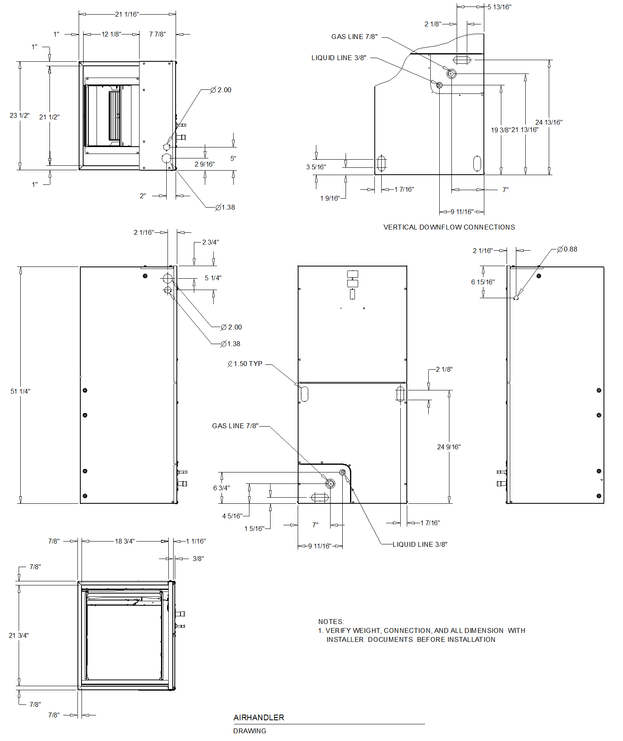
Dimensional Drawings - Split System Air Conditioning Units (Small)
Item: B1 Qty: 1 Tag(s): AHU CU-1

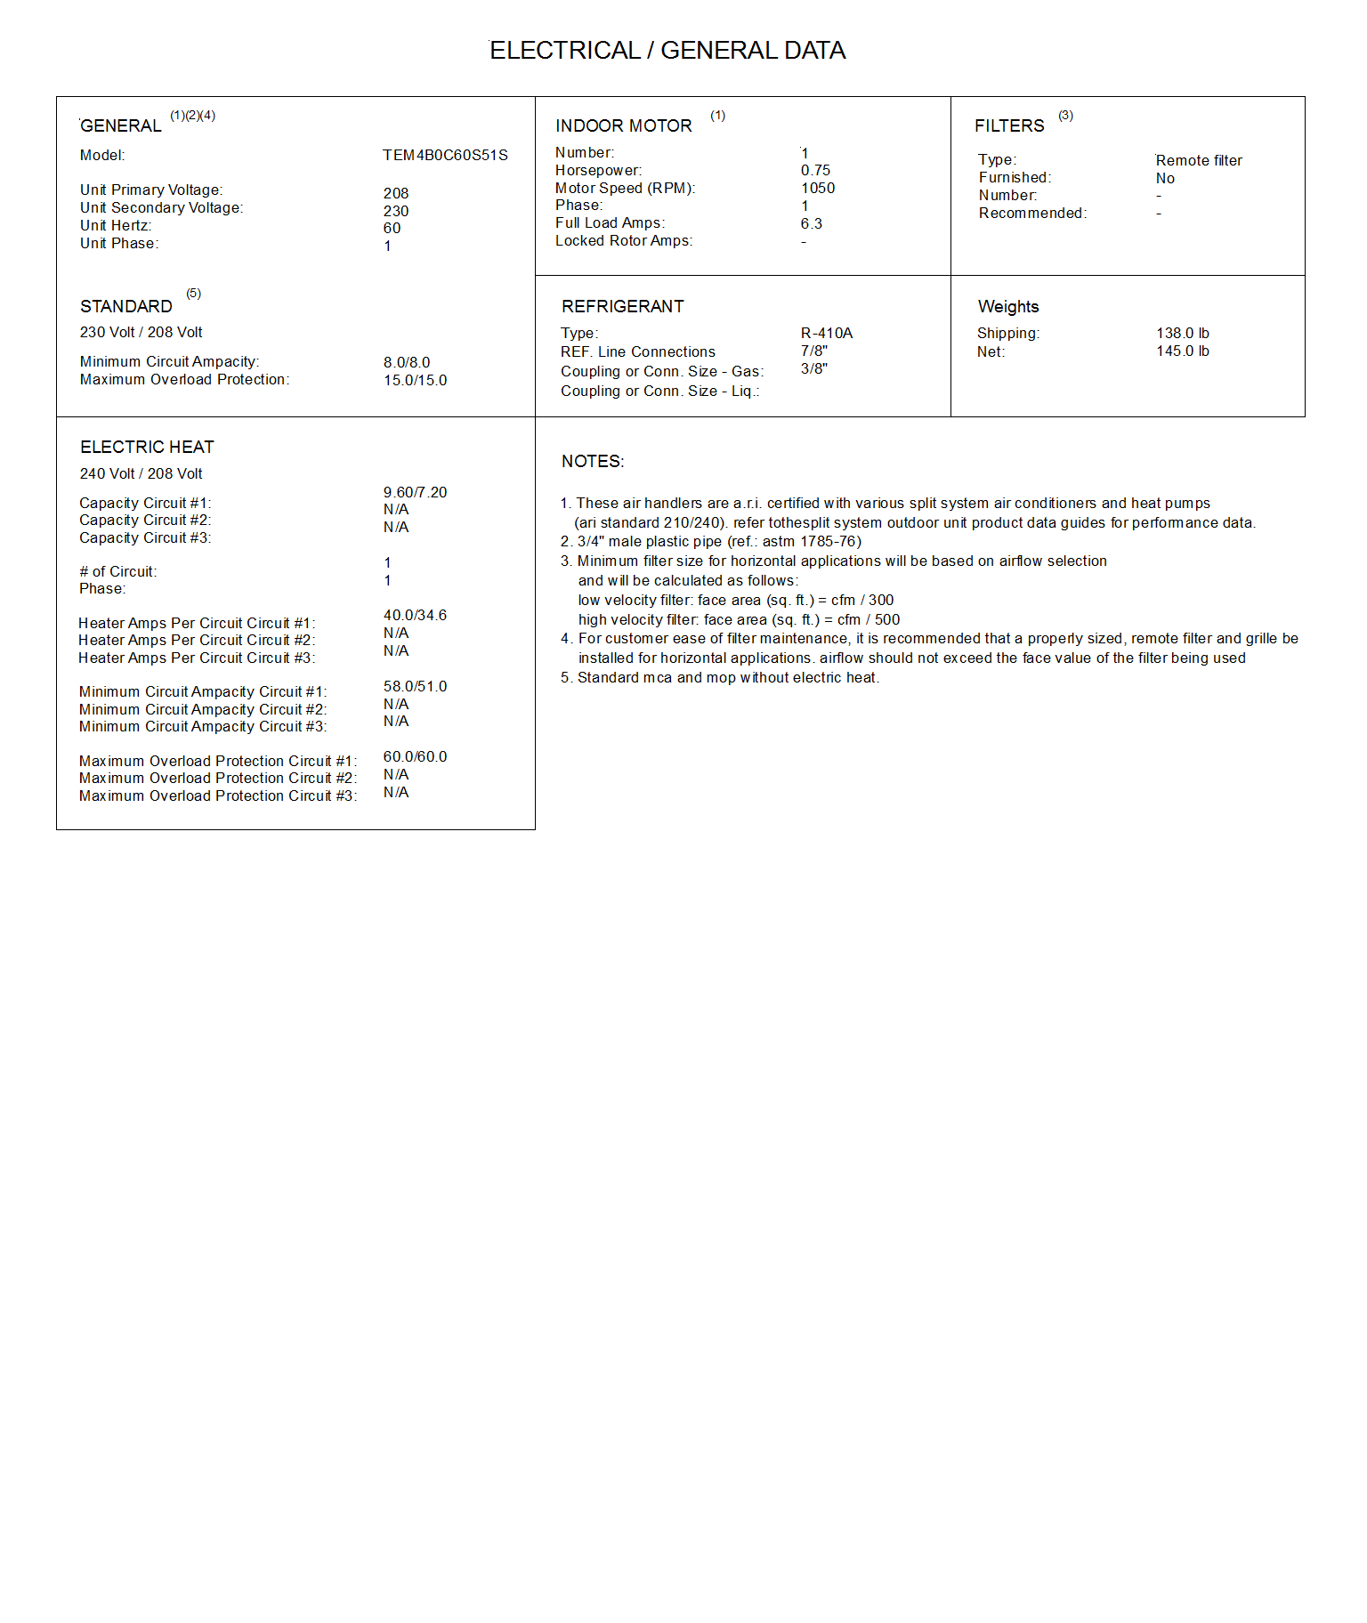
Dimensional Drawings - Split System Air Conditioning Units (Small)
Item: B1 Qty: 1 Tag(s): AHU CU-1

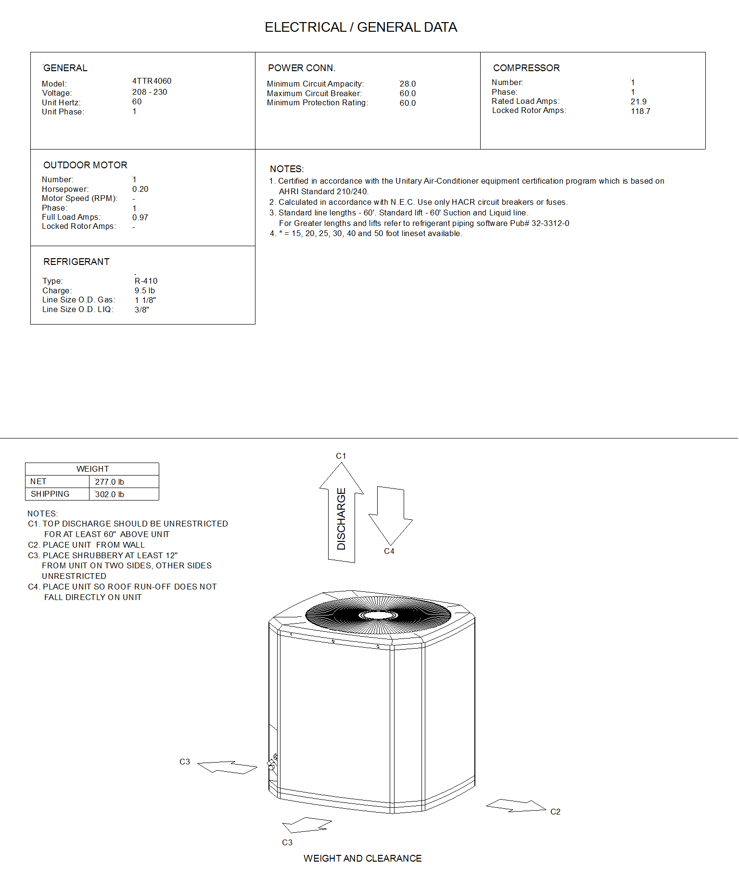
Dimensional Drawings - Split System Air Conditioning Units (Small)
Item: B1 Qty: 1 Tag(s): AHU CU-1

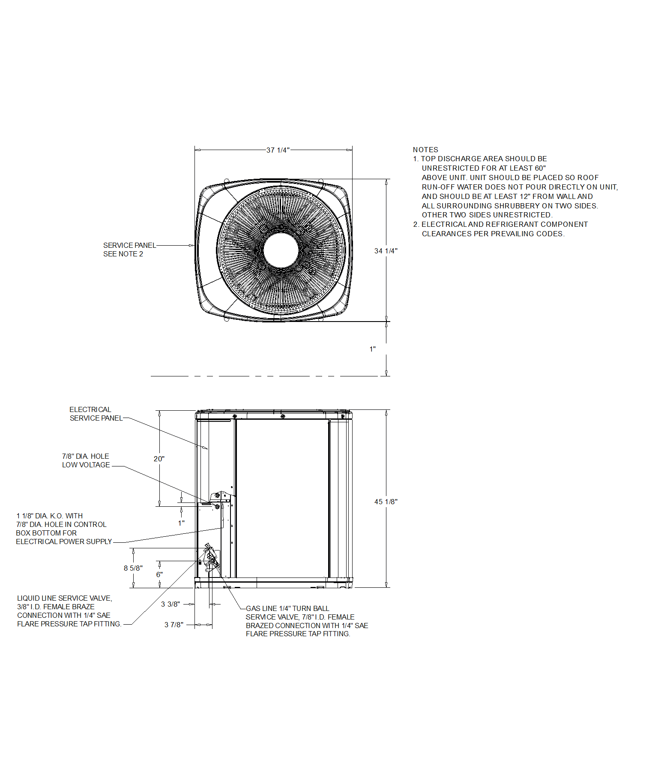
Weight, Clearance & Rigging - Split System Air Conditioning Units (Small)
Item: B1 Qty: 1 Tag(s): AHU CU-1

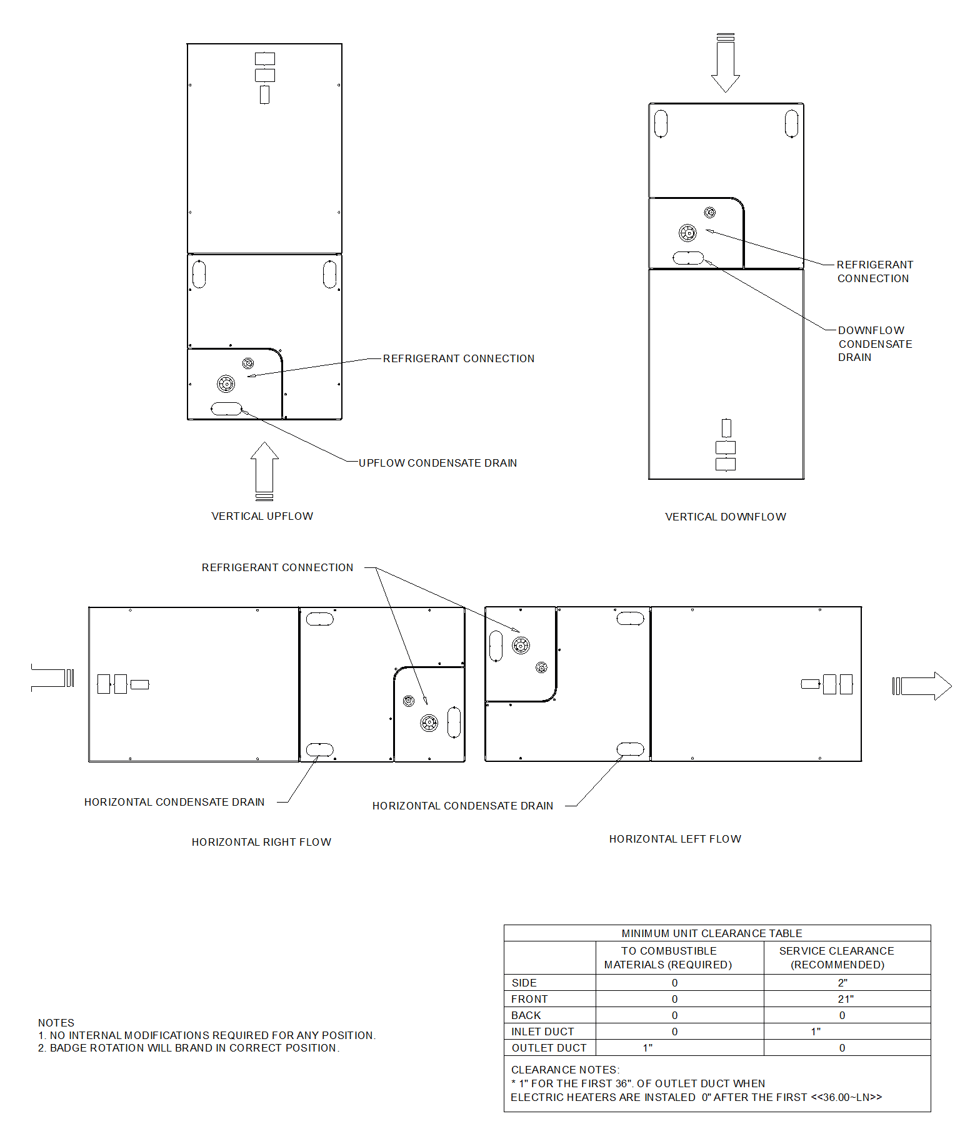
Field Installed Options - Part/Order Number Summary
This is a report to help you locate field installed options that arrive at the jobsite. This report provides part or order numbers for each field installed option, and references it to a specific product tag. It is NOT intended as a bill of material for the job.

Product Family - PREC
Item | Tag(s) | Qty | Description | Model Number
A1 | RTU-1,  RTU-2 | 2 | 6- 25 Ton PKGD Precedent Unitary Rooftop | TSJ180A3S00**000000000000000000000000000

Field Installed Option Description | Part/Ordering Number
Motorized outside damper 0-50% | FIADMPR102A
Horizontal Conversion Panel | FIAHZDC001A

Product Family - Split System Air Conditioning Units (Small)
Item | Tag(s) | Qty | Description | Model Number
B1 | AHU CU-1 | 1 | 1.5 - 5 Ton Unitary Split Systems (SSC) | 4TTR4060N10000*00000*TEM4B0C60S51S*********000**0000*0***000000000000000000000*0**0

Field Installed Option Description | Part/Ordering Number
7.21/9.60 kW Htr w/Ckt Brk 208/240/1 | BAYHTR1510BRKC

