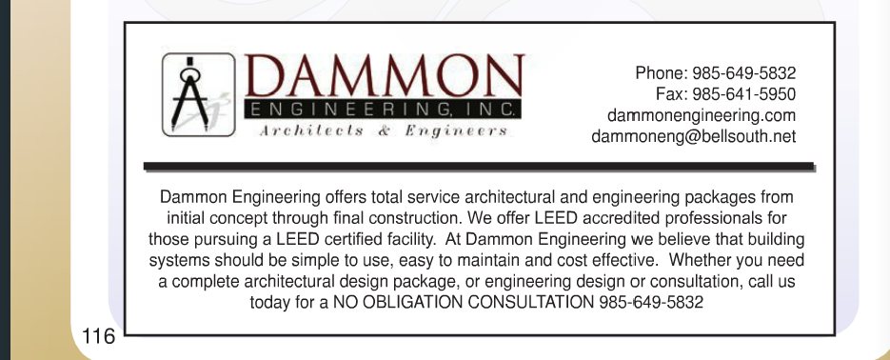

Change email address to info@dammonengineering.com

Change text to:
Dammon Engineering offers total service architectural and engineering packages from initial concept through final construction. Whether you need a complete architectural design package, or engineering design or consultation, call us today for a NO OBLIGATION CONSULTATION 985-649-5832.

