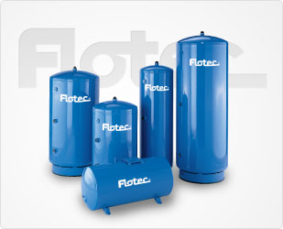 Model FP7250

Air-Over-Water Pressure Tank (Vertical) - 120 Gallons
Epoxy-lined standard water tanks are excellent corrosion resistant tanks for home water systems applications such as retention tank, holding tank and pressure tank.

Key Features
- Replaces any standard galvanized, glass-lined or epoxy-lined tank
- Precision press fit design minimizes gaps between components, reducing the possibility of corrosion and seam leaks
- Tough polyester exterior paint
- Air volume control tap is standard

Warranty
1 year limited warranty

