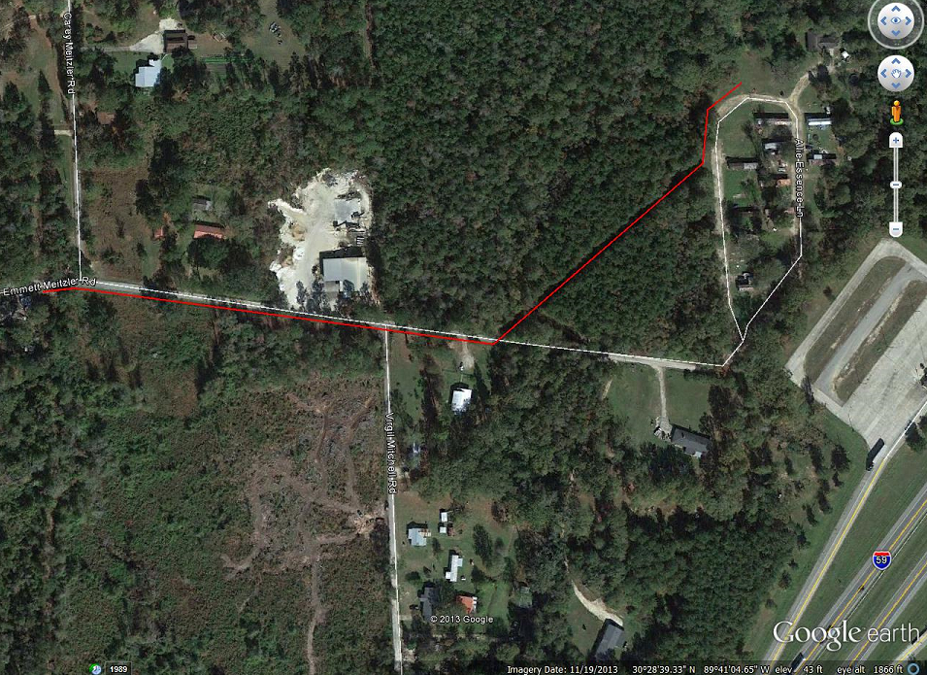
Tie into Existing Manhole Nicholson Sewer System
WORK SITE
New Sewer Lift Station
763' +/- OF 3"
DR-17HDPE PIPE
Install South East Side of Power Line/Follow Utility Right of Way
Install South Side of Road/Follow Utility Right of Way

