March 28, 2017
Dr. Jimmy Guidry,
State Health Officer

RE: Request for Variance of Main Drain Suction Outlet at the Lowest Point of the Pool Floor
Project Name: Wax Museum Condos

Mr. Guidry,
Please grant a variance to the requirement to have main drain suction in the lowest point of the pool floor as described in LAC 51 XXIV, Swimming Pools, paragraph 509 C.1. This pool being installed is going to be installed on the 3rd floor of the condos directly above an apartment.
- This pool is designed as fiberglass pool shell and has a flat bottom which in flush contact with the concrete decking supporting it. Since the pool shell has a flat bottom it would require any main drain(s) on the bottom of the pool to have piping run through the apartment below.

- Since this pool is located on the 3rd floor the piping will be installed such a manner that creates a hydraulically elevated invert which is no more than 6 inches below the static water level of the pool. In the event that a pipe is damaged or equipment below the 3rd floor starts to leak, the amount of water that will be excavated is limited to the amount of water inside the pipe and only 6 inches of water from the pool.

- This pool has been designed to have two (2) sidewall drains at the lowest possible location on the side of the pool to act as the main drains. An additional floor drain has been designed to act as a drain to evacuate the pool water for cleaning and maintenance. This floor drain has piping that is small enough to be included inside the concrete deck and will not enter the apartment below. This floor drain will be connected to the sidewall drain above, however the normal flow for circulation will mainly be coming from the sidewall drain because of the restricted flow through the smaller piping. A separate valve has been designed to allow the excavation of the pool below the level of the sidewall drains.

We are attempting to create a safe and healthy environment for all in this condominium and to conform to the Louisiana State Code as close as possible. We feel this is a common sense approach given the limitations of the pool shell and the construction at the facility.
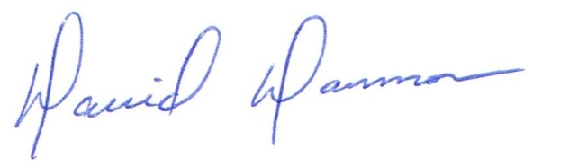
David Dammon
President
Dammon Engineering, Inc.
(985) 649-5832

