Sewer System Renovation
Bridge City Center for Youth
Project No.: 08-403-11-01, Part 01
Files : J:\Jobs\Government\STATE OF LOUISIANA\2156 - SEWER SYSTEM - BRIDGE CITY CENTER FOR YOUTH

- Facility Planning and Control (Baton Rouge)
MARK MOSES, Director of FPC; P.E.
Creighton Stout, Project Manager; Architect
- Mailing Address : Facility Planning and Control P.O. Box 94095, ​Baton Rouge, LA 70804
- Physical Address : Facility Planning and Control 1201 N. Third Street, Suite 7-160, Baton Rouge, LA 70802​
Ph. 225-342-3378
Fax. 225-342-0921
Email - creighton.stout@la.gov

Denise Brumfield, Administrative Director
phone: (225) 342-0821
email: denise.brumfield@la.gov

- Office of Juvenile Justice (Bridge City)
Curtis Badon, Facility Engineer; P.E. (Not on Site)
Mechanical Engineer

Office of Juvenile Justice
Physical Address : Office of Juvenile Justice 7919 Independence Blvd.
Mailing Address : Office of Juvenile Justice P.O. Box 66458 Baton Rouge, LA 70896
State Police Building, 1st Floor
Baton Rouge, LA 70806
225-287-7658 (office)
225-287-7931 (fax)
Curtis.Badon@LA.GOV

BCCY
(SITE) 3225 RIVER ROAD
BRIDGE CITY, LA 70094
(504) 436-4253 BCCY Main number
- Jacqueline Page
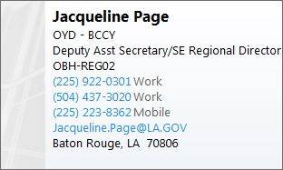
- Leroy Crawford, Assistant Director Over Maintenance BCCY
(504) 436-4253
Leroy.Crawford@LA.GOV
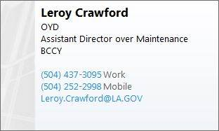
- Tim Maple, Assistant Director
© (504) 418-8544
Timothy.Maple@la.gov

- Michelle Thomas SE OJJ Regional Director
(225) 922-0301 (Work)
© (225) 439-7208

- Susan Miller, Regional Director BCCY
- Peter Pobocik, Assistant Director BCCY
- Angela Sutton, Facility Director
(504) 437-3020
angela.sutton@la.gov
- Nadira Ricks, Interim Facility Director
Bridge City Center for Youth
Nadira.Ricks@LA.GOV
(504) 436-4253 work
(318) 307-5353 cell
- Darrell Foster, Director (On Site)
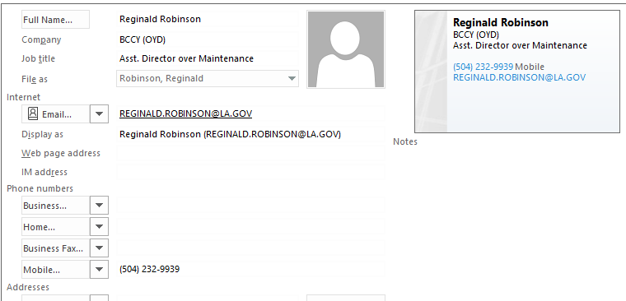
- Lance Daniels, Assistant Director (On Site )
Lance.Daniels@LA.GOV
(504) 437-3089

- Aubrey Moore, Maintenance Director (On Site)
Aubrey.Moore@LA.GOV
(504) 437-3049

- Sterling White, Asst Maintenance Director (On Site)
Sterling.White@LA.GOV
(504) 437-3049

- John Vititoe
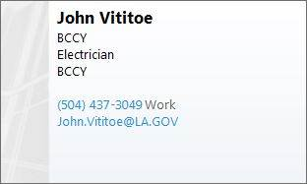
- Tyron e Carey, Plumber on site
Tyrone.Carey@La.Gov

- Janell Perry, Maintenance Admin
Janell.Perry@La.Gov

- Alana Burke, Background Checks
Alana.burke@la.gov
(504) 437-3031

Contractor:
BFM, Land Surveyor
Brandon McCain, P.L.S. (Mandeville)

BFM Corporation, L.L.C.
1011 North Causeway Blvd., Suite 16
Mandeville, Louisiana 70471
205-368-2809 – cell
985-778-0751 – office
985-778-0752 – fax

Department of Health and Hospitals
Parish Engineer – John Williams
John.Williams@LA.GOV
(504) 599-0112

Roto Rooter
Mr. Michael McCloskey
Roto-Rooter Services
General Manager - New Orleans
© 504-329-9772
504-818-1517 ext. 5139

+++++++++++++++++++++++++++++++++++++++++++++++++++++++
Contractor ARC Mechanical
(985) 661-9191

James M. Brocato
Vice President
Phone: (985) 661-9191
Fax: (985) 661-9169
Email: jbrocatoarc@bellsouth.net

Brett Cabirac
Estimator / Project Manager
brettarc@bellsouth.net
Cell: 1-504-247-2083

Maurice Cabirac
Project Manager
moarc@bellsouth.net

Norman Solar
Foreman
normansolar@icloud.com
(504) 218-3986

Tim Marlowe
Project Manager
timmarlowearc@icloud.com
504-432-1249

A.J. Bouchon
(504) 235-3962
ajbouchon@icloud.com

