Calculate a beam to replace a load bearing wall in the residence at 3801 St. Charles Ave. Unit #301

GIVEN: This is a 5 Story building, Red Iron framing with 3” concrete decking. The load bearing wall is situated between two rooms. The living room measures 19’-6 ½” orthogonal to the load bearing wall and the family room measures 9’-6” on the other side of the load bearing wall. There are 2 floors and a roof above the load bearing wall to support.
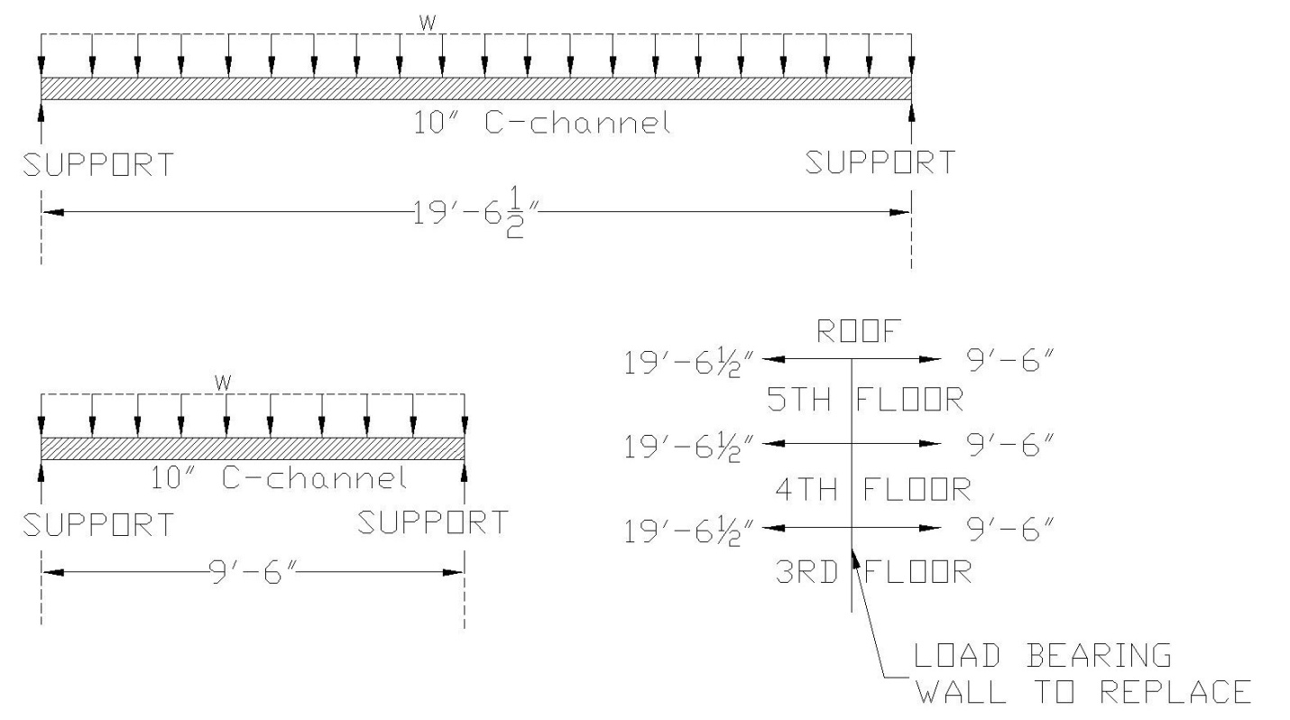
w loading for each area:
Lighting 1 psf
Hvac ductwork 2 psf
5/8” Sheetrock ceiling 2.8 psf
Metal decking for concrete 2.5 psf
3” concrete floor 3/12 * 120 pcf = 30 psf
Hardwood floor 4 psf
Each C-channel is approximately 24” o.c. so the area supported by each C-channel is approximately 24” wide x 12” along the C-channel:
42.3 psf x 2’ x1’ = 84.6 plf
Assumption : 10” C-channel weights approx. 7 plf
Adding these together we get 84.6 plf + 7 plf = 91.6 plf along each C-channel
The DEAD LOAD from each C-channel supported by load bearing wall =
[(19.5’ / 2) + (9.5’ / 2)] x 91.6 plf = 1328.2 # (1.3k)
LIVE LOAD on each C-channel @ 40 psf =
[(19.5’ / 2) + (9.5’ / 2)] x 2s.f. x 40psf = 1160 # (1.2k)

LRFD Loads 1.2 D + 1.6 L
[(1.3k x 1.2) + (1.2k x 1.6)] = 3.48 k @ 24” o.c.

Also include the dead loads from the load bearing walls on the 4th and 5th floors
(9’ x 2’ o.c.) x 10 psf = 180 #/24” o.c. (.2k @ 24” o.c.)
.
Total load from load bearing wall 3.68k @ 24”o.c.
Length of load bearing wall = 13’-2” (13.2’)
.
Deflection Limit Δ = (13.2’ x 12”/ft) / 360 = 0.44”
w from 3rd , 4th and 5th ceiling loads
w= 3.68k x 3 = 11.04 k @ 24” o.c.
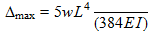
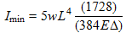
For I use unfactored w
I_{min} = 5 x (8.1/2) x (13.2)⁴ x 1728 / (384 x 29,000 x .44)
I_{min} = 216.8 in⁴
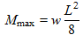 = (11.04/2) (13.2)² /8 = 120.2 ^{ft-k}
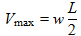 = (11.04/2) (13.2) / 2 = 36.43k
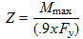 = 120.2 ^{ft-k} x 12 “/ft / (.9x50ksi) 32.5 in³
Wide Flange Options:
W8x58 A = 17.1, d=8.75, t_{w} = 0.510
I_{xx} = 228 > 216.8 Z_{xx} = 59.8 > 32.05
W10x45 A=13.3, d=10.1, t_{w} = 0.350
I_{xx} = 248 > 216.8 Z_{xx} = 54.9 > 32.05
W12x30 A=8.79, d=12.3, t_{w} = 0.26
I_{xx} = 238 > 216.8 Z_{xx} = 43.1 > 32.05
W14x26 A=7.69, d=13.9, t_{w} = 0.255
I_{xx} = 245 > 216.8 Z_{xx} = 40.2 > 32.05
Check Shear
W8x58 = 8.75x.51x50=223k > 36.48k
W10x45 = 10.1x.35x50=176.7k >36.48k
W12x30 = 12.3x.26x50=159.9k >36.48k
W14x26 = 13.9x.255x50=177k > 36.48k
Column Selection:
V_{Total} = w x L = = (11.04/2) (13.2) / 2 = 72.86k
Each column supports half the load = 72.86k /2 = 36.43k
Column Slenderness factor K = 1.5
Column height = KL = 1.5 x 10 = 15
HSS4x ¼” F_{y} = 46 ksi

