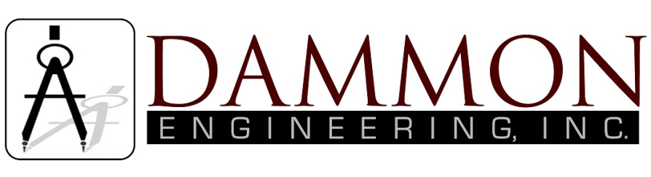
554 Old Spanish Trail
Slidell, LA 70458
Phone: 985-649-5832

dammonengineering.com
info@dammonengineering.com

Structural Inspection
May 9, 2018

For: Supreme Automotive Group
400 E. Howze Beach Rd.
Slidell, La. 70458
Ref: Flagpole

History:
Dammon Engineering was contacted to perform a visual structural inspection of the steel flagpole located in the parking lot of the subject dealership.

Findings:
An exterior visual inspection of the steel flagpole was conducted to a height of 10 feet. The steel flag pole appears to be up to a approximately ½” thick and the base of the steel pole is showing signs of deterioration that are surface rust.

When inspected, it was noted that the halyard cover is missing and was found on the ground. The decorative trim piece around the pole is rusted loose and no longer useable as a rain deterrent.

Dammon Engineering had asked to have what is left of the trim piece removed and dig down and around to where there is no signs of corrosion on the steel pole. It was done so, and it appears to only have corrosion approximately 18” down. It was also noted that there is approximately 140” of water inside the flagpole itself.

Recommendation:
Items to be addressed are as follows:

1) Remove standing water from inside the flagpole.
2) Remove rust at the base of the flagpole, chemprime and paint.
3) Attach halyard hatch with a seal to prevent further water intrusion.
4) Provide a new decorative trim piece at the base to prevent further water intrusion.
5) Prep and paint entire flagpole.

This should provide another 10 years of service.

Sincerely,

Brian Mistich, P.E.

