Intro to Environmental, ENCE 3323

Bottled Water vs. Tap Water
Is your Bottled Water as safe as Tap Water
which is More Sustainable?

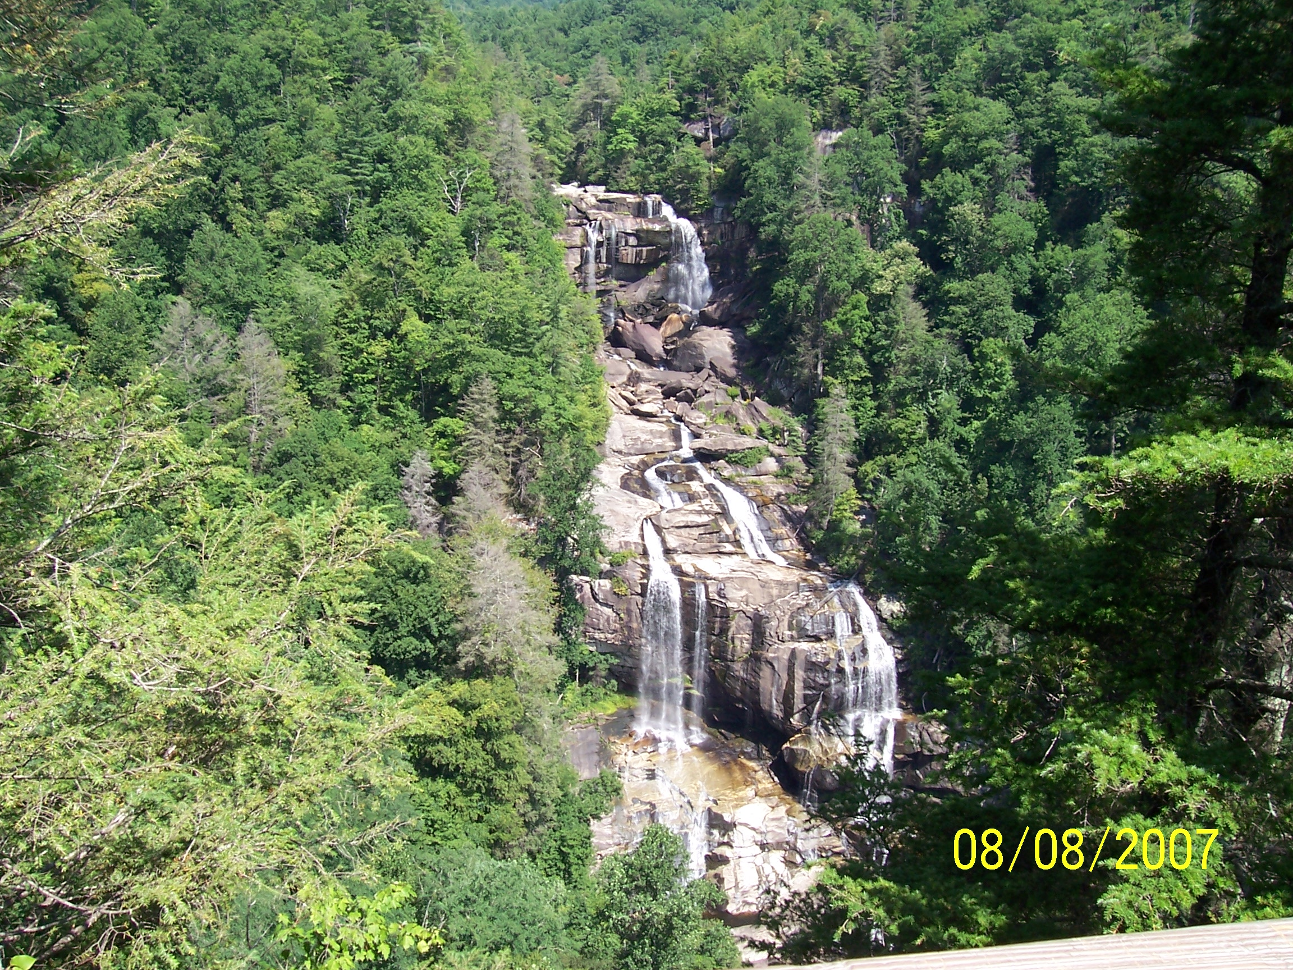

April, 23, 2011

David Dammon

Bottled Water vs. Tap Water
Is your Bottled Water as safe as Tap Water and which is More Sustainable?

Sustainability is something which must be considered when looking at any commodity used for consumption. Sustainability is defined by Webster as “of, relating to, or being a method of harvesting or using a resource so that the resource is not depleted or permanently damaged” (Merriam Webster Dictionary). It is this definition that we are concerned with in relation to water, the using of a resource so that the resource is properly harvested and so that it is not depleted or permanently damaged. An additional parameter is applicable to completely define a sustainable resource. The additional parameter needed is that the manufacturing, distribution and deposition of the resource must also meet the requirements of sustainability. All energy, materials and the local environment used in the manufacturing, distribution and deposition must maintain a sustainable posture throughout the process. The energy used must not solely be dependent on a single source of non reusable resources, materials used in manufacturing and distributing must not deplete available resources, and the environment must not be adversely affected.

Drinking water appears, on the surface, to be as abundant as the light coming from the sun. There are a lot of different estimates of how much water there is on this planet but, some estimate it between 326 x 106 and 400 x 106 gallons of water. We drink water, use it in our house and office, use it in manufacturing as well as using it in other ways. The water from your house goes down the drain, then on to a treatment plant. The treatment plant cleans it and deposits it into some aquatic distribution system. Some water is vaporized, rises into atmosphere where it is redeposited back on the surface. This redistribution of water gives us ground water but, first the water must travel back down through the atmosphere then through the soils on its way to underground aquifers along the path it takes this water can pick up tiny particles which can be toxic. We get our drinking water from many sources, one method is by underground wells. Another source of drinking water is from streams and other water ways. All of it comes from the same planet but, depending on who harvests the water in the United States of America determines which form of government monitors its safety for human consumption.
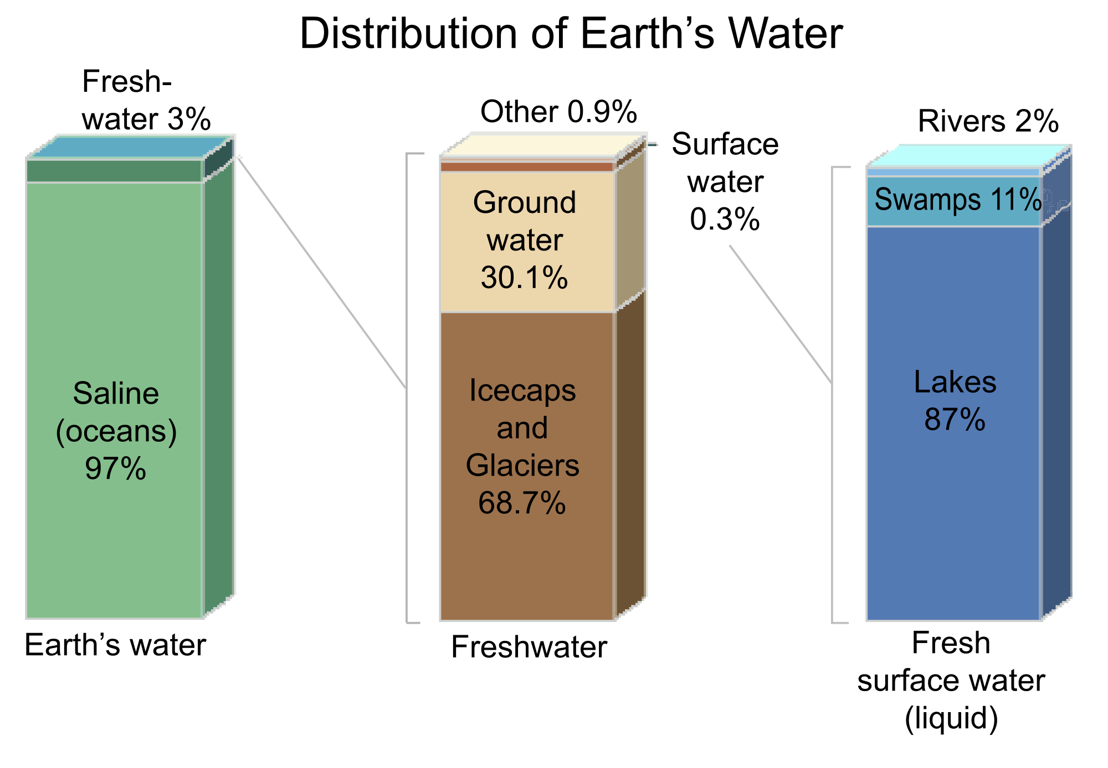
Source: Wikimedia Commons
When water is harvested and provided directly to customers through piping systems we call it tap water. The EPA monitors tap water for communities larger than 25 people or 15 service connections for at least 60 days per year. “The Safe Drinking Water Act (SDWA) is the main federal law that ensures the quality of Americans' drinking water. Under SDWA, the EPA sets standards for drinking water quality and oversees the states, localities, and water suppliers who implement those standards. SDWA was originally passed by Congress in 1974 to protect public health by regulating the nation's public drinking | 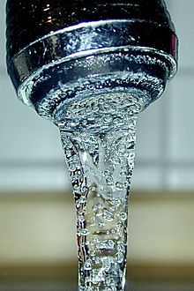
water supply. The law, which was amended in 1986 and 1996, requires many actions to protect drinking water and its sources: rivers, lakes, reservoirs, springs, and ground water wells“ (EPA SDWA). The SDWA allowed the EPA to delegate some of its administrative elements to the individual states; in Louisiana the Health Department manages the SDWA, however the EPA still retains oversight responsibility to ensure the program meets the SDWA mandates. Approximately 32% of the population in the United States receives tap water from underground aquifer well systems, while the remaining 68% receive tap water from surface water systems. The EPA requirements for pre-treatment of each underground well system varies from location to location. The EPA mandates that all surface water collection systems must provide treatment for this water, some of the reasons for this requirement are that surface water collection systems are directly exposed to rainfall run-off, the atmosphere and other sources of pollutants.
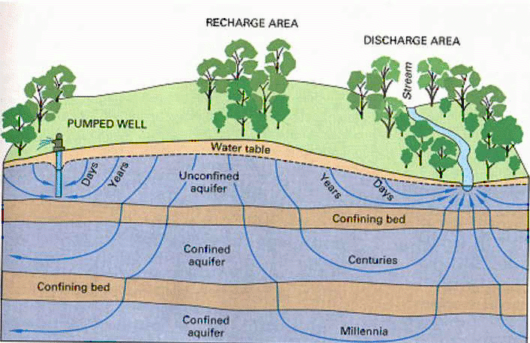
Source: Wikimedia Commons
When water is harvested and bottled in a manufacturing setting, the Federal Drug Administration (FDA) monitors this procedure. “FDA regulates bottled water as a food. The Federal Food, Drug, and Cosmetic Act (FFDCA) provides FDA with broad regulatory authority over food that is introduced or delivered for introduction into interstate commerce. Under the FFDCA, manufacturers are responsible for producing safe, wholesome and truthfully labeled food products, including bottled water products” | 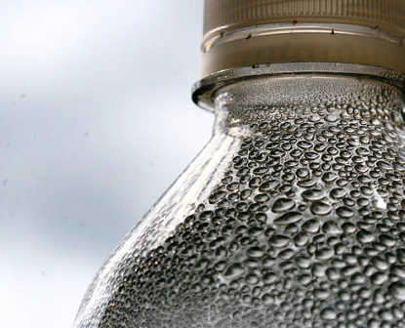
(FDA Regulations). The FDA identifies spring and mineral water as different types of bottled water, both are covered under Title 21 of the Code of Federal Regulations (21 CFR). The FDA has established Current Good Manufacturing Practice (CGMP) regulations for the processing and bottling of bottled drinking water under 21 CFR part 129. “21 CFR Part 129. These regulations require that bottled water be safe and that it be processed, bottled, held and transported under sanitary conditions. Processing practices addressed in the CGMP regulations include protection of the water source from contamination, sanitation at the bottling facility, quality control to assure the bacteriological and chemical safety of the water, and sampling and testing of source water and the final product for microbiological, chemical, and radiological contaminants” ( FDA Regulations).

Both the FDA and the EPA have regulations in place to monitor drinking water for contaminants. A full list of these contaminants and each maximum contaminant level (MCL) can be found under attachment #1 to this paper. A review of these contaminants shows that for the most part both agencies monitor for the same contaminants and MCL. The one area in this monitoring process that does not show up on the list of contaminants is how and when the public are informed when an MCL has been violated. In a report to the United States Congress the Government Accountability Office (GAO) reported in June of 2009, “The FFDCA (Federal Food, Drug, and Cosmetic Act) does not specifically authorize FDA to require bottlers to report test results, even if violations of the standard of quality regulations are found. Instead, inspectors review testing records when they inspect bottling facilities. In contrast, under the Safe Drinking Water Act, public water systems must notify the public as well as the appropriate regulatory agency (e.g., state environmental agency) within 24 hours of detecting certain violations of the national primary drinking water regulations that have significant potential to have serious adverse effects on human health as a result of short-term exposure. For violations that have the potential to have serious adverse effects on human health and all other violations, public water systems must provide notice within 30 days and 1 year, respectively. FDA officials told us that to comply with the Food and Drug Administration Amendments Act of 2007, the agency is developing a means for all food facilities it regulates to report instances when there is a reasonable probability that the use of, or exposure to, a food will cause serious adverse health consequences or death to humans or animals. This act required FDA to establish, by September 2008, a Reportable Food Registry—an electronic portal by which responsible parties or public health officials may submit such instances to FDA. FDA officials have told us that the registry is still under development, and that it is taking steps to create an interim Reportable Food Registry by the end of fiscal year 2009. “ (GAO Report to Congressional Requesters) In a personal report to Congress, July 8, 2009, the Principal Deputy of the FDA, Joshua M. Sharfstein, M. D. reported , “Bottlers are required to maintain source approval and testing records to show to government inspectors.... FDA monitors and inspects bottled water products and processing plants as part of its general food safety program. Because FDA's experience over the years has shown that bottled water has a good safety record, bottled water plants generally are assigned a relatively low priority for inspection” (Subcommittee). This report by the Principal Deputy of the FDA and the GAO's report show that bottled water does not meet the same requirements of the EPA for monitoring and reporting when the drinking water has exceeded an MCL.

Which method of distributing water is sustainable? Both methods provide unique issues to deal with sustainability. When you are setting up a public water system, miles and miles of piping and hundreds of gate valves must be purchased and installed by disturbing the environment in order to install all of these mechanisms. These materials must be suitable for the use they are intended to provide as well as be from a sustainable resource and be manufactured within sustainability guidelines. The life expectancy of a public water system and the number of breaks due to ground movement as well as occasional breakage due to someone digging in an area that contains a water line must be considered in the sustainability factor. The product of choice, since the early 2000s, for public water systems has been Polyvinyl Chloride (PVC) and the PVC industry has touted its technical and economic merits rather than its sustainability for the reasons why it is the best product for this use. The water bottling industry uses a plastic product to deliver drinking water to its paying customer. This plastic product has been the conversation of many environmentalist not only for its production but also the amount of product that shows up in the solid waste landfills. Neglecting the water distribution system to your neighborhood, each house normally would have a 3/4” water line from the distribution system into your house and the average length of that connection is 150 feet. PVC has a very similar density to that of plastic used in a plastic water bottle, approximately 1.4 g/cm3. For an average length of 150 ft of PVC, it would occupy 10,205 cm3 (0.3604 ft3) of space in a landfill, let us say for averages that a house will use that water line for approximately 25 years without repair or demolition. A typical 16.9 oz single serving of bottled water displaces appropriately 9.07 cm3 (0.0003203 ft3) of space per plastic bottle. If you consider a small family of 2, consuming a minimum of 4 containers of bottled water per day by each person, those water bottle containers will occupy a landfill at a rate of 72.6 cm3/day (26,488 cm3/year). Given the current trends, IAWA reports that approximately 30% of these plastic bottles are recycled which would leave 18,541 cm3/year of plastic waste due to bottled water filling our landfills per small family in the United States. With this comparison you can see that with only 2 people drinking 4 bottles of water each day they contribute more waste in our landfills each year than using tap water from a house would in 25 years. Please note that no one is going to build a house in the United States without having running water inside the house, so this bottled water dilemma is in addition to the PVC used in a house.

The United States of America has long been observed as a disposable society, we do not purchase products to last but would rather purchase inexpensively and dispose of unwanted refuse. The EPA, for water distribution systems, and the FDA, for bottle water, both monitor for the same contaminants but the FDA doesn't necessarily tell the public when a manufacturer exceeds an MCL. A small family of two drinking only 4 bottles of water per day each produce more waste in our sanitary landfill than their living accommodations produce in 25 years. Considering all of these issues we can conclude that tap water is safer for the public because they are informed within 24 hours of their water system when it has exceeded an MCL. Neither method meets all of the sustainability parameters when looking at the containers that deliver the product to the consumer; however one particular parameter stands out with an enormous differential and that parameter is our landfill.

Works Cited

1. Merriam Webster Dictionary, http://www.merriam-webster.com/dictionary/sustainability, March 10, 2011
2. EPA, SDWA, http://water.epa.gov/lawsregs/rulesregs/sdwa/index.cfm, 3/11/2011
3. Lauren M. Posnick, Sc.D. and Henry Kim, Ph.D. Series Editor , FDA Regulations, Reprint of Food Safety Magazine August/September 2002, http://www.fda.gov/Food/FoodSafety/Product-SpecificInformation/BottledWaterCarbonatedSoftDrinks/ucm077079.htm, 3/11/2011
4. Joshua M. Sharfstein, M.D., Subcommittee on Oversight and Investigations
House Committee on Energy and Commerce, http://www.fda.gov/NewsEvents/Testimony/ucm170932.htm , 3/15/2011
Attachment 1 of 2
Attachment 2 of 2

