NOAA.gov
The problem of disposing plastic bottles in or near the ocean and where do these bottles accumulate.
Link http://marinedebris.noaa.gov/info/patch.html

EPA.gov
The EPA paid for a study from a community college in CA for the answer “the concerns of students have over the consumption of tap water and why they are willing to pay for something that they could otherwise get for free.” This study looked at the major technical challenge to sustainability is reduction of use of plastic bottled water and bottled water in general. http://cfpub.epa.gov/si/si_public_record_report.cfm?direntryid=200985 The final report is at http://cfpub.epa.gov/ncer_abstracts/index.cfm/fuseaction/display.abstractDetail/abstract/8836/report/F

The EPA regulates all ground water suppliers for human consumption using the Safe Drinking Water Act of 1974. The EPA and delegated states and tribes, regulate the public drinking water systems that provide 90 percent of Americans their drinking water. Public drinking water systems are defined as those who service at least 25 people or 15 service connections for at least 60 days per year. Private individual home wells are not regulated by the EPA. http://www.epa.gov/compliance/civil/sdwa/index.html
http://www.epa.gov/compliance/civil/sdwa/sdwaenfprog.html
http://water.epa.gov/lawsregs/rulesregs/sdwa/index.cfm

The Chemical Contaminants were regulated in phases, which are collectively referred to as the Chemical Phase Rules. These rules regulate over 65 contaminants in three contaminant groups: Inorganic Contaminants (IOCs), Volatile Organic Contaminants (VOCs), and Synthetic Organic Contaminants (SOCs). The rules apply to all public water systems (PWS). PWS type, size, and water source determine which contaminants require monitoring for that system.

FDA.gov
In the U.S., bottled water and tap water are regulated by two different agencies; the FDA regulates bottled water and the U.S. Environmental Protection Agency (EPA) regulates tap water (also referred to as municipal water or public drinking water). FDA regulates bottled water as a food. http://www.fda.gov/Food/FoodSafety/Product-SpecificInformation/BottledWaterCarbonatedSoftDrinks/ucm077079.htm

Some pro's for plastic packaging of products and the sustainability of these products. http://www.americanchemistry.com/plastics/sec_content.asp?CID=1078&DID=9461

Sustainability http://yalesustainability.wordpress.com/2009/04/29/do-you-know-which-number-plastic-bottles-are-safe-to-reuse/

Possible solutions:

The only tried and true way of changing a society is to start with the children in public schools. This approach has worked well for our liberal government with the issue of homosexuality, why can't it work with sustainability? This method of approach may take some time to resolve the issue but otherwise we spend a lot of money trying to change the minds of taxpayers. Solutions to the different aspects of bottle usage, sports and hiking etc. will need to be overcome to give these young absorbent minds an alternative to using a disposable plastic bottle.

GAO Report on FDA Safety bottled water: http://www.gao.gov/new.items/d09610.pdf

GAO Report :

How violations are reported: The FFDCA does not specifically authorize FDA to require bottlers to report test results, even if violations of the standard of quality regulations are found. Instead, inspectors review testing records when they inspect bottling facilities. In contrast, under the Safe Drinking Water Act, public water systems must notify the public as well as the appropriate regulatory agency (e.g., state environmental agency) within 24 hours of detecting certain violations of the national primary drinking water regulations that have significant potential to have serious adverse effects on human health as a result of short-term exposure. For violations that have the potential to have serious adverse effects on human health and all other violations, public water systems must provide notice within 30 days and 1 year, respectively. FDA officials told us that to comply with the Food and Drug Administration Amendments Act of 2007,11 the agency is developing a means for all food facilities it regulates to report instances when there is a reasonable probability that the use of, or exposure to, a food will cause serious adverse health consequences or death to humans or animals. This act required FDA to establish, by September 2008, a Reportable Food Registry—an electronic portal by which responsible parties or public health officials may submit such instances to FDA. FDA officials have told us that the registry is still under development, and that it is taking steps to create an interim Reportable Food Registry by the end of fiscal year 2009.

Sustainability is something which must be considered when looking at any commodity used for consumption. Sustainability is defined by Webster as “of, relating to, or being a method of harvesting or using a resource so that the resource is not depleted or permanently damaged.” (http://www.merriam-webster.com/dictionary/sustainability, March 10, 2011 ) It is this definition that we are concerned with in relation to water, the using of a resource so that the resource is properly harvested and so that it is not depleted or permanently damaged. An additional parameter is applicable to completely define a sustainable resource. The additional parameter needed is that the manufacturing and distribution of the reusable resource must also meet the requirements of sustainability. All energy, materials and local environment used in the manufacturing and distribution must maintain a sustainable posture throughout the process. The energy used must not solely be dependent on a single source of non reusable resources, materials in manufacturing and distributing must not deplete the resources available, the environment must not be affected adversely.

Drinking water appears, on the surface, to be as abundant as the light coming from the sun. There are a lot of different estimates of how much water there is on this planet but, some estimate it between 326 x 106 and 400 x 106 gallons of water. We drink water, use it in our house and office, use it in manufacturing and many other ways. The water goes down the drain, then on to a treatment plant. The treatment plant cleans it and deposits it into some aquatic distribution system. Some water is vaporized, rises into atmosphere where it is redeposited back on the surface. This redistribution of water gives us ground water but, first the water must travel back down through the atmosphere then through the soils on its way to underground aquifers along the path it takes this water can pick up tiny particles which can be toxic. We get our drinking water from many sources, one method is by underground wells. Another source of drinking water is from streams and other water ways. All of it comes from the same planet but, who harvests the water determines which form of government monitors its safety for human consumption.

When water is harvested and provided directly to customers through piping systems we call it is tap water. The EPA monitors tap water for communities larger than 25 people or 15 service connections for at least 60 days per year. “The Safe Drinking Water Act (SDWA) is the main federal law that ensures the quality of Americans' drinking water. Under SDWA, EPA sets standards for drinking water quality and oversees the states, localities, and water suppliers who implement those standards.  SDWA was originally passed by Congress in 1974 to protect public health by regulating the nation's | 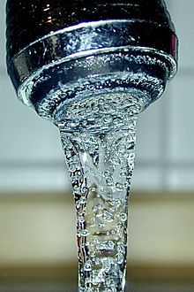
public drinking water supply. The law was amended in 1986 and 1996 and requires many actions to protect drinking water and its sources: rivers, lakes, reservoirs, springs, and ground water wells.“ (http://water.epa.gov/lawsregs/rulesregs/sdwa/index.cfm, 3/11/2011) The SDWA allowed the EPA to delegate the administrative elements to the individual states; in Louisiana the Health Department manages the SDWA, however the EPA still retains oversight responsibility to ensure the program meets the SDWA mandates. Approximately 32% of the population in the United States receives drinking water from underground aquifer well systems, while the remaining 68% receive drinking water from surface water systems. The EPA requirements for each underground well system varies from location to location. The EPA mandates that all surface water collection systems must provide treatment for this water, some of the reasons for this requirement are that surface water collection systems are directly exposed to rainfall run-off, the atmosphere and other sources of pollutants.
When water is harvested and bottled in a manufacturing setting, the Federal Drug Administration (FDA) monitors this procedure. “FDA regulates bottled water as a food. The Federal Food, Drug, and Cosmetic Act (FFDCA) provides FDA with broad regulatory authority over food that is introduced or delivered for introduction into interstate commerce. Under the FFDCA, manufacturers are responsible for producing safe, wholesome and truthfully labeled food products, including bottled water products.” | 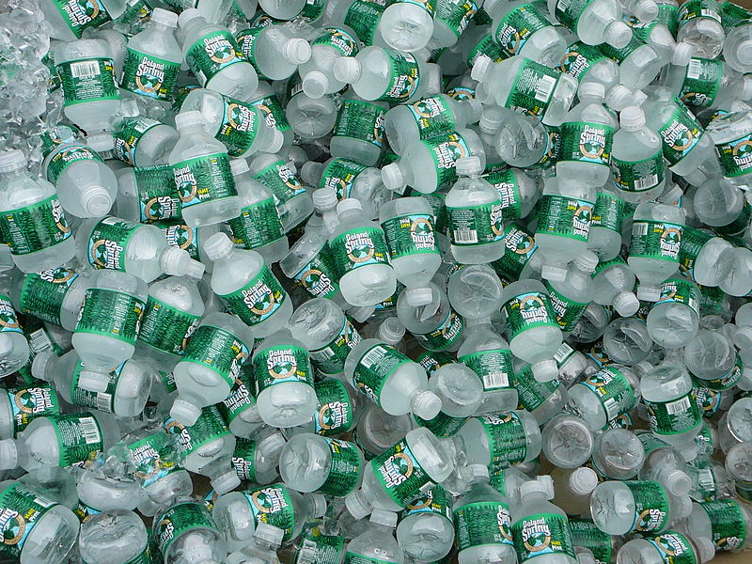
(http://www.fda.gov/Food/FoodSafety/Product-SpecificInformation/BottledWaterCarbonatedSoftDrinks/ucm077079.htm, 3/11/2011) The FDA identifies spring and mineral water as different types of bottled water, both are covered under Title 21 of the Code of Federal Regulations (21 CFR). The FDA has established Current Good manufacturing Practice (CGMP) regulations for the processing and bottling of bottled drinking water under 21 CFR part 129. “21 CFR Part 129. These regulations require that bottled water be safe and that it be processed, bottled, held and transported under sanitary conditions. Processing practices addressed in the CGMP regulations include protection of the water source from contamination, sanitation at the bottling facility, quality control to assure the bacteriological and chemical safety of the water, and sampling and testing of source water and the final product for microbiological, chemical, and radiological contaminants.” ( http://www.fda.gov/Food/FoodSafety/Product-SpecificInformation/BottledWaterCarbonatedSoftDrinks/ucm077079.htm, 3/11/2011)

Both the FDA and the EPA have regulations in place to monitor drinking water for contaminants. A full list of these contaminants and each maximum contaminant level (MCL) can be found under attachment #1 Appendix II to this paper. A review of these contaminants shows that for the most part both agencies monitor for the same contaminants and MCL. The one area in the monitoring process that does not show up on the list of contaminants is how and when the public are informed when a MCL has been violated. In a report to the United States Congress the Government Accountability Office (GAO) reported in June of 2009, “The FFDCA (Federal Food, Drug, and Cosmetic Act) does not specifically authorize FDA to require bottlers to report test results, even if violations of the standard of quality regulations are found. Instead, inspectors review testing records when they inspect bottling facilities. In contrast, under the Safe Drinking Water Act, public water systems must notify the public as well as the appropriate regulatory agency (e.g., state environmental agency) within 24 hours of detecting certain violations of the national primary drinking water regulations that have significant potential to have serious adverse effects on human health as a result of short-term exposure. For violations that have the potential to have serious adverse effects on human health and all other violations, public water systems must provide notice within 30 days and 1 year, respectively. FDA officials told us that to comply with the Food and Drug Administration Amendments Act of 2007, the agency is developing a means for all food facilities it regulates to report instances when there is a reasonable probability that the use of, or exposure to, a food will cause serious adverse health consequences or death to humans or animals. This act required FDA to establish, by September 2008, a Reportable Food Registry—an electronic portal by which responsible parties or public health officials may submit such instances to FDA. FDA officials have told us that the registry is still under development, and that it is taking steps to create an interim Reportable Food Registry by the end of fiscal year 2009. “ (GAO Report to Congressional Requesters)

