Chapter 9

- What is solid waste?
Things we throw away which includes things we commonly describe as garbage, refuse and trash.
- What materials are included in solid waste?
USEPA Definition: any discarded item; things destined for reuse, recycle, or reclamation; sludges; and hazardous wastes. Except radioactive wastes and insitu mining wastes.
- 60% of solid waste comes from residential sources and the remaining from commercial sources. Studies show there are wide differences in amounts collected by municipalities because of :
differences in climate
living standards
time of year
education
location
collection and disposal practices
4. Classify solid wastes based on the nature of the waste:
Organic
Inorganic
Combustible
Non-Combustible
Putrescible (Solid waste that contains organic matter capable of being decomposed by microorganisms and of such a character and proportion as to cause obnoxious odors and to be capable of attracting or providing food for birds or animals)
Non – putrescible
- Trash has combustible rubbish consisting of paper, rags, cartons, boxes, furniture, wood, tree branches, yard trimmings. Trash is not putrescible and can be stored for longer periods of time
- For collection of solid waste, the maximum period should be less than:
Normal time for the accumulation of the amount that can be placed in container
Time taken for fresh garbage to putrefy and emit foul odors under average storage conditions
Length of the fly-breeding cycle, which during summer is less than seven days
- Define a sanitary landfill.
A land disposal site (1) employing an engineered method of disposing of solid wastes (2) on land in a manner that minimizes environmental hazards (3) by spreading the solid wastes to the smallest practical volume (4) applying and compacting cover material at the end of each day.
- What are the two different methods used in landfills?
Area and Trench. Area method deposits solid wastes on the surface, compacted then covered with a layer of compacted soil. Trench is an excavated site where solid wastes is placed in it and compacted and the soil removed during excavation is used to cover the solid waste.
- List the components of a landfill
cell
face
cover
lift
benches
final cover
- Liquid that passes through the landfill and that has extracted dissolved and suspended matter is called LEACHATE.

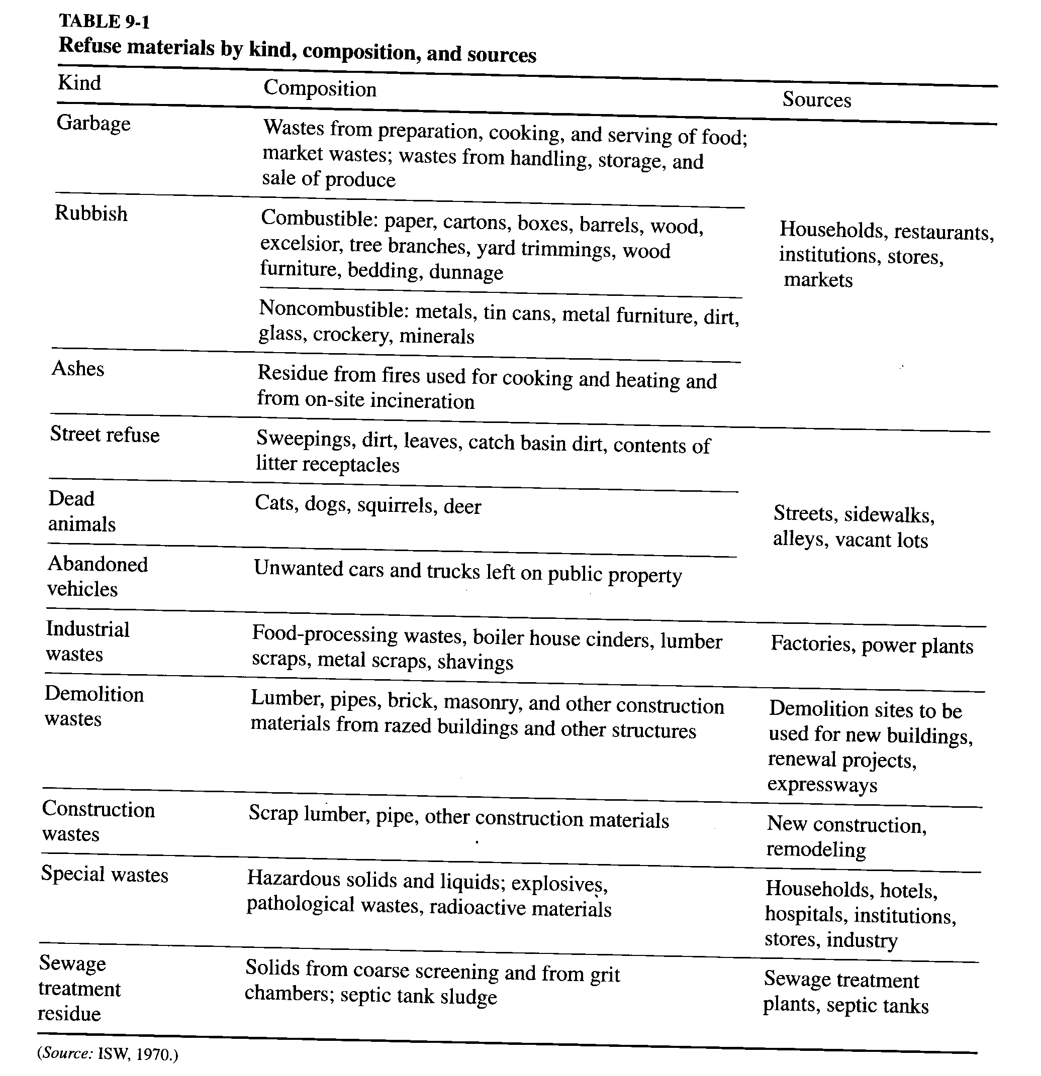

Chapter 7

- What is ambient air?
Ambient air is the atmosphere, external to buildings, to which the general public has access
- What are the sources of pollution?
a. Industries – combustion: particulate matter, SO2, NOx, CO, CO2 + H2O
- chemicals / refineries, VOCs,
b. Transportation - road, marine, rail,air PM10, SO2, NOx, CO, CO2
c. Nature – volcano, desert storms, forest fires, lightning
d. Heating and ventilation of building
- List the six criteria pollutats for which the EPA has designated NAAQS
PM10, SO2, NOx, CO, O3, Pb
- What are VOCs?
Volatile organic compound
- What is non-attainment?
When one or more pollutants do not meet NAAQS limit
- What are HAPs and name some?
Hazardous Air Pollutants, VOCs like Benzene, Metals like Cr, Mn, Ni, Pb
- What is the average inhalation rate per day and typical concentration of air pollutants?
20m3/day inhalation and 1 µg/m3 of pollutants
- What is the Unit Risk Estimate Cr=0.012 mean?
12 out of 1000 people might get cancer
- What measurement units are used in air pollutants?
a. Concentration Units - micrograms/m3 & ppm
b. Particle Size Units - microns or micrometer (10-6 meters)
- Convert ppm to ug/m3
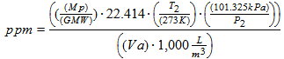
- Explain the difference between ppm in air pollution and ppm in water pollution.
Ppm in air is a volume to volume ration when in water it is a mass to mass ratio.
- Explain the effect of temperature and pressure on readings made in ppm.
?
- What are the five mechanisms of deterioration that have been attributed to air pollution?
Abrasion, deposition and removal, direct chemical attach, indirect chemical attack, and electrochemical erosion.
- Explain the influence of moisture, temperature, and sunlight on the severity of air pollution effects on materials.
Moisture is required for deterioration, higher temperature generally results in higher reaction rates, sunlight stimulates air pollution damage by providing the energy for pollutant formation.
- Define emission factors and give two examples.
Indoor air pollution sources and pollutants measured in ug/h*m2. Tbl 7-12, Formaldehyde, Styrene, Toluene, TVOC, Decane, Nonane, Pentylcyclohexane, Undecane, Xylenes, Acetaldehyde, Ethylene glycol
- A gas stream carries particles which require removal using appropriate air pollution control device. Particle size distribution indicates that significant portion consists of particles less than 5 microns in size. Between the two options you have, a cyclone versus an ESP, which one would you recommend?
Cyclones are good for particle sizes greater than 10 µm, ElectroStatic Precipitation has a high efficiency for the dry collection of particles of hot gas streams.
- What two specific air pollutants are responsible for acid rain?
SO2, NOx, decrease in crop yield, fish kill, hazard to human health/safety, damage to property (corrosion of buildings, bridges)
- List at least two air pollutants emitted by automobile.
CO2 & Nitrogen
- Differentiate between acute and chronic health effects from air pollutants.

- List three potential chronic health effects of air pollution.

