Chapter 2
Uniformity Coeff. Coeff. Of gradation
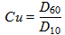
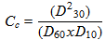
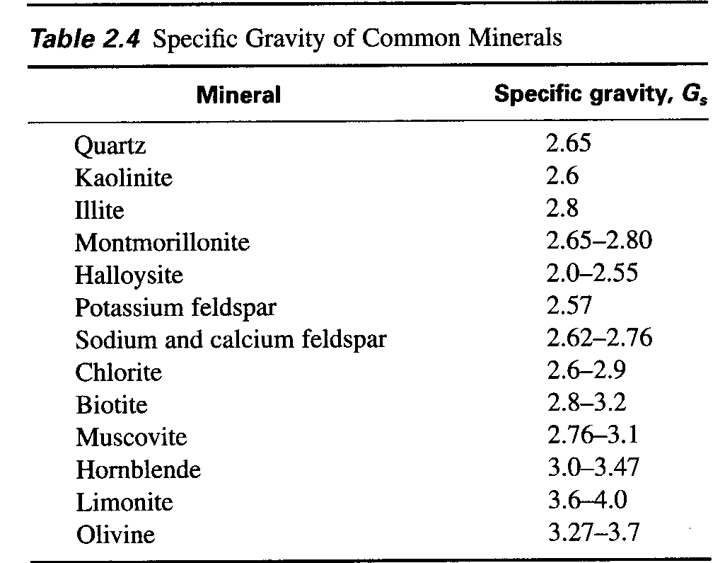
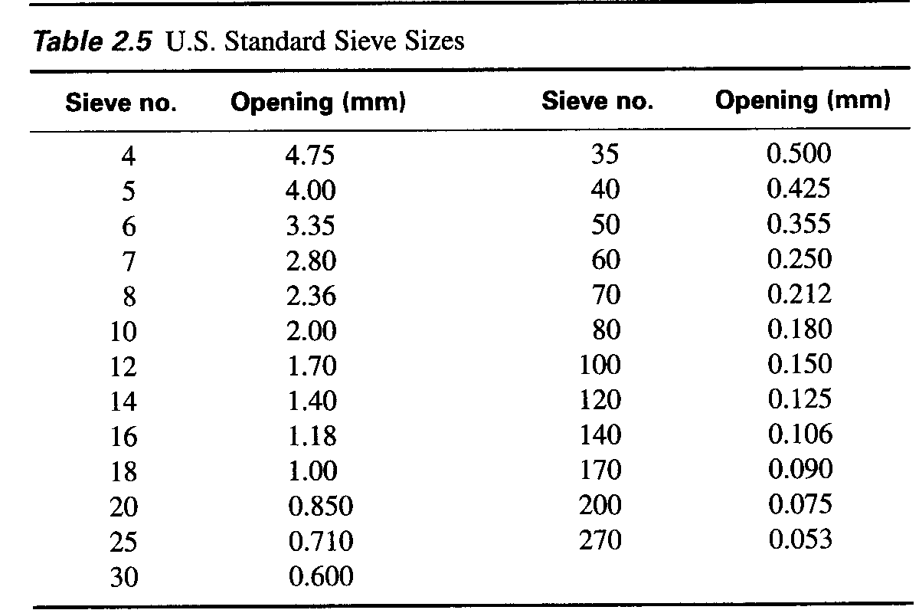
Hydrometer Analysis
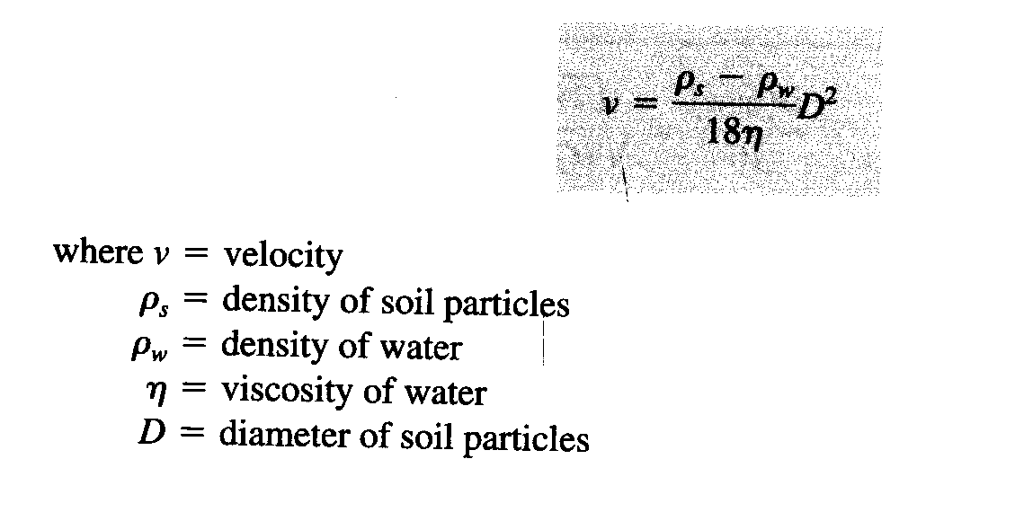

Liquid Limit is where the number of blows = 25, read on the curve the moisture content.
Plastic Limit is
PI = LL – PL

Dry Unit Weight: Degree of Saturation: Moisture Content:

Void Ratio: Relative Density:
e = in situ void ration of the soil
emax = void ratio of the soil in the loosest state
emin = void ratio of the soil in the densest state

(US) Moisture content w = Wwater/Wsolid soil Ww = Wns -Wd
Moist unit weight γ = W/V γd = Ws/V γw = 62.4#/ft3
Degree of saturation Se = wGs
Porosity γd = Gs γw (1-n) Solve for n

(Metric) Dry density
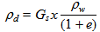
Porosity n = e/(1+e)
Degree of Saturation %
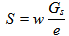
Mass of water in kg/m3
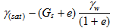
Chapter 6 Soil Compaction
Standard Proctor Compaction test:
Volume (mold) Wt.of wet soil Moisture content Moist Unit weight of compaction Dry Unit weight ZAV weight
1/30 W w
Zero Air Voids:
Moisture Content ZAV Unit weight
w

Relative Compaction R = γd / γd(max) [from curve] x 100
Dry density γd (field)
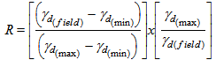
Relative Compaction Percent: where

Vibroflotation Device: Vibroflotation given D10, D20 and D50; When Sn 10 – 20 (good)

Suitability No.:

Chapter 7 Permeability

Total head: where Z=hydraulic head, u=pressure Head loss: where i=hydraulic gradient

Darcy's Law: where v=discharge velocity, k=hydraulic conductivity

Hydraulic Conductivity: where ή=viscosity of water, K=absolute permeability

Constant Head Test:

Equivalent Hydraulic Conductivity:

Equiv. Hyd. conductivity:

Moisture Density Curve

Volume cm3 | Volume m3 | Mass of wet soil | γ | Moisture Content | γd
943.3 | 0 | 1.68
 | X 10 -6 |  | W/V |  | γ/(1+w/100)

