U = the design or ultimate load
D = dead load
L = live load
L_{r} = roof live load
S = snow load
R = nominal load due to initial rainwater or ice, exclusive of the ponding contributions
W = wind load
E = earthquake load

LRFD Combined Loads

- U = 1.4D
- U = 1.2D + 1.6L + 0.5(L_{r} or S or R)
- U = 1.2D + 1.6(L_{r} or S or R) + (0.5L or 0.8W)
- U = 1.2D + 1.6W + 0.5L + 0.5(L_{r} or S or R) 1.6W represents 500 year
- U = 1.2D +/- 1.0E + 0.5L + 0.2S 1.0E represents 500 year
- U = 0.9D +/- (1.6W or 1.0E)

ASD combined loads

- D
- D + L
- D + (L_{r} or S or R)
- D + 0.75L + 0.75(L_{r} or S or R)
- D +/- (W or 0.7E) .7E reduces the earthquake to 50 year
- D + 0.75(W or 0.7E) + 0.75L + 0.75(L_{r} or S or R) .7E reduces the earthquake to 50 year
- 0.6D +/- (W or 0.7E)

Tension Member Section LRFD Design Strength and ASD Allowable Strengths

Gross section yielding

P_{n} = F_{y} x A_{g}
LRFD Φ_{t}=0.90 ASD Ω_{t}=1.67
Φ_{t} x P_{n} P_{n}/ Ω_{t}

Tensile rupture strength
_
U= 1 – ^{x}/L (measured center of bolt hole to furtherest bolt hole) or U from table 3.2 (pg 75)
A_{effective} = U x A_{net}
(remember when calculating A_{net} to add 1/8” to bolt size)
P_{n} = F_{u} x A_{e}

LRFD Φ_{t}=0.75 ASD Ω_{t}=2.00
Φ_{t} x P_{n} P_{n}/ Ω_{t}

Compresive Member Section LRFD Design Strength and ASD Allowable Strengths

1. Using the Euler Buckling Load determine the column's elastic critical or buckling load:

Use this method
Using the AISC manual determine the column's r_{x} & r_{y}.
Find the Length to 'r' ratio using the smaller r_{x} or r_{y}.: L/r

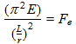
Or Use this method

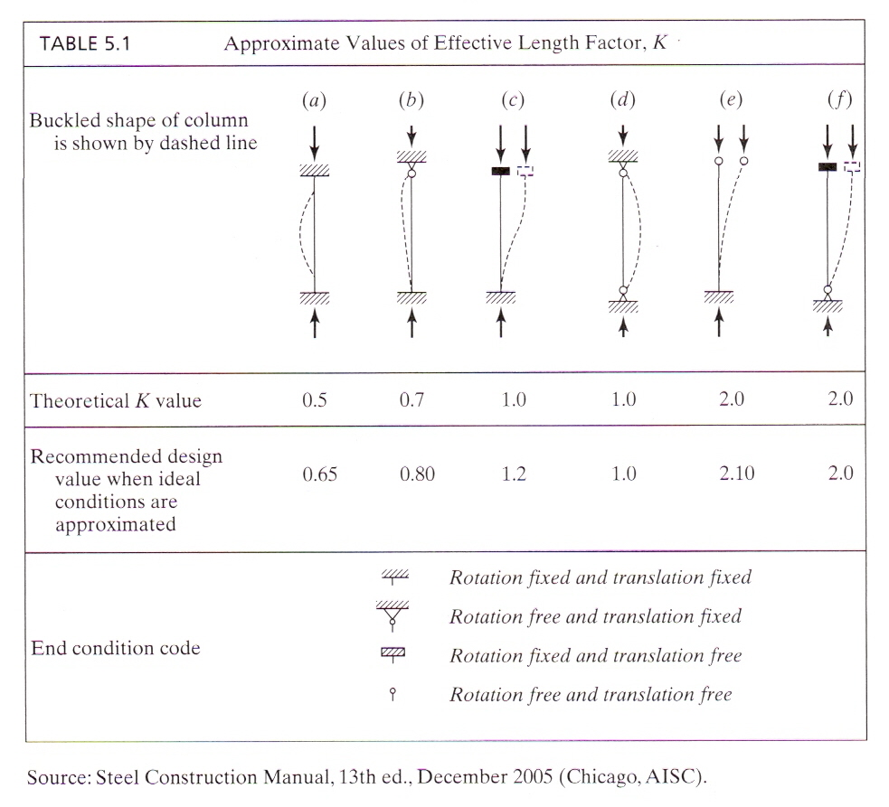

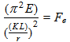
- Determine the F_{cr} flexural buckling stress of a column:
(a) If KL/r < 4.71 √(E/F_{y} ( or F_{e} > 0.44 F_{y}) This is the inelastic buckling
F_{cr} = [0.658 ^{Fy/Fe}]F_{y}

(b) If KL/r > 4.71 √(E/F_{y} ( or F_{e} < 0.44 F_{y}) This is the elastic buckling
F_{cr} = 0.877 F_{e}

- Calculate LRFD and ASD loads
P_{n} = F_{cr} x A_{g}

LRFD Φ_{c}=0.90 ASD Ω_{c}=1.67
Φ_{c} x P_{n} P_{n}/ Ω_{c}

