#1 Design square footing to support 10”x14” steel column.

Column Footing
D_{L} = 100psf f’_{c} = 4,000 psi
L_{L} = 120psf 5” slab on top with live load = 120 psf
q_{allow} of soil = 2,500 psf (2k/ft²)
Assume the Steel f_{y} = 60,000
- Compute factored loads:
Total Ceiling Dead Loads to Beam = 324plf (See Center beam and Column Calcs.doc)
Total Roof Dead Loads to Beam = 236plf (See Center beam and Column Calcs.doc)
ASCE 7-10
1.2DL + 1.6RoofLive + .8W
1.2(324 + 236) + 1.6(480) + .8(134.4) = 1,547 plf or 1.547klf
The W-Flange is 40 ft in length and each column will support ½ load, 20ft
U = 1547 plf x 20ft = 30,940 # or 31k

- Estimate footing size and net soil pressure.
q_{NET} = q_{allow} – weight of footing = 1,500 psf – (3’ x 150 pcf concrete) = 1,050 psf

- Using unfactored loads, obtain area of footing required to support q_{NET}.
A_{req} = D_{L} + L_{L} / q_{NET} = (324 * 20) + (480 * 20) + (134.4 * 20) / 1,050 = 18 s.f.

try using 4’ x 4’ x 36” thick b_{w} = 4’ or 48” (The other spread footing around the Square footing will compensate for the additional 2 s.f. required.

- Using factored load calculate net soil pressures:
u / Area = (324 * 20) + (480 * 20) + (134.4 * 20)/ 4² = 1173 # /ft²

- Check Thickness for 2-way Shear
average ≈ d = 12” (thick) – 3” (cover) – .5” (d_{b}) = 8.5”
Column width = 4”
x = 4’ y = 4’
x’ = Column width + d = 4”+8.5”= 12.5” y’ = same as x

V_{u} = u * [x² – (x’/12)² ]
V_{u} = 1173 # / ft² * [ (4 ft)² – (12.5” / 12 “/ft)² ] = 17,495 #
b_{o} = 4 * x’ = 4 * 12.5 = 50”

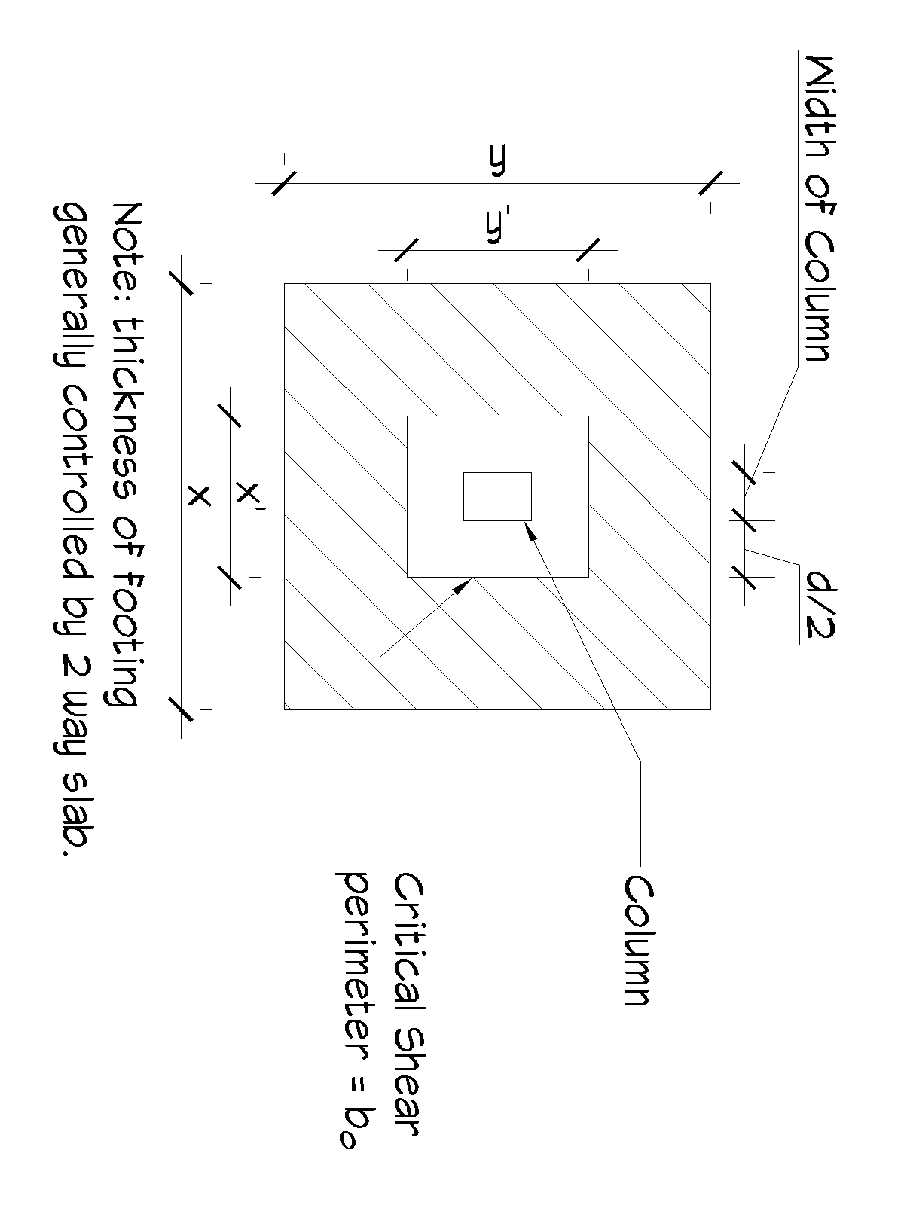

ФV_{c} = smallest of the following three:
- 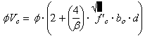
0.75 (2+ (4/1))√4000* 50” * 12.5” = 118,586 #
2) 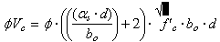
0.75*(((40*8.5)/50)+2)* √4000 * 50” * 12.5” = 260,888 #
3) 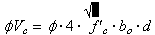
0.75*4*√4000* 50” *12.5” = 118,585
ФV_{c} > V_{u} 118,585# > 17,495 # : footing is OK
- Check for 1 way shear:
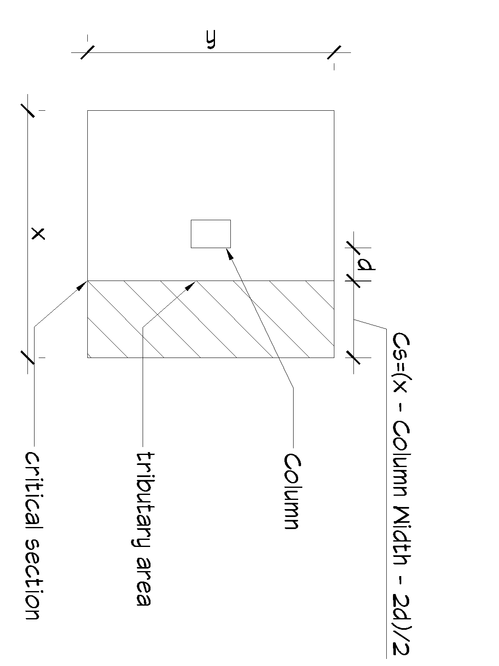
Critical Section = ((x * 12”/ft) – Column Width – (2d))/2
Critical Section = ((4 * 12) – 4” – (2 * 8.5) ) / 2 = 13.5”
V_{u} = u * [x * (Critical Section/12) ]
V_{u} = 1173 # / ft² * (4 ‘ * 13.5”/12) = 5,278 #
ФV_{c} = Ф*2*λ*√ f’_{c} * b_{w} * d λ = 1 for normal weight concrete
0.75 * 2 * 1 * √4000 * 4’ * 12 “/ft * 8.5” = 38,706 #
ФV_{c} > V_{u} 38,706 > 5,278 # : footing is OK

- Design for flexural reinforcement
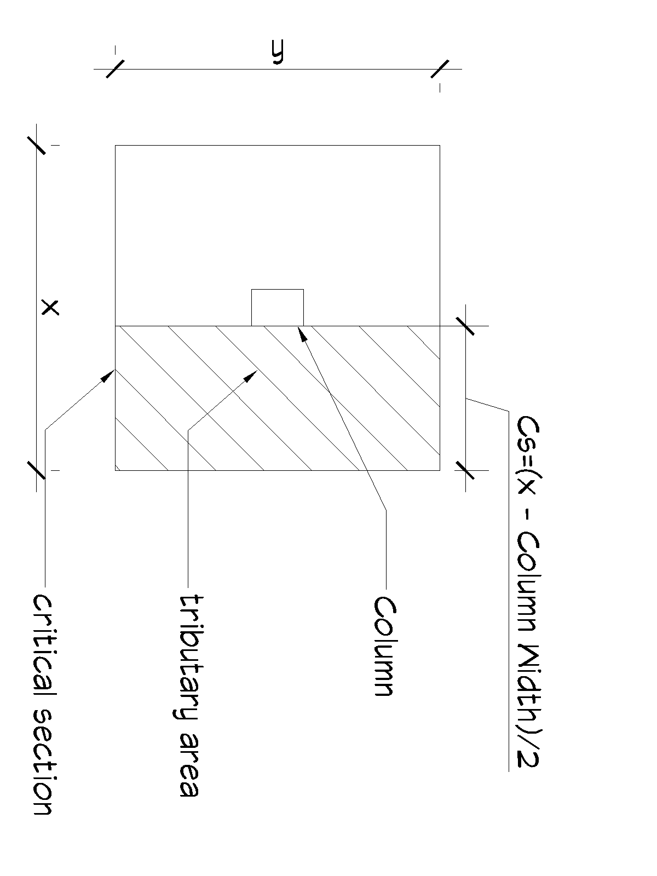
Critical Section = ((x * 12”/ft) – Column Width)/2
Critical Section = ((4 * 12) – 4” ) / 2 = 22”
M_{u} = u * x * (Critical Section /12)² )/2
M_{u} = 1173 # / ft² * 4 ‘ * ((22/12)² )/2= 7,885 ft-#
assume j = 0.9 & Ф = 0.9
A_{s} = M_{u} (12,000) / Ф f_{y} (j) (d) = 7.885k * 12,000 / .9 * 60k *.9 *8.5 = .229 in²
- For a square footing use the same bars in both directions
- Check for A_{s} minimum [10.5.3] and [7.12.2]
A_{s, min} = 0.0018bh = 0.0018 * 48” * 12” = 1.04 in²
Steel Separation S_{max} = 18” apart [7.6.5]
Try 7 ea # 4 bars (A_{s} = 1.4 in²) # 4 bar 6” o.c. d_{b} = 0.5”
Recompute ФM_{n}
a = A_{s} * f_{y} / 0.85 f_{c} b_{w} = ( 1.4 in² * 60k/in² )/(0.85 * 4k/in² * 48”) = 0.515”
c = a/β₁ = 0.515 / 0.85 = 0.61”
M_{n} T (d-a/2) = A_{s} * f_{y} (d-a/2) = 1.4 in² * 60ksi * (8.5 –.515/2) = 692 in-k or 8,308 ft-k
Ф M_{n} = .9 M_{n} = 7,477 ft-k
Ф M_{n} > M_{u} 7,477 ft-k > 7.885 ft-k OK
Check ε_{t} > 0.005
ε_{t} = 0.003 (d_{t} – c )/ c = 0.003 ( 8.5 -.61) / .61 = 0.0388 > 0.005 OK
- Check development length of steel in footing
Clear Space > 2d_{b} Clear Cover > d_{b}

[12.2.2] ld = d_{b} (f_{y} ψ_{t} ψ_{e} ) / (25 √ f’_{c} λ) for #6 and smaller bars AND d_{b} (f_{y} ψ_{t} ψ_{e} ) / (20 √ f’_{c} λ) for #7 bars and larger

ld= 0.5 (60,000 in² *1*1) / (25 * √4000 * 1) = 19.0”
bar extension past critical moment section Critical Section 22” > 19.0” OK

