To setup Microsoft Outlook to Send from one account and receive from another account go to :
Tools -- Options – Select the Mail Setup Tab – Select the Send/Receive button –
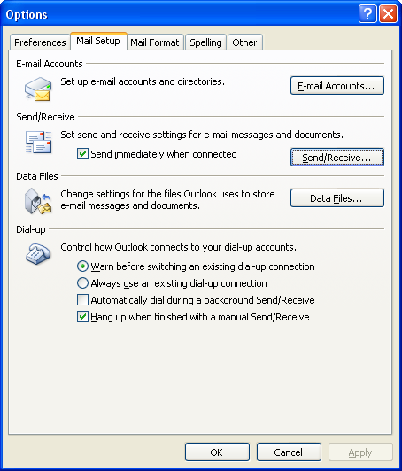
In the middle of the window Edit “All Accounts”
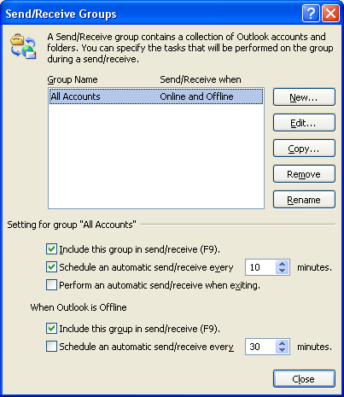
Select which account to receive mail items and which account to send mail items:
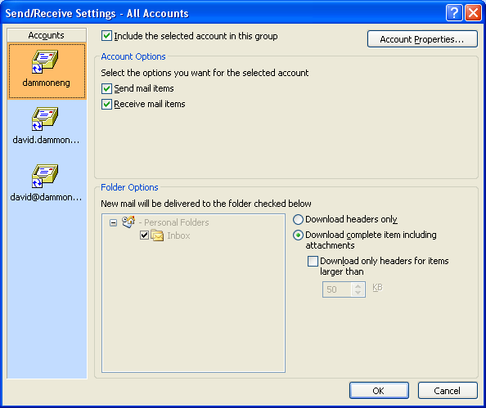
Next go to Tools -- Account Settings and dammonengineering as the default account.
