ENCE 3318
PRINCIPLES OF HYDRAULICS

TEST 2

- Assume that wet light weight concrete (γ = 130 lbf/ft³) behaves as a liquid.
- Determine the force per unit foot of length exerted on the forms.
- If the forms are held in place as shown, with ties between vertical braces spaced every 4 ft, what force is exerted on the bottom tie?

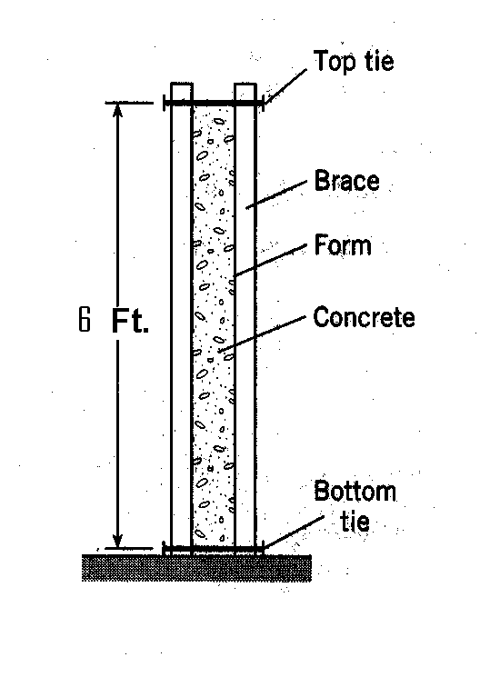
Y_{cp}
4 ft

F=PA
= $γ\frac{h}{2}A$
=(130)(3)(6)(1)
F=2340lbf

Y_{cp}=6($\frac{2}{3}$) = 4ft $↺+M$_{top tie} =-2340*4+F_{bottom} *6=0 ⇒ F_{bottom} =1560 lb

F_{bottom tie}=1560*4 ⇒ 6240lbf
- Determine the force R_{T} on the triangular gate, which is hinged at the bottom edge. The liquid is water (γ = 62.4 lbf/ft³), h = 4 feet, and W = 6 feet. Neglect the weight of the gate.

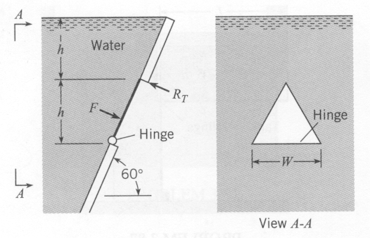
_ _
Y= $\frac{2}{3}\left(\frac{4}{\sin{60}}\right)+\left(\frac{4}{\sin{60}}\right)$ I = $\frac{6(\frac{4}{\sin{60}})}{36}$ A=$\frac{6(\frac{4}{\sin{60}})}{2}$
=7.7ft = 16.42ft⁴ =13.86 ft²

Y_{cp} =7.7+$\frac{16.42}{\left(7.7\right)(13.86)}$
= 7.85 ft

F=PA
=(4+8/3)(62.4)$\left[\frac{\frac{\left(6\right)(4)}{\sin{60}}}{2}\right]$
=5764.3 lb

$↺+M$_{top tie} =-5764.3* $\left[2*\frac{4}{\sin{60}}-7.85\right]+Rt\left[\frac{4}{\sin{60}}\right]$ ⇒ Rt=1729.3 lb
- For the curved surface AB:
- Determine the magnitude, direction, and line of action of the vertical component of the hydrostatic force acting on the surface. Here l = 1 m.
- Determine the magnitude, direction, and line of action of the horizontal component of the hydrostatic force acting on the surface.
- Determine the resultant hydrostatic force acting on the surface.

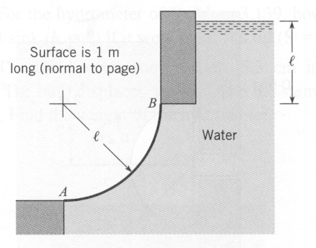.
b) FH=PA =9810(1+.5)[1*1]=14715 N
Y_{cp}= y + $\frac{I}{y*A}$ = 1.5 + $\frac{\frac{(1)({1)}^{3}}{12}}{1.5\left(1*1\right)}$ = 1.56m

a) F_{y} = F_{v}+W ; F_{v}=$∀*γ$= (1)(1)(1)(9810) =9810 ; W=$∀_{abc}*γ$ =9810*1/4*π(1)² = 7704.756 N
=9810+7704.756
= 17514.76 N
X_{cp} F_{y} = F_{v}(.5)+W($\frac{4}{3π})$ =[9810(.5)+(7704.76)($\frac{4}{3π})$]/17514.76 = 0.47 m

c) F_{r} =$\sqrt{{\left(17514.76\right)}^{2}+ {\left(14715\right)}^{2} }$ = 2287.7 N
$\tan{θ=}\frac{17514}{14715}$ ⇒ $θ=49.96°$

- Determine the minimum volume of concrete (γ = 23.6 kN/m³ in air) needed to keep the gate (1 m wide) in a closed position; l = 2 m. Note the hinge at the bottom of the gate.

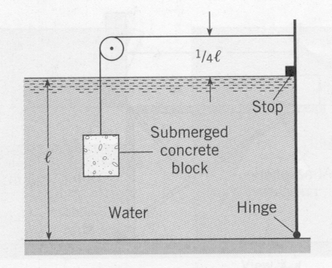

F= PA ⇒ 9810*1*2*1 = 19620N
Y_{cp} = 2/3(2m) =4/3 m
$↺+M$_{top tie} =-19620*2/3+T(2.5)=0 ⇒ T=5232 N
$↑+\sum{F_{y}=0}$ ⇒ T- W=0 ⇒ T=W; W = 5232 N

W=γ$∀$ ⇒ $∀$=W/γ ⇒ $\frac{5232}{(23600-9810)}$ = 0.38m³
- The tank shown below is 20 feet long, 10 feet high, and 6 feet wide, and it is closed except for a small opening at the right end. It contains water to a depth of 5 feet in a static situation. If the tank is uniformly accelerated to the right at a rate of 21.0 ft/s², what will be the maximum pressure intensity (in lbf per ft² gage) in the tank during acceleration?

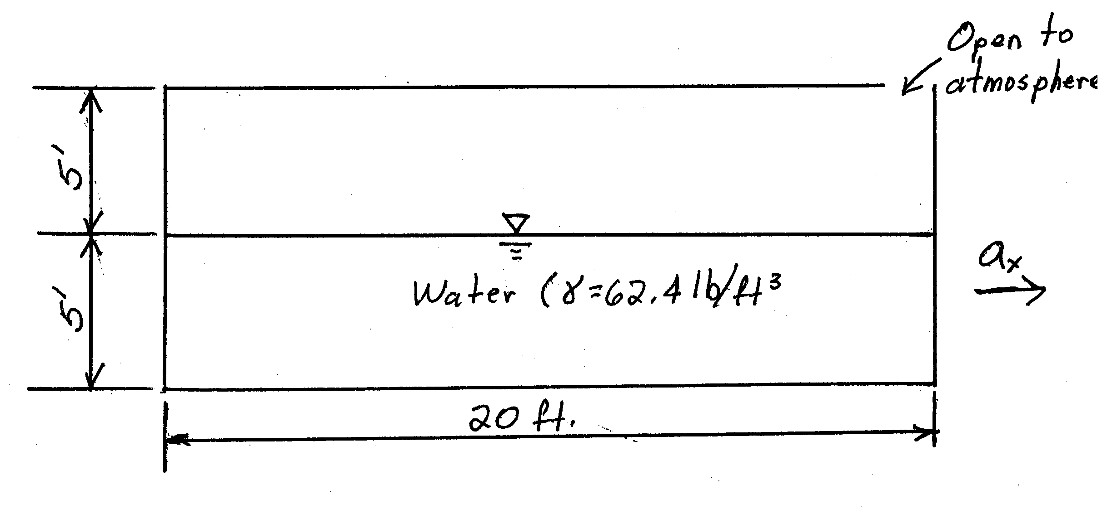
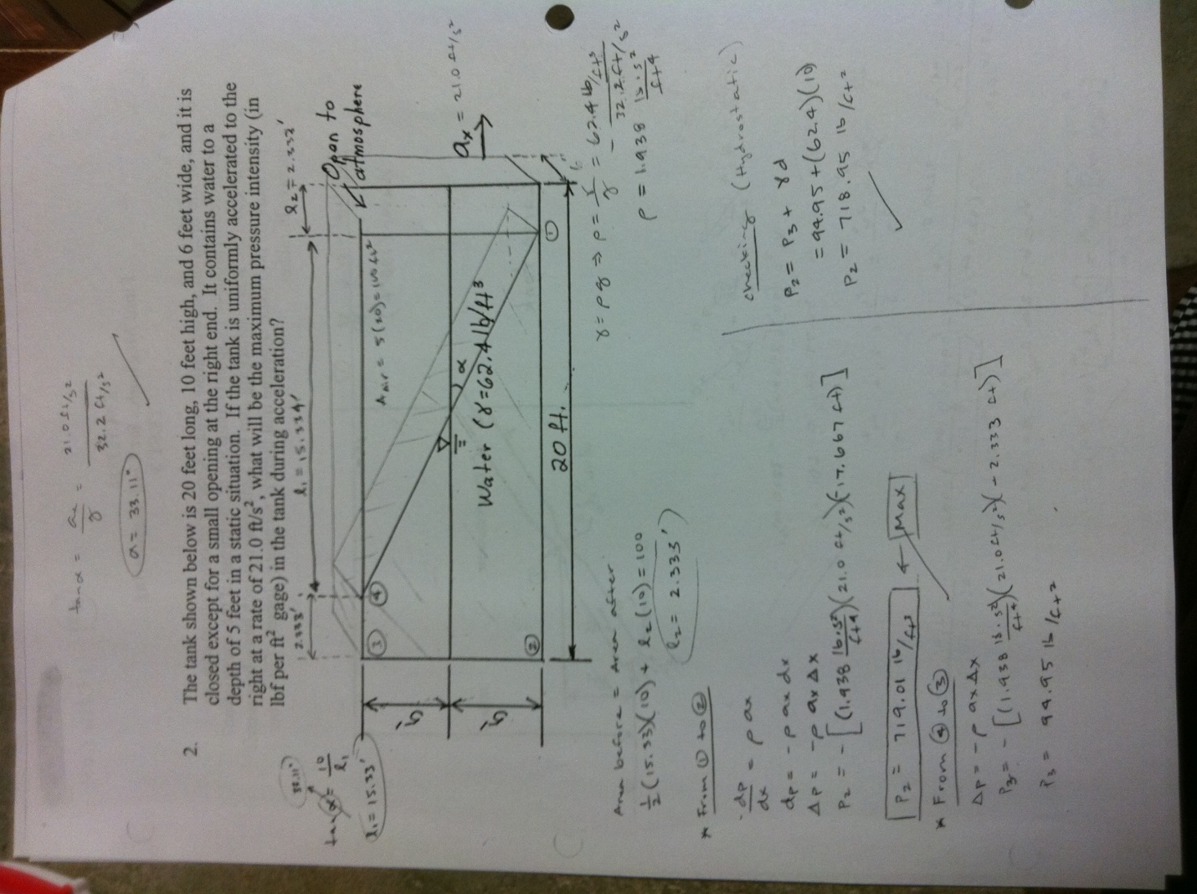
- Two types of gasoline are blended by passing them through a horizontal “wye” as shown. The gasoline entering at 1 has a S.G.=.95 and the gasoline entering at 2 has a S.G.=.90.
- Calculate the velocity at 1, 2, and 3.
- What is the discharge at point 3.
- What is the density at point 3.

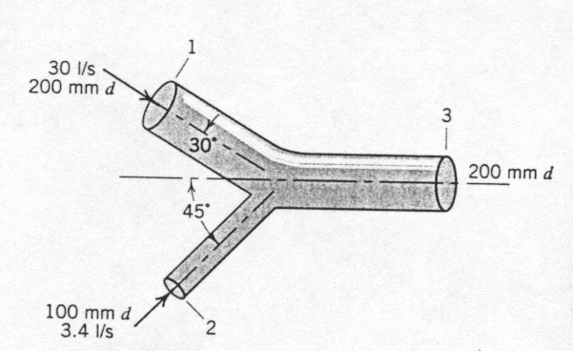

b) Q₃=Q₂+Q₁
=0.0334m³/s
a)Q=AV
V₁=Q/A
= 0.95m/s

V₂=0.43m/s
V₃=1.06m/s

c)r₃Q₃ = r₁Q₁ + r₂Q₂
r₃(0.033) = [1000*.95*.03]+[1000*.9*.0034]
r₃=944.91kg/m³

7.
Water flows into a cylindrical tank at a steady velocity of 40 ft/s through pipe 1 and leaves through pipes 2 and 3 at rates of 16 ft/s and 10 ft/s, respectively. Determine the rate of change of the free surface (indicate if it is going up or down). D₁ = 2.5 in.; D₂ = 2 in.; D₃ = 3.0 in.

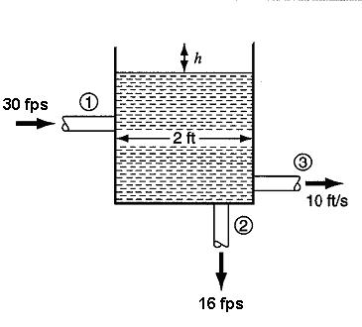
Q_{in}=40*$\frac{π{\left(\frac{5}{24}\right)}^{2}}{4 }$ = 1.36ft³/s

Q_{out}=16*$\frac{π{\left(\frac{1}{6}\right)}^{2}}{4 }$ + 10*$\frac{π{\left(\frac{1}{4}\right)}^{2}}{4 }$ = 0.84ft³/s

V=$\frac{{Q_{out}- Q}_{in}}{A}$ =0.17ft/s

