Baroque Period (1600-1750)

Ensemble Music
During the Baroque period, instrumental music was written for every conceivable size of ensemble. On the smaller side, the Baroque sonata offered one of the finest examples of chamber music. Two types of sonata were written during this period: the sonata da chiesa (church sonata), and the sonata da camera (chamber sonata). The sonata da chiesa was more somber, while the sonata da camera, much like the suite, usually comprised dance forms. The gigue from Corelli's Sonata for 2 violins and lute is a fine example of the sonata da camera.
Arcangelo Corelli
Sonata for 2 violins and lute
The term sonata was used during the early Baroque to denote musical works to be played instead of sung. Sonatas were usually played by a small number of instruments, anywhere from three to a small group of maybe six or eight. These groups were called chamber groups because they usually performed in small spaces, typically rooms in aristocratic homes or palaces. This example illustrates a chamber group playing Bach's Air on the G String from the Suite No. 3 in D.
J.S. Bach
Suite No. 3 in D, BWV 1068: Air on the G String

Suite
A popular form among composers was the suite, a series of movements based upon the rhythm and style of a particular dance. The suite could be written for a solo instrument such as the harpsichord or violoncello or for a small instrumental ensemble. Dances included the German Allemande, the French Courante, the Sarabande (originally from Spain), and the English or Irish Gigue (Jig). Many suites also included the Gavotte: a French folk dance characterized by the raising rather than the sliding of the feet. At times, non-dance movements such as the Prelude were also employed. This series of movements was designed to offer interesting contrasts in meter, tempo, and texture.
J.S. Bach
Sarabande: Cello Suite
The dance suite became very popular in the late Baroque. Examples include Handel's two most popular orchestral suites: Fireworks Music and Water Music. The Fireworks Music suite was, appropriately, first performed at a large fireworks display, while the Water Music was written for a party held on the Thames River. Legend has it that the partygoers rode on one barge floating down the Thames, while Handel and the musicians played on another barge immediately following. The most famous movement from these suites is entitled Alla Hornpipe from the Water Music suite. Other important composers of the Baroque suite were J.S. Bach, the German keyboard virtuoso Jakob Froberger, and the French organist and harpsichordist François Couperin (whose keyboard suites were called ordres)
G.F. Handel
Water Music: Alla Hornpipe

Music for Keyboard
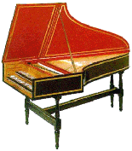  The Harpsichord | 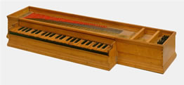  The Clavichord

Baroque keyboard music falls into two categories:
- free forms that rely on harmony and improvisation (prelude, toccata, fantasia)
- more structured forms that use counterpoint or imitation (ricercar, fugue)
The three primary keyboard instruments used during the Baroque period were the organ, harpsichord, and clavichord. The term clavier was often used as an umbrella term for both the harpsichord and clavichord.
Girolamo Frescobaldi
Fuga in G minor

François Couperin
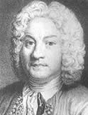
François Couperin
Concerts Royaux: Premier Concert: Allemande

François Couperin
Born: 1668
Died: 1733
Period: Baroque
Country: France
Couperin was the master of French Baroque keyboard music. His highly ornamental style may be found in his ordres, groups of dances comparable to the Baroque suites. The aristocratic quality, concise musical language, and light emotional quality of pieces such as this Allemande helped usher in the French rococo period.

Jean-Philippe Rameau
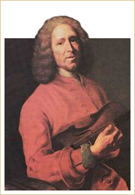
Jean-Philippe Rameau
Pieces De Clavecin, Suite In A minor-major: I. Prelude

Jean-Philippe Rameau
Born: 1683
Died: 1764
Period: Baroque
Country: France
After the death of Couperin in 1733, Rameau became the leading French composer. The tradition of French harpsichord music is exemplified by Minuet from Suite in A minor-major. He made a significant and lasting contribution to musical theory with the publication of his Treatise on Harmony (1722).
Pieces De Clavecin, Suite In A minor-major: IX. Minuet

Baroque Period: Keyboard Music

Girolamo Frescobaldi
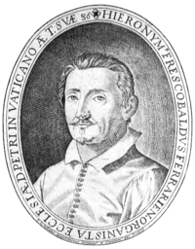
Girolamo Alessandro Frescobaldi
Fuga in G minor

Girolamo Alessandro Frescobaldi
Born: 1583
Died: 1643
Period: Baroque
Country: Italy
Frescobaldi is arguably one of the most important keyboard composers of the first half of the 17th century. He was born in Ferrara, where the musical tastes of the ruling duke, Alfonso II d'Este, attracted musicians of great distinction.
As an important composer for the organ and other keyboard instruments, Frescobaldi published a number of collections of keyboard pieces as well as compositions for varied groups of instruments. The keyboard works include toccatas, such as the Toccata nona, caprices, ricercari, and dance movements; and fugues, such as the Fugue in G minor that the 20th-century composer Béla Bartók transcribed for the piano.
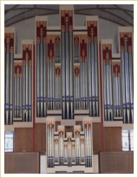
The Organ
Fugue in G minor (trans. Béla Bartók)
In 1608, Frescobaldi became the organist at St. Peter's in Rome, a prestigious position he held until his death in 1643.

Bach's Well-Tempered Clavier
To demonstrate the feasibility of equal-tempered tuning, Bach wrote a monumental set of preludes and fugues. Commonly known as The 48, they consist of two series, or Books, each with 24 preludes and fugues, which explore the twelve major and minor keys. The Well-Tempered Clavier is one of the most important keyboard works of the late Baroque period and of all keyboard literature. In the following example, the Prelude and Fugue in C minor from Book I is performed on a modern piano.
WTC I: Prelude and Fugue in C minor

