Classical Period (1750-1825)

Listening Bridge
Both of these excerpts are from CONCERTOS. Listen and compare, using the following questions as guides:
- What is the solo instrument in each piece?
- How would you describe the orchestra that accompanies the soloist in each example?
- In which piece does the orchestra and soloist play the same “theme”?
- In which piece does the accompaniment part include many repeated tones?
- In which piece are there more sudden and extreme changes in dynamics?
- Which one has a basso continuo?
- Which one features a more “singable” melody?
- What purpose do you think each piece was intended to serve?

Four Seasons: Winter  Antonio Vivaldi  Born: 1678  Died: 1741  Period: Baroque  Country: Italy | Piano Concerto No. 21 C major  Wolfgang Amadeus Mozart  Born: 1756  Died: 1791  Period: Classical  Country: Austria

Listening Prelude
This is an excerpt from the first movement of what is arguably the most frequently heard piece from the Classical period. Listen to it and consider the following questions.
- What would you call the ensemble that is performing this piece?
- Is there a “singable melody” in this excerpt?
- Are there clear phrases? (Can you tell where one idea ends and another begins?)
- Are musical ideas repeated within this excerpt?
- Does there appear to be a “working out” and development of ideas, or is there a constant stream of new ones?
- Is there a regular and consistent pulse?
- Are rhythmic ideas repeated?
- Does this piece appear to be “free-flowing” or highly structured?
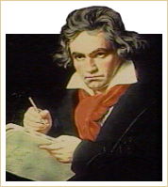
Ludwig van Beethoven
Symphony No. 5:
I. Allegro con brio (excerpt)

Ludwig van Beethoven
Born: Bonn, Dec. 16, 1770
Died: March 26, 1827
Period: Classical
Country: Germany

Social, Cultural, and Political Background
European intellectuals of the eighteenth century were the first to consider themselves fully free from the restrictions of the Middle Ages. They spoke of themselves as living in an Age of Enlightenment, an Age of Reason. The first encyclopedia was published during this time. A strong belief in God remained, but people increasingly believed in human control over a reasonable world, in the marvelous machine of a universe they thought they understood. God was no longer conceptualized as the awesome Father and Judge but rather as the cosmic keeper of the seasons and rhythms of nature. Of course, not everyone felt this way. In the early nineteenth century, many intellectuals dismissed those who had absolute faith in reason as naive or hypocritical.
In the eighteenth century, towns grew, interregional trade flourished, fortunes were made, and the bourgeoisie (the middle class) enjoyed more economic power than ever before. The eighteenth century was also a period of vigorous intellectual activity. Scientific advancement continued with great speed.

Political Upheaval
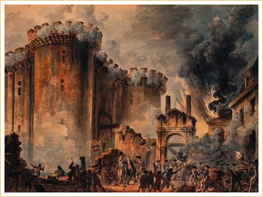
The Storming of the Bastille
The fall of the Bastille in Paris on July 14, 1789 helped ignite the French Revolution
Arguably, the most significant event in Europe during the classical period was the French Revolution (1789-1794) and the subsequent beheading of King Louis XVI and Marie Antoinette. Decades of political instability would result from the vacuum left by the destruction of the monarchy, an institution that had been in place in France for over 1,400 years.
The full impact of the revolution would not be felt in the artistic community until the next generation, but the era in which composers could rely solely on aristocratic patronage was nearing its end.
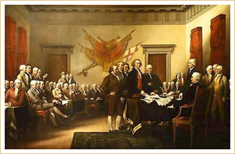
Declaration of Independence
Across the Atlantic, America declared independence from England as part of the American Revolution (1775-1783), which signaled the beginning of the end of the British Empire.

Philosophy and Science
The realm of science witnessed some tremendous advances during the classical period. Benjamin Franklin published his first writings on electricity. The steam engine, the modern factory, the electric battery, the steamboat, and the cotton gin all came into being. Discoveries included oxygen and hydrogen. There were also some important archeological findings; one of the most monumental was that of the ruins of Pompeii.
Great intellectual and philosophical minds influenced the Age of Enlightenment. Among them were French philosophers Jean-Jacques Rousseau (1712-1778) and François Voltaire (1694-1778), whose writings helped establish the French rococo. Other important philosophers and writers of the time include David Hume (1711-1776) and Immanuel Kant (1724-1804).

Aspects of Art during the Classical Period
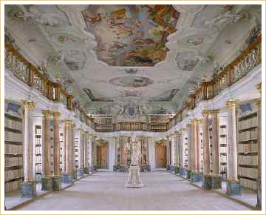
Benedictine Abbey Library
Rococo interior
Ottobeuren, Germany
For much of this period, the visual arts, dominated by the late Baroque style called rococo, did not reflect the rising tide of reason and simplicity. The rococo style emphasized elegance, delicacy, softness, and playfulness. Interiors were decorated with beautiful gold and white curved woods, crystal chandeliers, pastel colors, and gilt ceilings.
The greatest painter of the French rococo was Jean Antoine Watteau (1684-1721), whose works exhibit the light yet ornate touch of artists of the period.
The sensibilities of the growing middle class were clearly portrayed in the plays of Pierre Beaumarchais (1732-1799), whose Marriage of Figaro (1784) was so disturbing to the aristocracy that it was banned in Vienna and nearly banned in Paris. In 1786, however, Mozart recreated the play as an opera that enjoyed great success.
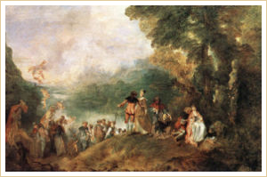
The Embarkation for Cythera
by Jean Antoine Watteau (Louvre version)

Later classical artists turned to portraiture as a way of capturing the elegance of the subject. Some of the famous paintings of this time include Duchess of Devonshire by Sir Joshua Reynolds (1723-1792), The Blue Boy by Thomas Gainsborough (1727-1788), and Paris and Helen by Jacques-Louis David (1748-1825). The art of Henry Fuseli (1741-1825) exemplified the interest in dark subjects of the Sturm und Drang artists.
In the 1790s, Napoleon's counterpart in the arts was Jacques-Louis David (1748-1825), a painter who became a kind of art dictator during the French Revolution. David painted solemn scenes of noble sacrifice and great historical moments in a clear, balanced, linear style. In politics and in art, the French Revolution was a culmination of the spirit of reform from the preceding generations. | 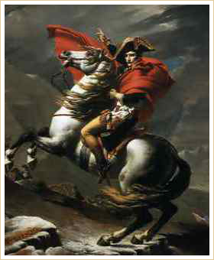  Napoleon  by Jaques-Louis David
Classical architecture reflected the revival of interest in Greek and Roman themes. Buildings constructed in the United States during the period, such as those designed by Thomas Jefferson, included columns and arches identical to those found on ancient buildings such as the Parthenon in Athens and the Coliseum in Rome.

