#1 Design square footing to support 10”x14” steel column.

Column Footing
D_{L} = 100psf f’_{c} = 4,000 psi
L_{L} = 120psf 5” slab on top with live load = 120 psf
Area supported by column = 500 ft² q_{allow} of soil = 2,500 psf (2k/ft²)
Assume the Steel f_{y} = 60,000
- Compute factored loads:
Dead = 500 ft² x 100 psf = 50,000 # (50.0k) Live = 500 ft² x 120 psf = 60,000 # (60.0k)
u = 1.2D_{L} + 1.6L_{r} = (1.2 x 50k) + (1.6 x 60k) = 156k

- Estimate footing size and net soil pressure.
q_{NET} = q_{allow} – weight of footing = 2,500 psf – (2’ x 150 pcf concrete) = 2,200 psf

- Using unfactored loads, obtain area of footing required to support q_{NET}.
A_{req} = D_{L} + L_{L} / q_{NET} = 50,000 +60,000 / 2,200 = 50 s.f.

try using 7.5’ x 7.5’ x 24” thick b_{w} = 7.5’ or 90”

- Using factored load calculate net soil pressures:
u / Area = 156k / 7.5² = 2773 # /ft²

- Check Thickness for 2-way Shear
(average ≈ d = 24” (thick) – 3” (cover) – 1” (d_{b}) = 20”
Column width = 14”
x = 7.5’ y = 7.5’
x’ = Column width + d = 14”+20”= 34” y’ = same as x

V_{u} = 2773 # / ft² * [ (7.5 ft)² – (34” / 12 “/ft)² ] = 133,720 #
b_{o} = 4 * (14” + 20”) = 136”

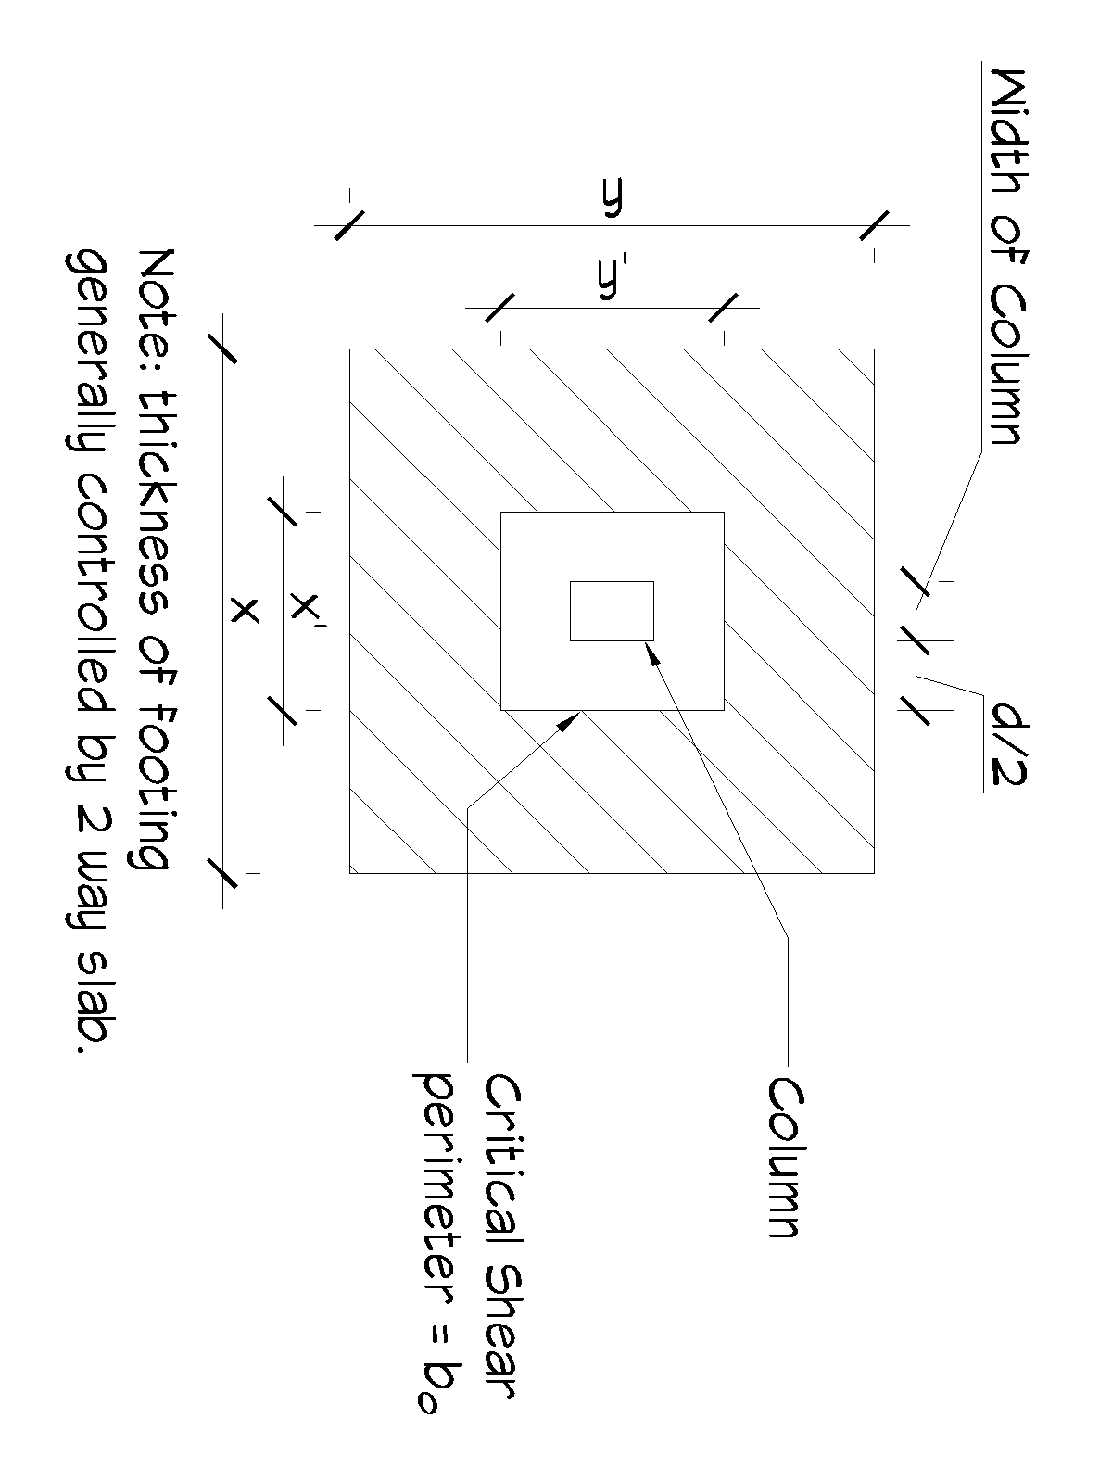

ФV_{c} = smallest of the following:
- 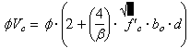
0.75 (2+ (4/1))√3000*136”*20 = 670,412 #
2) 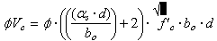
0.75*(((40*20)/136)+2)* √3000*136”*20 = 880,737 #
3) 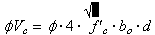
0.75*4*√3000*136”*20 = 446,941
ФV_{c} > V_{u} 446,941# > 133,720 # : footing is OK
- Check for 1 way shear:
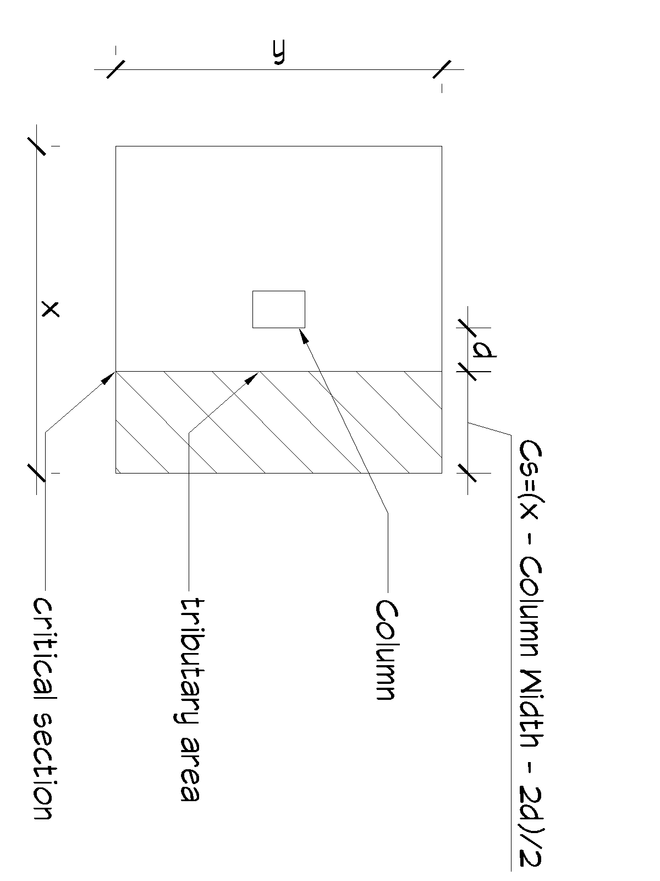
Critical Section = ((7.5 * 12) – 14” – (2 * 20) ) / 2 = 18”
V_{u} = 2773 # / ft² * (7.5 ‘ * 18”/12) = 24,957 #
ФV_{c} = Ф*2*λ*√ f’_{c} * b_{w} * d λ = 1 for normal weight concrete
0.75 * 2 * 1 * √3000 * 7.5’ * 12 “/ft * 20” = 147,885 #
ФV_{c} > V_{u} 147,885 > 133,720 # : footing is OK

- Design for flexural reinforcement
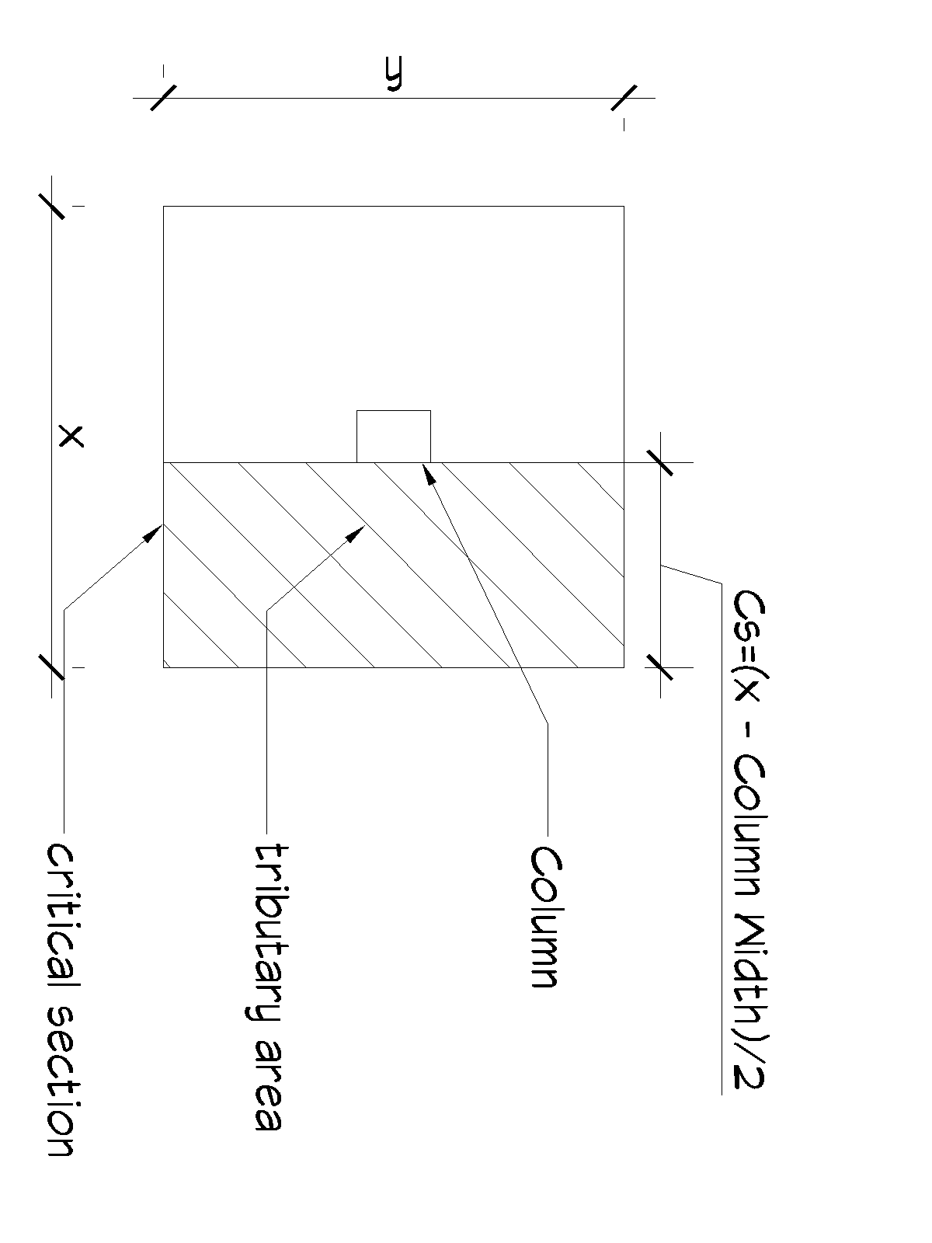
Critical Section = ((7.5 * 12) – 14” ) / 2 = 38”
M_{u} = 2773 # / ft² * 7.5 ‘ * ((38/12)² )/2= 104,276 ft-#
assume j = 0.9 & Ф = 0.9
A_{s} = M_{u} (12,000) / Ф f_{y} (j) (d) = 104.3k * 12,000 / .9 * 60k *.9 *30 = .858 in²
- For a square footing use the same bars in both directions
- Check for A_{s} minimum [10.5.3] and [7.12.2]
A_{s, min} = 0.0018bh = 0.0018 * 90” * 24” = 3.89 in²
Steel Separation S_{max} = 18” apart [7.6.5]
Try 15 ea # 6 bars (A_{s} = 15 * 0.31 = 4.65 in²) # 6 bar 6” o.c. d_{b} = 0.625”
Recompute ФM_{n}
a = A_{s} * f_{y} / 0.85 f_{c} b_{w} = ( 4.65 in² * 60k/in² )/(0.85 * 3k/in² * 90”) = 1.22”
c = a/β₁ 1.22 / 0.85 = 1.43”
M_{n} T (d-a/2) = A_{s} * f_{y} (d-a/2) = 4.65 in² * 60ksi * (30 – 1.22/2) = 8,199.8 in-k or 683.3 ft-k
Ф M_{n} = .9 M_{n} = 615 ft-k
Ф M_{n} > M_{u} 615 ft-k > 104ft-k OK
Check ε_{t} > 0.005
ε_{t} = 0.003 (d_{t} – c )/ c = 0.003 ( 20 -1.43) / 1.43 = 0.0389 > 0.005 OK
- Check development length of steel in footing
Clear Space > 2d_{b} Clear Cover > d_{b}

ld = d_{b} (f_{y} ψ_{t} ψ_{e} ) / (20 √ f’_{c} λ) = 0.625 (60ksi *1*1) / (20 * √3000 * 1) = 34.2”
bar extension past critical moment section Critical Section 38” > 34.2” OK

