Sizing Power Exhaust Fans for dehumidifying attics & Net Free Area of vents
Two (2) Methods
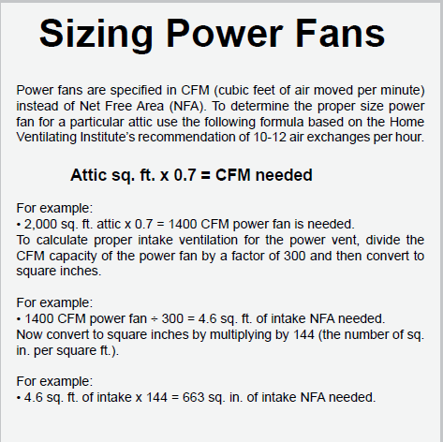

Second Method is to calculate the volume of the attic and get 10 ACHs

Say a flat roof is 3,000 s.f. and the drop ceiling is 4 ft below ceiling deck.
3,000 s.f. x 4 ft cavity = 12,000 cubic feet
12,000 c.f. x 10 AC/Hr = 120,000 cf/hr or 2,000 cfm

Use the same method of determining Net Free Area above.
Divide the cfm / 300 to Net Free Area in s.f. then multiply by 144 to sq inches.

