SCS Curve Number Method
The SCS curve number method is a simple, widely used and efficient method for determining the approximate amount of runoff from a rainfall even in a particular area. Although the method is designed for a single storm event, it can be scaled to find average annual runoff values. The stat requirements for this method are very low, rainfall amount and curve number. The curve number is based on the area's hydrologic soil group, land use, treatment and hydrologic condition. The 2 former being of greatest importance.
The general equation for the SCS curve number method is as follows:
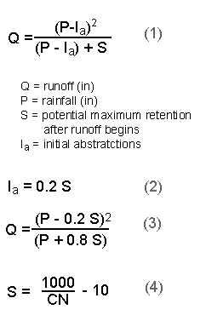
The initial equation (1) is based on trends observed in data from collected sites, therefore it is an empirical equation instead of a physically based equation. After further empirical evaluation of the trends in the data base, the initial abstractions, Ia, could be defined as a percentage of S (2). With this assumption, the equation (3) could be written in a more simplified form with only 3 variables. The parameter CN is a transformation of S, and it is used to make interpolating, averaging, and weighting operations more linear (4).
With the following chart, the amount of runoff can be found if the rainfall amount (in inches) and curve number is known.
There are two advantages of using L-THIA over a manual method. One, the availability of the data. L-THIA provides the rainfall data for any area in the United States. Two, L-THIA completes this calculation for every rainfall event for thirty years and then reports the average annual runoff value.

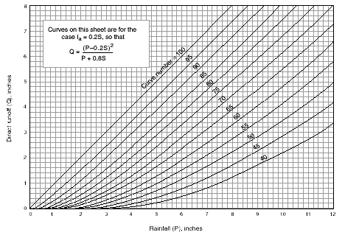
Land Use Description on Input Screen | Description and Curve Numbers from TR-55
Land Use Description on Input Screen | Cover Description |  | Curve Number for Hydrologic Soil Group
Land Use Description on Input Screen | Cover Type and Hydrologic Condition | % Impervious Areas | A | B | C | D
Agricultural | Row Crops - Straight Rows + Crop Residue Cover- Good Condition (1) |  | 64 | 75 | 82 | 85
Commercial | Urban Districts: Commercial and Business | 85 | 89 | 92 | 94 | 95
Forest | Woods (2) - Good Condition |  | 30 | 55 | 70 | 77
Grass/Pasture | Pasture, Grassland, or Range (3) - Good Condition |  | 39 | 61 | 74 | 80
High Density Residential | Residential districts by average lot size: 1/8 acre or less | 65 | 77 | 85 | 90 | 92
Industrial | Urban district: Industrial | 72 | 81 | 88 | 91 | 93
Low Density Residential | Residential districts by average lot size: 1/2 acre lot | 25 | 54 | 70 | 80 | 85
Open Spaces | Open Space (lawns, parks, golf courses, cemeteries, etc.)(4) Fair Condition (grass cover 50% to 70%) |  | 49 | 69 | 79 | 84
Parking and Paved Spaces | Impervious areas: Paved parking lots, roofs, driveways, etc. (excluding right-of-way) | 100 | 98 | 98 | 98 | 98
Residential 1/8 acre | Residential districts by average lot size: 1/8 acre or less | 65 | 77 | 85 | 90 | 92
Residential 1/4 acre | Residential districts by average lot size: 1/4 acre | 38 | 61 | 75 | 83 | 87
Residential 1/3 acre | Residential districts by average lot size: 1/3 acre | 30 | 57 | 72 | 81 | 86
Residential 1/2 acre | Residential districts by average lot size: 1/2 acre | 25 | 54 | 70 | 80 | 85
Residential 1 acre | Residential districts by average lot size: 1 acre | 20 | 51 | 68 | 79 | 84
Residential 2 acres | Residential districts by average lot size: 2 acre | 12 | 46 | 65 | 77 | 82
Water/ Wetlands |  | 0 | 0 | 0 | 0 | 0
Color Key
Basic Input Value | Detailed Input Value | Basic and Detailed Input Type Value
Notes:
(1) Hydraulic condition is based on combination factors that affect infiltration and runoff, including (a) density and canopy of vegetative areas, (b) amount of year-round cover, (c) amount of grass or close-seeded legumes, (d) percent of residue on the land surface (good>=20%), and (e) degree of surface roughness.
(2) Good: Woods are protected form grazing, and litter and brush adequately cover the soil.
(3) Good: >75% ground cover and lightly or only occasionally grazed.
(4) CN's shown sre equivalent to those of pasture. Composite CN's may be computed for other combinations of open space cover type.
The NRCS curve number is related to soil type, soil infiltration capability, land use, and the depth of the seasonal high water table. To account for different soils' ability to infiltrate, NRCS has divided soils into four hydrologic soil groups (HSGs). They are defined as follows.^{[1]}
- HSG Group A (low runoff potential): Soils with high infiltration rates even when thoroughly wetted. These consist chiefly of deep, well-drained sands and gravels. These soils have a high rate of water transmission (final infiltration rate greater than 0.30 in (7.6 mm) per hour).
- HSG Group B Soils with moderate infiltration rates when thoroughly wetted. These consist chiefly of soils that are moderately deep to deep, moderately well drained to well drained with moderately fine to moderately coarse textures. These soils have a moderate rate of water transmission (final infiltration rate of 0.15–0.30 in (3.8–7.6 mm) per hour).
- HSG Group C: Soils with slow infiltration rates when thoroughly wetted. These consist chiefly of soils with a layer that impedes downward movement of water or soils with moderately fine to fine textures. These soils have a slow rate of water transmission (final infiltration rate 0.05–0.15 in (1.3–3.8 mm) per hour).
- HSG Group D (high runoff potential): Soils with very slow infiltration rates when thoroughly wetted. These consist chiefly of clay soils with a high swelling potential, soils with a permanent high water table, soils with a claypan or clay layer at or near the surface, and shallow soils over nearly impervious materials. These soils have a very slow rate of water transmission (final infiltration rate less than 0.05 in (1.3 mm) per hour).
Selection of a hydrologic soil group should be done based on measured infiltration rates, soil survey (such as the NRCS Web Soil Survey), or judgement from a qualified soil science or geotechnical professional. The table below presents curve numbers for antecedent soil moisture condition II (average moisture condition). To alter the curve number based on moisture condition or other parameters, see Adjustments.

