How to create a filter in Yahoo Mail
Open Yahoo Mail and look for the gear in the top right corner that says “Settings” and click on this.

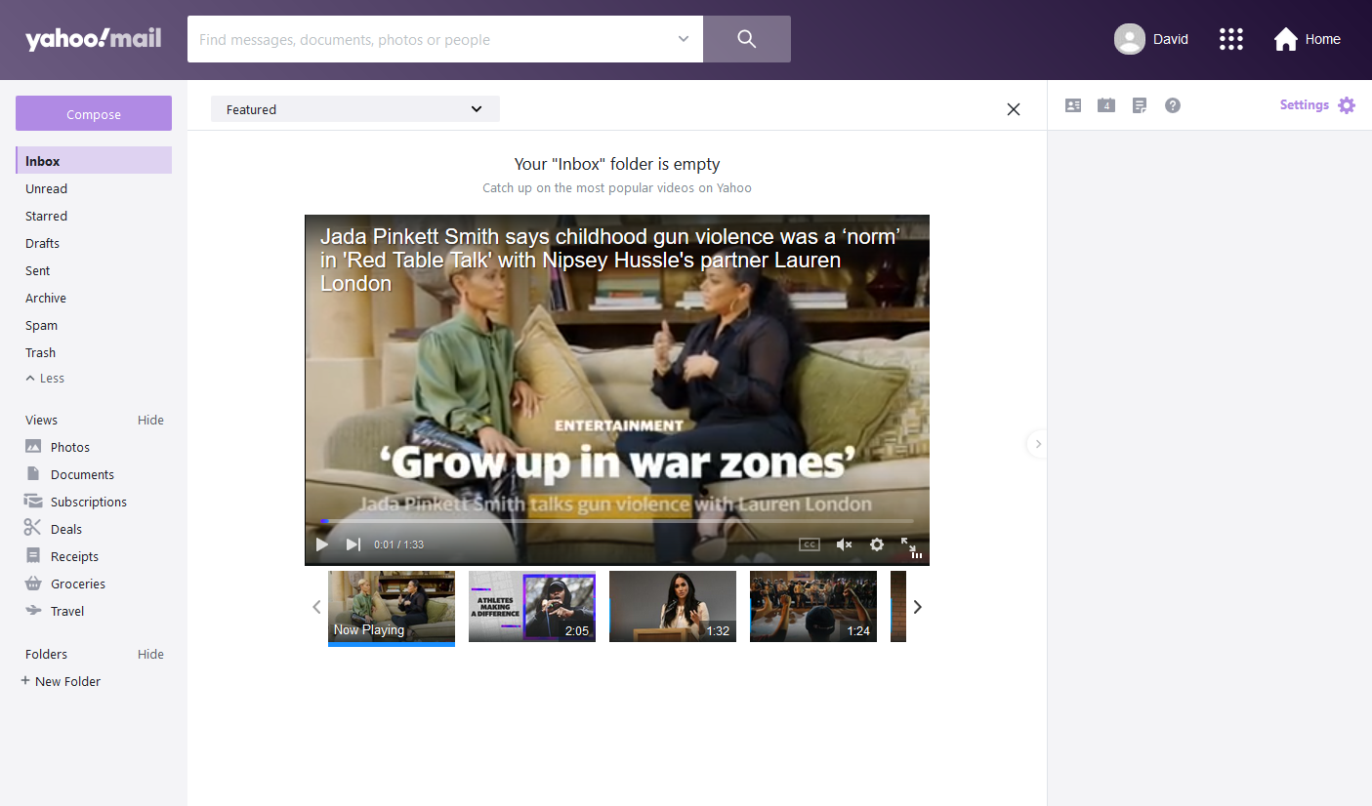

Then look down the page and find where is says “More Settings” and click on this.
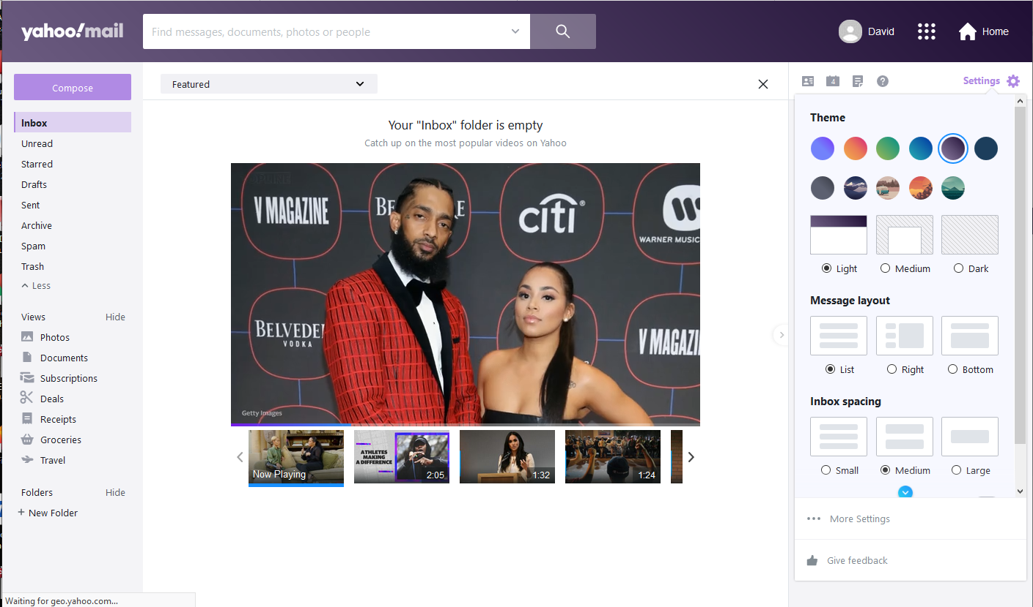
Then find the filters on the left
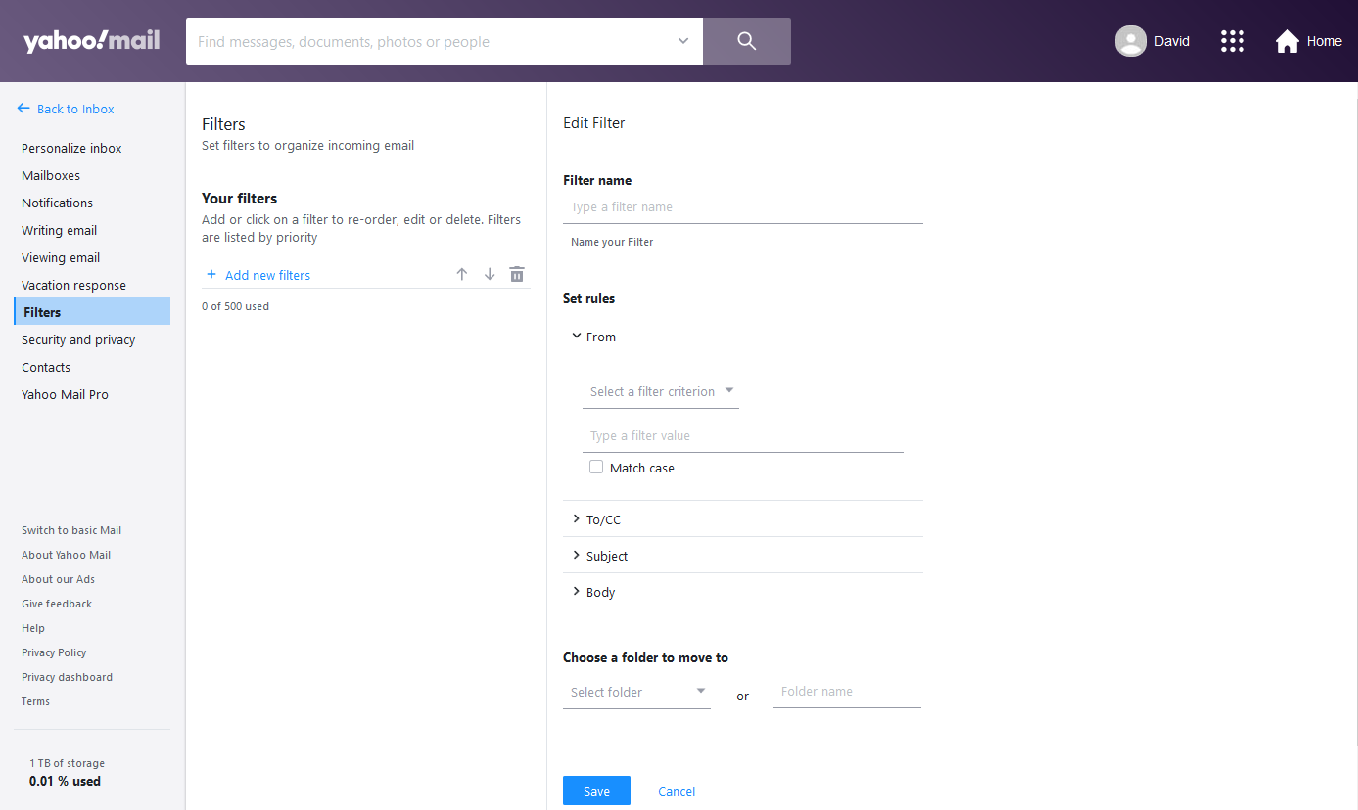

Then click “Add new filters”. Then on the right side of the page and you will see “Edit Filter” .

Add a filter name, then under “Set rules” select the “From” and also select “ends with”. Add dammonengineering.com as shown below. Next select the “Save” button.
