Display the Developer Ribbon
I’m basing this how-to on a great bit of custom Visual Basic code written by Michael Kizer. Michael wrote this VBA snippet for Outlook 2007, but it works for Outlook 2010. The only problem: it’s a bit tough to find Visual Basic Editor in Outlook 2010. It’s hiding in the Developer ribbon, which, by default, is hidden from view. Here’s how to enable it:

Step 1
Launch Outlook 2010.

Step 2
Click the File tab and choose Options.
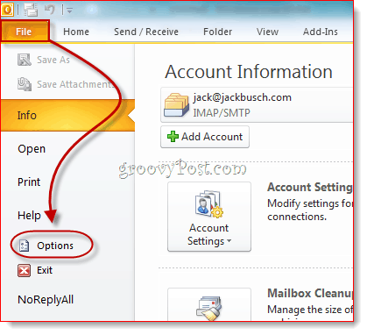

Step 3
Click Customize Ribbon on the left-hand panel. Now, in the list on the far right, make sure Developer is checked. Click OK.
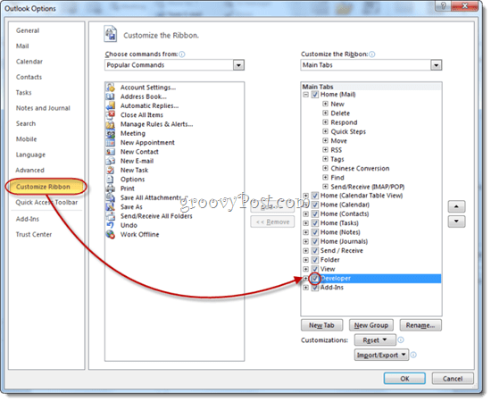

Step 4
The Developer tab will now be revealed in your Outlook 2010 ribbon.
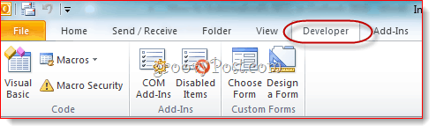

Automatically BCC Outgoing Messages in Outlook 2010
Now, it’s time to add the code that Mr. Kizer put together.

Step 1
Go to the Developer tab and click Visual Basic.

Step 2
On the left, expand Project1 (VbaProject.OTM to reveal Microsoft Outlook Objects. Expand Microsoft Outlook Objects and then double-click ThisOutlookSession.
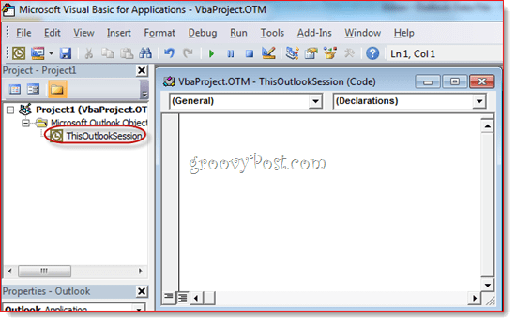

Step 3
In the code editor window, choose Application from the drop-down menu in the top-left.
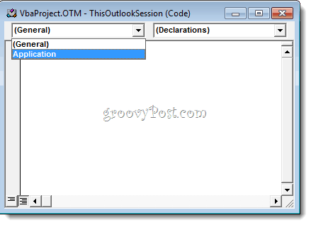

Step 4
In the top-left drop-down menu, choose ItemSend.
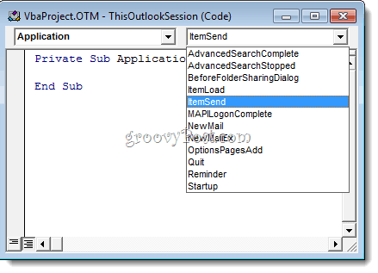

Step 5
Position your cursor after “Private Sub Application_ItemSend(ByVal Item As Object, Cancel As Boolean)” and before “End Sub.” Now, copy and paste the following between those two lines.
Dim objRecip As Recipient
Dim strMsg As String
Dim res As Integer
Dim strBcc As String
On Error Resume Next

' #### USER OPTIONS ####
' address for Bcc -- must be SMTP address or resolvable
' to a name in the address book
strBcc = "SomeEmailAddress@domain.com"

Set objRecip = Item.Recipients.Add(strBcc)
objRecip.Type = olBCC
If Not objRecip.Resolve Then
strMsg = "Could not resolve the Bcc recipient. " & _
"Do you want still to send the message?"
res = MsgBox(strMsg, vbYesNo + vbDefaultButton1, _
"Could Not Resolve Bcc Recipient")
If res = vbNo Then
Cancel = True
End If
End If

Set objRecip = Nothing

Step 6
Look for the line that reads: strBcc=”SomeEmailAddress@domain.com” and replace it with the email address you’d like to BCC for SomeEmailAddress@domain.com. For example, swap it out for mysecondaryemail@gmail.com or igbrother@supervisor.com.
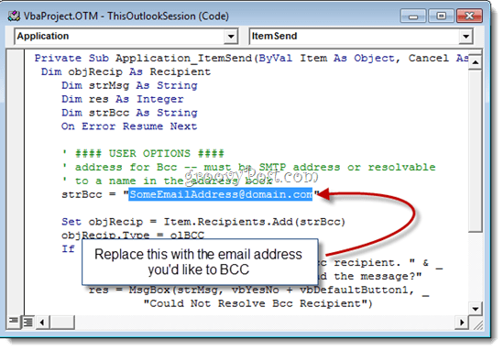

Step 7
Don’t forget to save the changes. Close the Visual Basic Editor and return to Outlook.
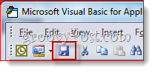
Now, when you send messages from Outlook 2010, they’ll be automatically BCC’d to the recipient you chose in the Visual Basic editor. You don’t have to type their name in the BCC field, nor will you even see it entered into the BCC field since the Visual Basic script kicks in after you hit send. (A handy tip for any cyber spies.)
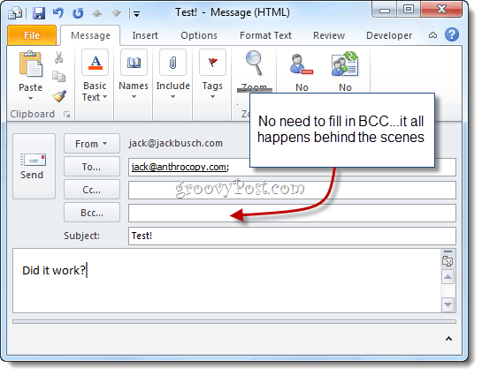
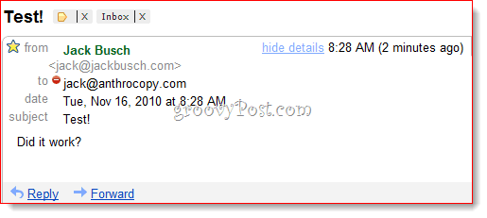
And there you have it.

Filtering BCC’d Gmail Messages
One last thing to note: if you are using this to build a Gmail archive, I recommend using a customized Gmail address with something like +bcc appended to it. However, since the address won’t show up in the to: field, you can’t filter it out like normal. So, instead, you’ll have to use the “deliveredto:” string in Gmail. For example, I’d use “deliveredto: username+bcc@gmail.com” and then set up a rule that automatically archives these messages and marks them as read.
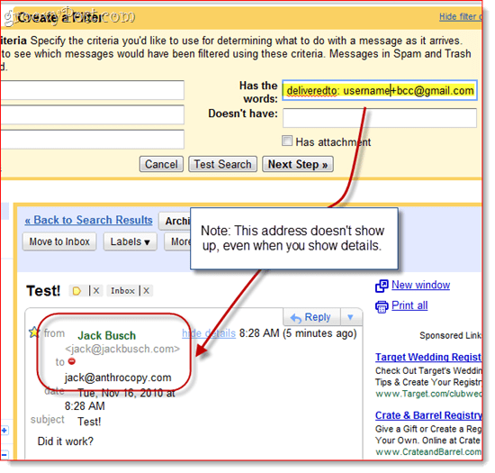

A Note About Macro Security
Note: This section may help those who find that the macro stops working the next day or after a system restart.
To get this to work, you may need to alter your macro security settings. Either way, you’ll probably get a nagging message like this when Outlook 2010 launches:
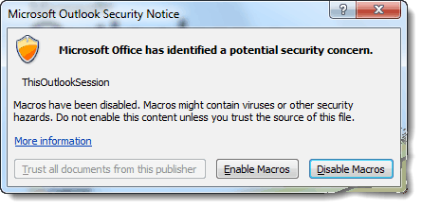
As you can see, that just refers to the script that you put into ThisOutlookSession—it doesn’t mean you have a virus. You can click Enable Macros to proceed with your Auto BCC script intact.
If you want to skip this step, you can change your Macro Security settings by going to the Developer tab and clicking Macro Security.
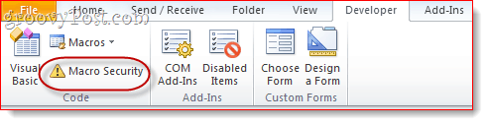
Under “Macro Settings,” you’ll have a few different options:
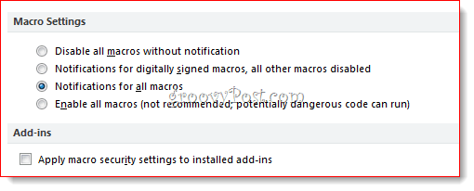
For a nag-free existence, choose “Enable all macros,” though this is, of course, potentially dangerous. The real solution here is to get your macro digitally signed—but that’s a bit of an involved process, which I’ll go over in another post (How to Create a Self-Signed Digital Certificate in Microsoft Office 2010). Stay tuned!

