Objective:
Equipment:
- Unconfined compression testing device
- Specimen trimmer and accessories
- Harvard miniature compaction device and accessories
- Scale
- Balance sensitive to 0.01g
- Oven
- Porcelain evaporating dish
Procedure:
- Obtain soil specimen for the test. If it is an undisturbed specimen, it has to be trimmed to proper size by using the specimen trimmer. For classroom laboratory work, specimens at various moisture contents can be prepared using the Harvard miniature compaction device. The cylindrical soil specimen should have a height-to-diameter ratio of between 2 and 3. In many instances, specimens with a diameter of 1.4 in and heights of 3.5 in are used.
- Measure the diameter and length of the specimen, and determine the mass of the specimen.
- Place the specimen centrally between the two loading plates of the unconfined compression testing machine. Move the top plate very carefully to touch the top of the specimen. Set the proving ring dial gauge to zero. A dial gauge should be attached to the unconfined compression testing machine to record the vertical upward movement of the bottom loading plate. Set this dial gauge to zero.
- Turn the machine on. Record loads and the corresponding specimen deformations. During the load application, adjust the rate of vertical strain to ½-2% per minute. The rate of strain should be chosen such that the time to failure does not exceed 15 minutes. At the initial stage of the test, readings are usually taken every 0.01in of specimen deformation. However, this can be varied to every 0.02in of specimen deformation at a later stage of the test, when the load deformation curve begins to flatten out.
- Continue to take reading until:
  - Load reaches a peak and then decreases; or
  - Load reaches a maximum value and remains approximately constant thereafter (take about 5 readings after it reaches its peak); or
  - Deformation of the specimen is past 15% strain before reaching the peak. This may happen in the case of soft clays.
- Unload the specimen by lowering the bottom loading plate.
- Remove the specimen from between the two loading plates.
- Draw a free-hand sketch of the specimen after failure. Show the nature of the failure.
- Put the specimen in a porcelain evaporating dish and determine the moisture content (after drying it in an oven to a constant weight).
Data:
Moist weight of the specimen = 1178.1 g
Dry weight of specimen = 912.4 g
Moisture content =
Length of specimen = 5.875 in
Diameter of specimen = 2.8125 in
Area = (∏/4)D² = 6.21 in²

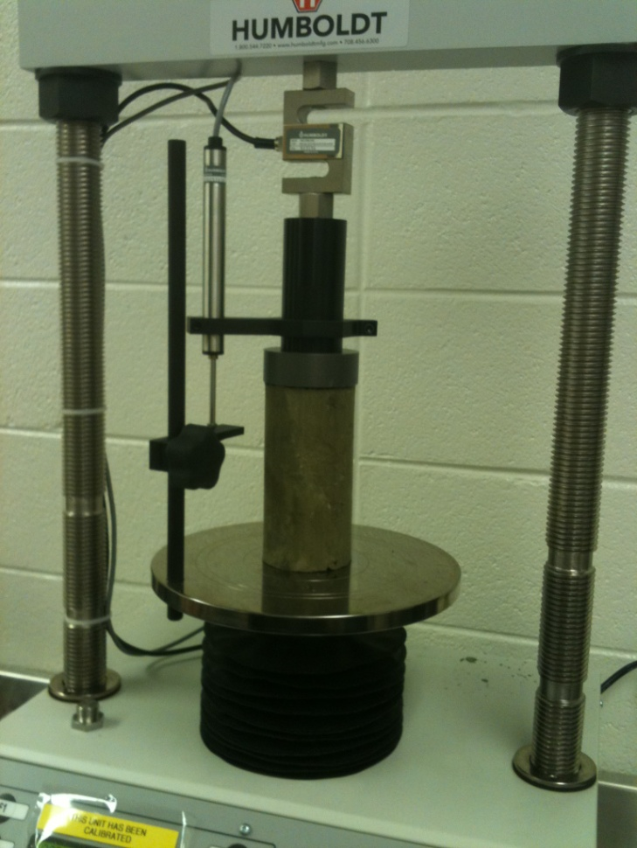
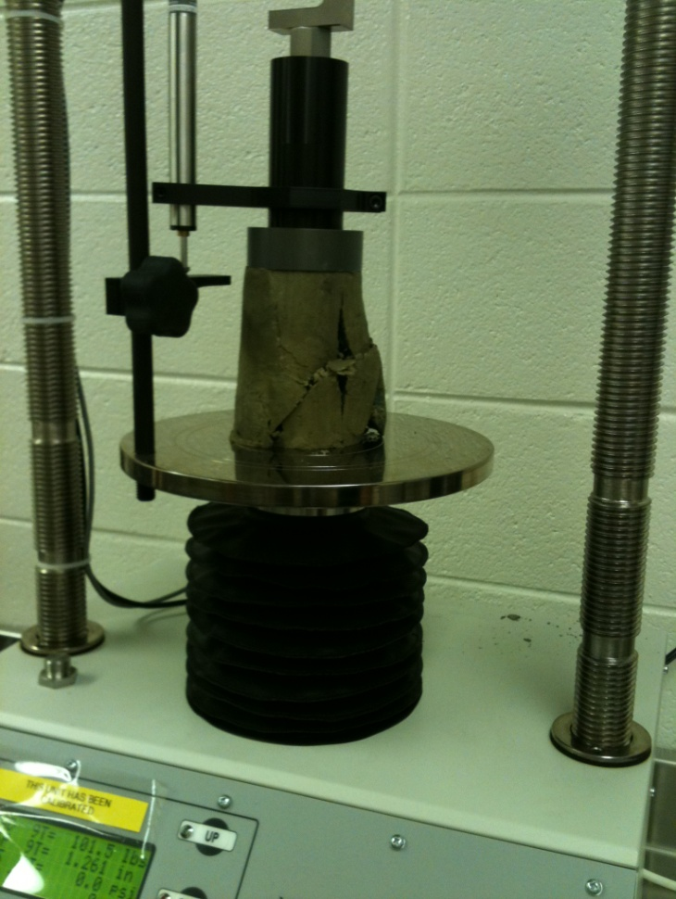
BEFORE AFTER

