Rhythm

Listening Prelude
Listen to Chopin's Waltz in C-sharp minor, and consider the following questions:
- Does this music have a pulse?
- Is it strong or weak?
- Does the pulse remain the same or change as the piece progresses?
- What is the tempo of this piece?
- Does the tempo remain the same or change as the piece progresses?
- What is the meter of this piece?
- What, if any, are the characteristic rhythmic patterns used in this piece?
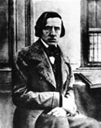Frédéric Chopin
Waltz in C-sharp minor

Frédéric Chopin
Born: 1810
Died: 1849
Period: Romantic
Country: Poland/France

Introduction
Rhythm is the organization of sound in time. Earlier, we learned that every tone has duration. It begins, exists for some period of time, and then ends.
When sounds are placed one after another, the combined durations create what is known as rhythm. Rhythm may be very complex, but some fundamental aspects of rhythm may be easily described and understood.
A basic component of rhythm is pulse (or beat). A great deal of the world’s music has a pulse. Pulse is what enables us to march, dance, or just tap a finger to music. Try tapping to the pulse in this excerpt.
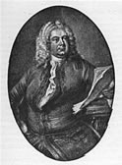
George Frideric Handel
Water Music: Suite No. 2 in D major: Alla Hornpipe

George Frideric Handel
Born: 1685
Died: 1759
Period: Baroque
Country: Germany/England
In some music the pulse is strong and quite obvious; in other music it is weak and may require very focused listening to detect. The two examples below illustrate musical pulses of different strengths. The pulse in the Barber example is weak, whereas the pulse in the Verdi example is strong.
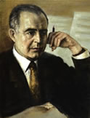
Samuel Barber
Adagio for Strings

Samuel Barber
Born: 1910
Died: 1981
Period: Contemporary
Country: USA
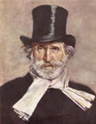
Giussepe Verdi
Aida: Triumphal March

Giussepe Verdi
Born: 1813
Died: 1901
Period: Romantic
Country: Italy
The pulse in music may move at different rates, creating what we describe in music as tempo. Compare the speed of the pulse in these examples:
Slow | Medium | Fast

Rhythm

Rhythm and the Body
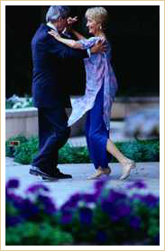
Dancing Couple
Because most people's nervous and muscular systems are stimulated by sound, reaction to the beat is often spontaneous and automatic. If the beat is strong enough to be heard or felt, most people will have a natural tendency to clap their hands, tap their feet, or move their heads with the music. Even babies respond naturally to beat and meter and will move on or to the beat. Reacting to the beat is more a matter of feeling it in the body than analyzing, hearing, or reading it from a music score.
There is a basic relationship between rhythm and the human body, essential to the understanding of rhythm. Our heartbeats, breathing, and walking may be used as metaphors for the organization of time into regular, ordered units. External and internal events affect the body's pulse and breathing rate. We also speak of a biological clock, and of real versus psychological time.
Rhythm is an important element in both music and dance. In some ways, dance is a physical and visual expression of rhythm.
Rhythm is strongly connected to movement through tension and relaxation. The alternation of tension and relaxation is experienced in motion and registered in the mind. The body's nervous and muscular systems respond to the rhythmic quality of music, creating a subjective feeling and mood in the listener. The subsequent visible and invisible responses to music are based on our perception of how music moves in time from one point of emphasis to another. These points of rhythmic emphasis or stress—called the beat in musical terms—are visibly evident in dance.
building tension | relaxation | alternation of tension and relaxation
Melody, harmony, and rhythm are traditionally regarded as elements of music. Although rhythm is the most easily perceived, the three are inseparably linked and work together as a whole. This holistic view of music is essential to understanding the function of rhythm in music. Although for classification purposes, it is sometimes useful to study rhythm as an independent entity, rhythm cannot be considered in isolation from the total musical phenomenon. Music is not a static object; listening to it is a temporal experience that requires being able to follow simultaneous events in time. Thus, melody, harmony, and rhythm are intertwined as a unit that moves in time.
Another basic concept related to rhythm is pace and its regular or irregular progression in time. Pace refers to the relative speed of a piece of music as a whole. It ranges from fast to slow. A piece may maintain a regular pace throughout or include one or many speed changes. Pulse, or beat, is another aspect of rhythm, but the word pulse suggests a sense of regularity that not all music has.
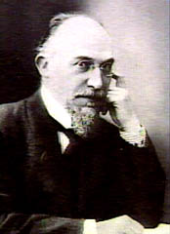
Erik Satie
Gymnopédie No. 1

Erik Satie
Born: 1866
Died: 1925
Period: Romantic
Country: France

Erik Satie's Gymnopédie No. 1 will help to illustrate some of these concepts and how they fit together. Listen for the beat, harmony, and melody. First, listen to the way the beat is emphasized by the first and the second notes in the bass. These are points of rhythmic stress. Satie combines these two sounds with chords. Together, these two elements constitute the harmony of the piece. They also set the stage for the entry of the melody. The three elements progress at a steady pace until the end of the piece.
Harmony | Melody
A French composer as eccentric in his way of life as in his music, Erik Satie exercised considerable influence over some of his more distinguished contemporaries, including Debussy, Ravel, and Poulenc, particularly through his tendency toward extreme simplicity. A number of his compositions have become very familiar, largely through their use in other contexts.
Satie has garnered popularity through his piano pieces. Among these, some bear characteristically eccentric titles, for example the Gymnopédies and the three Gnossiennes.

Silence
Silence is also an integral part of rhythm. The legendary conductor Leopold Stokowski (1882-1977) once remarked that “silence is the canvas on which music is painted.” Without silence between sounds, music would have no meaning. Listen to the effective way in which Johann Strauss, Jr. (1825-1899) used silence in this passage from his popular Blue Danube Waltz.
Blue Danube Waltz

