Tempo
The rate at which pulses in music recur give the impression of speed. In music, this is called tempo.
Definition...
"Tempo: The time of a musical composition; hence the speed at which its performance proceeds."
Grove Dictionary of Music
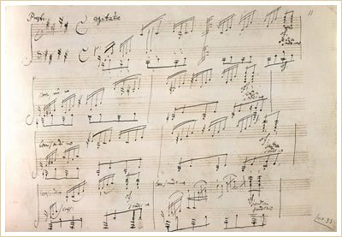
Ludwig van Beethoven (1770-1827)
Piano Sonata Op. 27 No. 2, Moonlight with presto (very fast) tempo indication on the top left
Tempo is an Italian universal musical term that refers to the speed at which a music composition is played. Tempo covers all the variations in speed, from very slow to very fast. In written music, tempo markings are usually written in Italian and appear over the staff. In the image above, the tempo marking is presto, which means very fast.

Italian Terms for Tempo
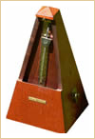
Mechanical metronome
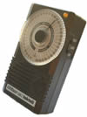
Electronic metronome
Tempo may also be indicated in a much more precise manner by stating the number of specified note values (whole note, half note, quarter note, and so on) per minute. For example, 72 quarter notes per minute corresponds roughly to the heartbeat rate. Musicians use the metronome to measure the standard tempo divisions. The divisions on a metronome scale correspond roughly to the Italian speed terms. For example, 60 beats per minute is lento (slow), 92 is andante (moderate), and 124 is presto (very fast).
Italian Term | English Equivalent
Largo | Broadly
Adagio or Lento | Slow
Andante | At leisurely walking speed
Moderato | Moderately fast
Allegretto | Fairly fast
Allegro | Fast
Vivace | Lively
Presto | Very fast
Common Italian terms denoting musical speed
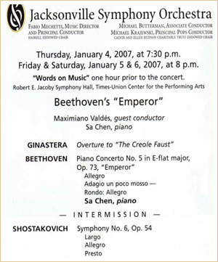
Concert Program
Jacksonville Symphony Orchestra
Notice the tempo indications for the movements in the Beethoven and the Shostakovich Symphonies
Tempo is so important in music that composers often use tempo designations as titles. Italian composers around the 1600s were the first to specifically indicate tempo and mood in their scores. Prior to that, precise tempo markings were practically unknown in music notation. With emerging nationalistic political and cultural trends in the mid-19th century, composers began indicating tempo and mood in their own language. More recently, they indicate speed and expression by a mixture of Italian and native language terms.
When you attend a concert, you may find that the different movements (sections) of a symphony or a sonata are labeled with the speed at which they are supposed to be performed, for instance, allegro or andante. This indicates the tempo you may expect to hear in those sections of the piece.
Of course, most aspects of rhythm are relative. What seems slow to you might be a moderate tempo for another listener. What seems to be a weak pulse the first time you hear a piece may seem very obvious and strong when you hear it again.

Variations in Tempo
A composer may decide to change the tempo within a piece. It is very common for the tempo to slow at the end of a composition as in the following examples:
G. F. Handel
Water Music: Suite No. 2 in D major, HWV 349 - II: Alla Hornpipe
J. S. Bach
Suite No. 3 in D major, BWV 1068: Air
The technical term for slowing down the tempo is ritardando.
A composer may, of course, also choose to have the tempo quicken within a piece. The Italian term used to describe an increase in tempo is accelerando.

Accelerando
Accelerando indicates a gradual increase or acceleration of the tempo. It usually comes before the climax or at the end of a composition to create a sense of excitement. Naturally, it would be impossible for a musician to stay in accelerando mode indefinitely. Therefore, accelerando indications usually lead into a new section of the piece where the tempo stabilizes at a faster speed than the preceding section. After this faster section, the composer may choose to have the music return to the original speed, in which case the indication a tempo (on tempo) or tempo primo (initial tempo) would be used.
The concepts of rhythm, meter, and tempo are closely interrelated. Let's look at a few pieces that may help us understand that relationship further.
Accelerando is featured in the ending of Edvard Grieg's In the Hall of the Mountain King. Mounting excitement is achieved by a gradual, though clearly noticeable, increase in tempo (accelerando), and volume (crescendo) as Peer sneakes into the Mountain King's castle and is subsequently persecuted by the Mountain King and his band of trolls. Listen to the five levels of increasing intensity in this music.
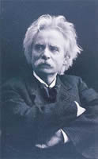
Edvard Grieg
Peer Gynt Suite No.1:
In the Hall of the Mountain King

Edvard Grieg
Born: 1843
Died: 1907
Period: Romantic
Country: Norway

Level 1 | Level 2 | Level 3 | Level 4 | Level 5

Grieg collaborated with Henrik Ibsen (1828-1906), an important Norwegian playwright of the 19th century, by providing the music for the play Peer Gynt. The original music makes use of solo voices, chorus, and orchestra, but it is most often heard in its orchestral form as two suites arranged by the composer.
In the Hall of the Mountain King portrays Gynt's encounter with a band of trolls, which is a type of mountain gnome in Scandinavian mythology. The trolls threaten him while dancing faster and faster. The accelerando is coupled with a gradual increase in volume called crescendo. Accelerando does not necessarily have to be accompanied by crescendo, however. These are independent music compositional techniques that, nonetheless, often happen together.

Ritardando
Ritardando refers to music that gradually slows down. Ritardando is, therefore, the opposite of accelerando. Another equivalent Italian for ritardando is rallentando. Ritardandos usually help to close off sections of a piece of music by providing an air of finality to a composition. The final bars of Handel's Hallelujah Chorus from Messiah exemplify this use of ritardando.
G. F. Handel
Messiah: Hallelujah Chorus
Schubert's Gretchen am Spinnrade is an example of a piece that alternates between accelerando and ritardando. In the song, Gretchen, a fair young lady, sings of her despair while she spins. She has been seduced and abandoned by Faust.
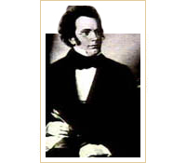
Franz Schubert
Gretchen am Spinnrade

Franz Schubert
Born: 1797
Died: 1828
Period: Romantic
Country: Austria
The piano part provides the setting that depicts the speeding up (accelerando), slowing down (ritardando), and faltering (final ritardando) of the spinning wheel. The lyrics tell Gretchen's story, which alternates between happy and sad events and emotions.
Meine Ruh' ist hin,  Mein Herz ist schwer,  Ich finde sie nimmer  Und nimmermehr. | My peace is gone,  My heart is heavy,  I will find it never  and never more.
Wo ich ihn nicht hab  Ist mir das Grab,  Die ganze Welt  Ist mir vergällt. | Where I do not have him,  That is the grave,  The whole world  Is bitter to me.
Mein armer Kopf  Ist mir verrückt,  Mein armer Sinn  Ist mir zerstückt. | My poor head  Is crazy to me,  My poor mind  Is torn apart.
Meine Ruh' ist hin,  Mein Herz ist schwer,  Ich finde sie nimmer  Und nimmermehr. | My peace is gone,  My heart is heavy,  I will find it never  and never more.
Nach ihm nur schau ich  Zum Fenster hinaus,  Nach ihm nur geh ich  Aus dem Haus. | For him only, I look  Out the window  Only for him do I go  Out of the house.
Sein hoher Gang,  Sein' edle Gestalt,  Seine Mundes Lächeln,  Seiner Augen Gewalt, | His tall walk,  His noble figure,  His mouth's smile,  His eyes' power,
Und seiner Rede  Zauberfluß,  Sein Händedruck,  Und ach, sein Kuß! | And his mouth's  Magic flow,  His handclasp,  and ah! his kiss!
Meine Ruh' ist hin,  Mein Herz ist schwer,  Ich finde sie nimmer  Und nimmermehr. | My peace is gone,  My heart is heavy,  I will find it never  and never more.
Mein Busen drängt sich  Nach ihm hin.  Ach, dürft ich fassen  Und halten ihn, | My bosom urges itself  toward him.  Ah, might I grasp  And hold him!
Und küssen ihn,  So wie ich wollt,  An seinen Küssen  Vergehen sollt! | And kiss him,  As I would wish,  At his kisses  I should die!
Und küssen ihn,  So wie ich wollt,  An seinen Küssen  Vergehen sollt! | And kiss him,  As I would wish,  At his kisses  I should die!
Meine Ruh' ist hin,  Mein Herz ist schwer,  Ich finde sie nimmer  Und nimmermehr. | My peace is gone,  My heart is heavy,  I will find it never  and never more.
Chopin's Waltz in C-sharp minor is another piece that features changes in tempo.
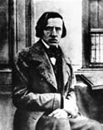
Frédéric Chopin
Waltz in C-sharp minor

Frédéric Chopin
Born: 1810
Died: 1849
Period: Romantic
Country: Poland/France
 | Section B | Section C
  Section A
  Part 1: Lively | Part 2: Fast
  Section A'
  Revisit Part 1: Lively | Revisit Part 2: Faster

Rubato
In some styles of music, tempo is rigid and consistent. In other styles, there is give and take. To make the music more expressive, the performer is expected to speed up in some places and slow down in others. This subtle speeding up and slowing down is called rubato or tempo rubato—Italian for stolen time. Listen to the following example and notice that the tempo is not the same from beginning to end. On the contrary, there are sections where the tempo is flexible, with gradual yet noticeable changes in speed:
Johann Strauss Jr. (1825-1899)
Blue Danube Waltz: excerpt
Now, listen to the entire waltz, and see if you can identify the sections that feature tempo rubato.
Johann Strauss Jr.
Blue Danube Waltz: entire piece

