Main characteristics of Renaissance Music
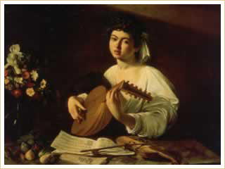
The Lute Player
Michelangelo Merissi da Caravaggio (1563-1610)
Precisely when the musical renaissance began is a matter of debate. Some historians place it at about 1400 with the generation of Gilles Binchois, also known as Gilles de Binche or Gilles de Bins (c.1400-1460), and Guillaume Dufay (c.1398-1474). Other historians argue that the rise of imitative counterpoint around 1450 ushered in the Renaissance, while still others place the beginning closer to 1500 when humanism created a strong link between music and poetry. It is, nonetheless, commonly accepted that the secular music associated with the Renaissance period flourished in the 15th century, mainly in the Court of Burgundy. Some of the salient characteristics of the period—fascination with classical antiquity, erosion of the authority of the church, burgeoning humanism, emergence of affluent urban centers, and the creation of important universities—were manifest in the northwestern area of present-day France.
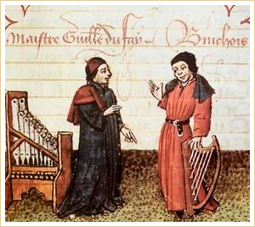
Guillaume Dufay and Gilles Binchois

Polyphonic Music
During the Renaissance, the polyphonic experiments of the Middle Ages reached fruition. During no other time in history has polyphonic music been produced more abundantly and beautifully.
Clement Jannequin
Le Chant des Oiseaux

Choral Music
For several reasons, the Renaissance is considered the Golden Age of Choral Music. First, more choral music—mainly for small ensembles—was written in this period than at any other time in music history. Most of these compositions were performed a cappella, meaning without accompaniment. Second, all the important forms of the age (motet, mass, anthem, chanson, and madrigal) were choral music forms. Third, across Europe, instruments were still undergoing a standardization process. It would be another 150 years before the modern orchestra took shape.
Choral Music | Chanson | Motet | Madrigal
Anthem | A cappella | Mass

Gregorian Chant
Gregorian chant was still used as the basis of many polyphonic church compositions. During the Renaissance, composers of sacred music continued the practice of keeping the original chant as the basis for the main melody; they called this chant the cantus firmus. The cantus firmus did not necessarily have to occupy the tenor part, although that was still the most common place for it.
Polyphonic church composition

Modes and Harmony
Although Renaissance composers, particularly sacred music composers, continued to use church modes, they gradually began adopting modes equivalent to our present major and minor scales. Probably the most important development in Renaissance music, due in part to the work of Dunstable and other English composers, was giving harmony a much more important role within the composition.
Modes equivalent to present major | Modes equivalent to present minor | Harmony

Characteristics of Renaissance Music
Below are some of the basic characteristics of Renaissance music.

Form
- Forms were mostly polyphonic, with the cantus firmus (chant melody) in the lowest voice.
- Composers made use of pre-existing music, often including entire pieces within a larger composition.
- Repetition and contrast were used in dance forms.

Melody
- An emphasis on melody was one of the most important factors in Renaissance music. Harmonic and/or rhythmic interest in compositions was centered mostly on the melodic part.
- A large number of compositions of the period were solo songs based on a melody with instrumental accompaniment.
- Melodies, even those for instruments, were vocal in style. Ranges rarely spanned more than one octave.

Rhythm
- Rhythms were free from strict meters, and were often very complicated.
- Rhythmic phrases were long and overlapped between voices.

Harmony
- Harmony resulted from the interaction of independent melodic lines rather than from pre-planned chord progressions.

Texture
- Textures were mostly polyphonic until the 16th century, at which point some homophonic textures were used for contrast and variety.

Timbre
- For much of the Renaissance, the human voice was the chosen timbre. Instruments doubled the voices in both sacred and secular music.
- In the 16th century, composers began using instruments without vocal accompaniment, particularly the organ and harpsichord.
- Toward the end of the 16th century, ensembles of string and wind instruments became popular with audiences and composers.
- The lute was the most popular stringed instrument. The vihuela—considered by many to be the precursor of the modern classical guitar—evolved in the mid 1400s in Spain.

