Renaissance Period (1450-1600)
This class highlights key composers who represented the changes in music that occurred during the Renaissance.

Giovanni da Palestrina
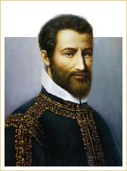
Giovanni da Palestrina
Pope Marcellus Mass: Credo

Giovanni da Palestrina
Born: 1525
Died: 1594
Period: Renaissance
Country: Italy
It is said that the Pope Marcellus Mass by Giovanni da Palestrina (1525-1594) saved polyphony from banishment from the Catholic service. The Credo from the mass showcases the hallmarks of the “Palestrina style,” which became the model for future generations of composers.
Palestrina's 104 masses and 177 motets make him the most prolific and consistent composer of the Counter-Reformation. It can be said that his style embodies the archaic, dogmatic completeness of Counter-Reformation Catholicism, making him the supreme musical theologian.

William Byrd
William Byrd, whose sacred compositions rank among the finest ever written in England, is the first superstar among English composers. He belongs to a select group of composers who, during their own lifetime, were recognized as geniuses. His contemporaries referred to him as “a Father of Musick” and “Our Phoenix.” The piece Qui passé, performed here on a virginal (an instrument related to the harpsichord), shows the composer's remarkable skill.
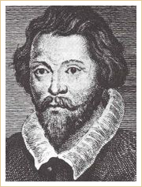
William Byrd
Qui passé

William Byrd
Born: 1540
Died: July 4, 1623
Period: Renaissance
Country: England
Although remaining Catholic, a loyalty that cost him considerable trouble in times of religious persecution in England, Byrd served as a member of the Chapel Royal, providing music for the liturgy of the Church of England and, on a more private scale, for his fellow Catholics.
Following the popular fashion of the time, Byrd composed music for various groups of instruments. He frequently performed in homogenous ensembles, generally playing viols and other bowed and fretted string instruments that were more highly esteemed than the lowly violin. Byrd's consort music, like that of his English contemporaries, used the forms of the fantasia, the dance forms of the stately pavan, and the more vigorous galliard. One such piece is the Galliard a 6. It is thought to be a relatively late work and probably one of Byrd's last for the viol consort.
Galliard a 6

Johannes Ockeghem
Ockeghem entered the service of the King of France in 1452. From 1465 until his death, he was the most important musician in Europe; his passing in 1497 was universally mourned. Among those mourners was Josquin Desprez, who wrote Déploration sur le trépas De Jean Ockeghem (Deploration on the death of Jean Ockeghem) as a tribute to the late Flemish master.
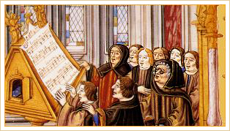
Johannes Ockeghem (on right, with glasses) and singers
Agnus Dei

Johannes Ockeghem
Born: 1410
Died: February 6, 1497
Period: Renaissance
Country: France/Belgium
In his masses, Ockeghem extended the range of each of the voice parts and occasionally varied the texture by including passages for only two or three voices. This shows an attention to the overall form of the piece that, at the time, was uncommon. Note the varying textures in the Agnus Dei from his Missa Prolationum.
Missa Prolationum: Agnus Dei

Jacob Obrecht
Few details are known about the life of Obrecht, other than that he held positions at various cities throughout Europe and that he died of the plague. His surviving works include masses, motets, chansons, and instrumental pieces. Most of his masses use a cantus firmus, which appears in various ingenious ways throughout each of the sections of the mass. Obrecht, unlike Ockeghem, loved imitation between the voices. The Agnus Dei from his Missa Caput opens with a clear point of imitation between the tenor and the bass parts. Obrecht's works contain some of the finest examples of structure and form in the early Renaissance.
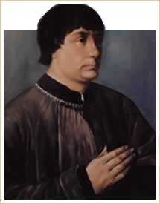
Jacob Obrecht
Missa Caput: Agnus Dei

Jacob Obrecht
Born: 1457/1458
Died: July, 1505
Period: Renaissance
Country: Netherlands

Carlo Gesualdo
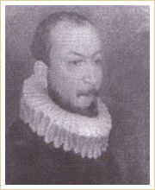
Carlo Gesualdo
O vos omnes

Carlo Gesualdo
Born: c.1560
Died: September 8, 1613
Period: Renaissance
Country: Italy
Gesualdo's madrigals contain the most extreme examples of renaissance dissonance and chromaticism. Igor Stravinsky, one of the 20th century's most daring composers, called Gesualdo “the crank of chromaticism.” While not stepping totally beyond acceptable bounds, Gesualdo's madrigals are restless and colorful. Works such as the motet O vos omnes use an advanced form of harmony that wasn't heard again until the late 19th century. Aside from his collection of madrigals, Gesualdo wrote a quantity of sacred vocal music and a relatively small number of instrumental pieces. The unexpected and sudden changes of tonality, harmonic daring and intensity of feeling of his music have found particular favor among some modern theorists.
Notorious for brutally murdering his wife and her lover in 1590, Gesualdo went on to marry Leonara d'Este of the house of Este. The Estes, rulers of the Italian city-state Ferrara, were renowned patrons of music and the arts during the Renaissance.

Thomas Weelkes
Weelkes is the second of the two principal English madrigal composers of the late 16th century, the first being William Byrd. His madrigals, such as As Vesta was, demonstrate the same concern with overall form as Byrd's while retaining an element of seriousness and depth. Note the imitation in this delicate madrigal.
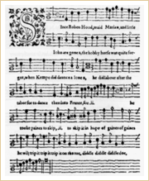
Madrigal by Weelkes
As Vesta was

Thomas Weelkes
Baptised: c.1576
Buried: December 1, 1623
Period: Renaissance
Country: England
Although he was a contemporary of the great madrigalist Claudio Monteverdi (1567-1643), whose groundbreaking work marked the transition from the Renaissance to the Baroque period, Thomas Weelkes would not have been aware of Monteverdi's successful synthesis of old and new forms. He was a busy Church of England musician whose music, in a typically English vein, had its own sense of values and destiny according to a national temperament, one which found continental histrionics and emotional outpourings rather embarrassing. Enough changes were afoot at the turn of the 17th century, however, for Weelkes to realize that he was operating in a world of transition; he quickly took advantage. The power of representing words and images, central to the upcoming baroque ethos, was particularly evident in his madrigal writing. His ability to illuminate texts is evident in his exquisitely focused and atmospheric sacred madrigal When David Heard.
When David Heard
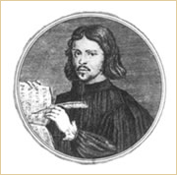
Thomas Tallis
Spem in alium

Thomas Tallis
Born: c.1505
Died: 1585
Period: Renaissance
Country: England
Thomas Tallis had a successful career as a church musician and composer during one of the most politically and socially turbulent periods in 16th century England. Although his royal service began in the reign of Henry VIII and ended in the reign of Queen Elizabeth I (a span of six monarchs), Tallis managed to avoid the religious controversies and conflicts that surrounded him constantly.
Tallis wrote a significant amount of Latin church music and also contributed to the reformed English liturgy, in some cases adapting earlier Latin compositions. His better-known works from the Elizabethan years include his settings of the Lamentation for the Holy Week services and the unique motet Spem in alium, written for eight five-voice choirs. It is thought that this 40-voice piece was part of a celebration of Queen Elizabeth's 40th birthday in 1573.

