Renaissance Period (1450-1600)

Sacred Music
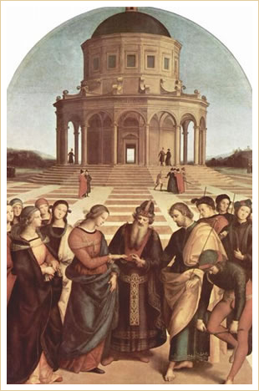
The Wedding of the Virgin
Raphael Sanzio (1483-1520)
The two principal types of music in the Catholic Church today, the mass and the motet, are both legacies from the Middle Ages and the Renaissance. The Renaissance mass was a setting of the ordinary texts to music: Kyrie, Gloria, Credo, Sanctus, and Agnus Dei. The practice of using a Venit ad Petrum as the basis for the mass continued, although a popular tune might be used instead of a chant melody. Certain masses became widely known because of the circumstances under which they were composed, for example, Palestrina's Pope Marcellus Mass, written for the Pope's premature death. Secular music began incorporating portions of the mass; witness the use of the cantus firmus in Ockeghem's Missa L'Homme armé (The Armed Man).
Motet | Kyrie | Agnus Dei | Venit ad Petrum
The Council of Trent in the mid-16th century came close to banning all polyphonic music from the Church, with some religious officials pushing for a return to chant instead. Several scholars maintain that the Pope Marcellus Mass by Giovanni da Palestrina (1525-1594) saved polyphony from banishment from the Catholic service. The Kyrie from that mass showcases the style of Giovanni da Palestrina that became the model for future generations of composers. These characteristics are:
- Melodic, plainsong-like quality in individual parts
- Smooth-sounding polyphony and homophony, the melodic movement suggesting the shape of an arch
- Long and elegant music phrases
- Extremely clear texture
- Controlled expressiveness

Evolution of Sacred Music
The Catholic Church underwent a major transformation during the Renaissance. The popularity of the motet toward the end of the 15th century led an increasing number of composers to experiment with church music forms, extending the boundaries of what was acceptable and altering the original chant to the point that it became almost unrecognizable.
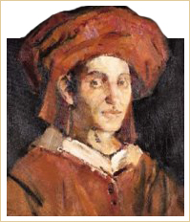
Josquin Desprez
Ave Maria

Josquin Desprez
Born: c.1450
Died: August 27, 1521
Period: Renaissance
Country: France
The career of Josquin Desprez (c.1450/55-1521) exemplified the dominance of composers from Northern France and the Netherlands during the Renaissance. He was employed at several locations throughout his career: Milan, the Papal chapel in Rome, in France by King Louis XII, the court of the d'Estes in Ferrara, and finally in his native Condé, where he died in 1521.
Josquin wrote a large number of motets. Many consider that, in this particular form, he represents the epitome of Renaissance music achievement.

Ave Maria Gratia Plena  Dominus tecum, Virgo serena,  Avecuius conceptiosolemni plena gaudio,  caelestia, terrestria,  nova replet laetitia,  Ave cuius nativitas.  nostra fuit solemnitas,  ut lucifer lux oriens,  verum solem praeveniens.  Ave pia humilitas,  sine vero fecunditas.  cuius annunciatio,  nostra fuit salvatio.  Ave vera virginitas,  immaculata castitas,  cuius purificatio,  nostra fuit purgatorio.  Ave praeclara omnibus  angelicis virtutibus,  cuius fuit assumptio,  nostra glorificatio.  O mater Dei,  memento mei. Amen. | Hail Mary Full of Grace  Hail Mary, full of grace,  the Lord is with you, Virgin serene,  Hail whose conception,  full of solemn joy,  heaven and earth  newly fills with happiness.  Hail whose birth  was our solemnity,  so that like a torch, the rising light  the true sun might herald.  Hail blessed humility,  without a man made fruitful,  whose annunciation  has been our salvation.  Hail true virginity,  spotless chastity,  whose purification  has been our cleansing.  Hail foremost among all  angelic virtues,  whose assumption has been  our glorification.  O mother of God, remember me. Amen.

