Baroque Period (1600-1750)

General Background
The years between 1600 and 1750 were full of contradiction, change and conflict in Europe. The future would be shaped by the far-reaching consequences of war. These conflicts mainly pitted the northern countries (Belgium, Germany, England and Sweden) against the Catholic kingdoms of the south (France, Spain and Austria), and they served to further accentuate the pre-existing cultural differences between Northern and Southern Europe. However, tremendous scientific, philosophical and artistic accomplishments that constitute the practical foundation of modern civilization flourished side by side with continual warfare, political instability and a religious fervor that bordered on fanaticism. Some of the most significant events of this period include:
- The Scientific Revolution: The separation of science and philosophy from religious dogma led to the establishment of a scientific method of inquiry. Science and mathematics influenced nearly every aspect of life.
- The Catholic Counter-Reformation: In response to the Protestant Reformation, an outpouring of exuberant sculpture, architecture, painting, and music to promulgate and support the power and doctrine of the Papacy in Rome and the Catholic Church took place. The Jesuit order led the Counter-Reformation campaign.
- The Thirty Years' War (1618-1648): The Holy Roman Empire, headed spiritually by the Pope (and temporarily by the Emperor), was dissolved, essentially establishing modern Europe as a community of sovereign states.
- Colonization: Large areas of the Americas and Africa were colonized by European powers. The English and the Dutch succeeded the Spanish and Portuguese as the main empire builders.
- Absolutism and Patronage: Absolutism in government and the patronage system created an environment that fostered enormous growth in the arts.
- The rise of the bourgeoisie: The new merchant class became a supporter of the arts, creating the climate for the development of a baroque style in Northern Europe, particularly in Holland.

The essential philosophical outlook of the period was characterized by:
- the emphasis on the individual, the personal character of religious experience, and the use of artistic expression to convey such experiences;
- the rise of capitalism and mercantilism as tools of empire building and the financial basis for the rise of the bourgeois class;
- the creation of the baroque style—an art style full of emotion, flamboyancy, symbolism, vigor and subtlety—largely as a product of the Catholic Church's patronage of the arts.

The Scientific Revolution
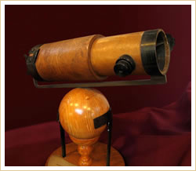
Newton's 6-inch telescope (1762)
Aided by philosophy, mathematics, and newly developed instruments and experimental methods, Baroque astronomers, mathematicians, philosophers, and writers fueled the scientific revolution of the 17th century by proposing world views that challenged conventional assumptions and questioned established Church dogmas. The scientific advances of this period had a profound impact on all spheres of human activity including the arts and music.
The scientific revolution is traditionally considered to have taken place between 1543—the year of publication of On the revolutions of the heavenly spheres by Nicolaus Copernicus (1473-1543)—and 1687, the year Isaac Newton wrote Mathematical Principles of Natural Philosophy.
At the dawn of the Baroque period, the Italian philosopher, priest and cosmologist Giordano Bruno (1548-1600) was tried, condemned, and publicly executed by the Catholic Inquisition for embracing the Copernican heliocentric (sun-centered) theory of the universe and suggesting that the universe itself was infinite and without center. A little over fifty years later, the Italian Galileo Galilei (1564-1642), in his Dialogue on the Two Main World Systems (1632), and the German Johannes Kepler (1571-1630) corroborated that the sun, not the earth, was the center of the universe and also pioneered the use of experimentation to validate physical theories—the cornerstone of the scientific method.
By the late 1600s, Sir Isaac Newton (1643-1727) had studied the work of Copernicus, Galileo, Kepler and many other giants of science and laid the groundwork for classical mechanics—the laws of gravitation and motion—in his Mathematical Principles of Natural Philosophy (1687). René Descartes (1596-1650), Blaise Pascal (1623-1662), Gottfried Leibniz (1646-1716), and Baruch de Spinoza (1632-1677) advocated the separation of philosophy and science from religious dogma; Francis Bacon (1561-1626), John Locke (1632-1704) and David Hume (1711-1776) established the foundation of the scientific system of observation, experimentation and testing of hypotheses. Montesquieu (1689-1755) proposed the theory of the separation of powers while Voltaire—pen name of Francoise-Marie Arouet (1694-1778) and a great admirer of Newton—criticized Church dogma and championed civil liberties, including freedom of religion, through his satirical writings and plays.
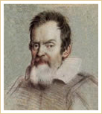 | Galileo Galilei  (1564-1642)  “All human reasoning must be placed second to direct experience.”  Italian physicist, astronomer and philosopher, considered by many the father of modern astronomy, physics and science. | 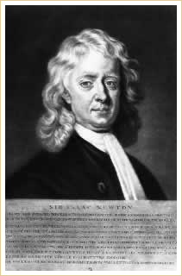 | Sir Isaac Newton  (1643-1727)  “If I have seen further it is by standing on the shoulders of giants.”  English physicist, astronomer and natural philosopher, remembered mostly for his Theory of Universal Gravitation and the application of calculus to general physics.
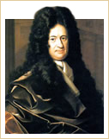 | Gottfried Leibniz  (1646-1716)  “Music is a hidden arithmetic exercise of the soul, which does not know that it is counting.”  German philosopher, mathematician and diplomat, Liebniz invented the binary system—the foundation of modern computer architecture—and accomplished major breakthroughs in calculus. | 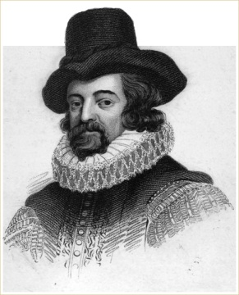 | Sir Francis Bacon  (1561-1626)  “Knowledge is power.”  English philosopher who established scientific empiricism with his method of observation and experimentation, laying the foundation for modern scientific inquiry.

