Aspects of Art during the Classical Period
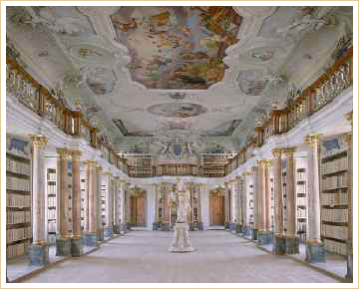
Benedictine Abbey Library
Rococo interior
Ottobeuren, Germany
For much of this period, the visual arts, dominated by the late Baroque style called rococo, did not reflect the rising tide of reason and simplicity. The rococo style emphasized elegance, delicacy, softness, and playfulness. Interiors were decorated with beautiful gold and white curved woods, crystal chandeliers, pastel colors, and gilt ceilings.
The greatest painter of the French rococo was Jean Antoine Watteau (1684-1721), whose works exhibit the light yet ornate touch of artists of the period.
The sensibilities of the growing middle class were clearly portrayed in the plays of Pierre Beaumarchais (1732-1799), whose Marriage of Figaro (1784) was so disturbing to the aristocracy that it was banned in Vienna and nearly banned in Paris. In 1786, however, Mozart recreated the play as an opera that enjoyed great success.
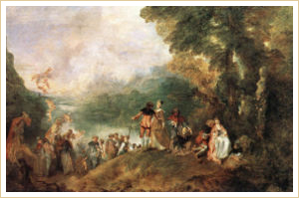
The Embarkation for Cythera
by Jean Antoine Watteau (Louvre version)

Later classical artists turned to portraiture as a way of capturing the elegance of the subject. Some of the famous paintings of this time include Duchess of Devonshire by Sir Joshua Reynolds (1723-1792), The Blue Boy by Thomas Gainsborough (1727-1788), and Paris and Helen by Jacques-Louis David (1748-1825). The art of Henry Fuseli (1741-1825) exemplified the interest in dark subjects of the Sturm und Drang artists.
In the 1790s, Napoleon's counterpart in the arts was Jacques-Louis David (1748-1825), a painter who became a kind of art dictator during the French Revolution. David painted solemn scenes of noble sacrifice and great historical moments in a clear, balanced, linear style. In politics and in art, the French Revolution was a culmination of the spirit of reform from the preceding generations. | 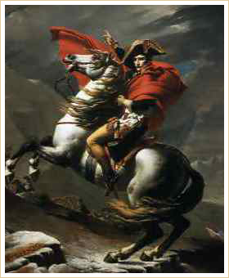  Napoleon  by Jaques-Louis David
Classical architecture reflected the revival of interest in Greek and Roman themes. Buildings constructed in the United States during the period, such as those designed by Thomas Jefferson, included columns and arches identical to those found on ancient buildings such as the Parthenon in Athens and the Coliseum in Rome.

