Classical Period (1750-1825)

Ludwig van Beethoven
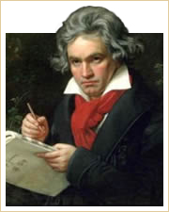
Ludwig van Beethoven
Symphony No. 3 in E flat major, Op. 55, Eroica: I. Allegro con brio

Ludwig van Beethoven
Born: 1770
Died: 1827
Period: Classical
Country: Germany

Leonard Bernstein on Beethoven:
"Many, many composers have been able to write heavenly tunes and respectable fugues. Some composers can orchestrate the C-major scale so that it sounds like a masterpiece, or fool with notes so that a harmonic novelty is achieved. But this is all mere dust—nothing compared to the magic ingredient sought by them all: the inexplicable ability to know what the next note has to be. Beethoven had this gift in a degree that leaves them all panting in the rear guard.
Beethoven broke all the rules, and turned out pieces of breath-taking rightness. Rightness—that's the word! When you get the feeling that whatever note succeeds the last is the only possible note that can rightly happen at that instant, in that context, then chances are you're listening to Beethoven. Melodies, fugues, rhythms—leave them to the Tchaikovskys and Hindemiths and Ravels. Our boy has the real goods, the stuff from Heaven, the power to make you feel at the finish: Something is right in the world. There is something that checks throughout, that follows its own law consistently: something we can trust, that will never let us down..."

Beethoven's Life
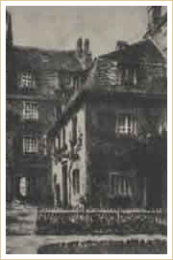
Beethoven's Birthplace
Bongasse 20, Bonn
Beethoven was born in Bonn on December 17, 1770. At the time, Germany was not a unified country but rather a loose grouping of some 250 states, each of which had its own laws, army, taxes, and to a large extent, customs. Beethoven came from a musical family. His father, an alcoholic tyrant prone to bouts of violence, was a singer in the Archbishop's chapel, the Elector of Cologne. He was also a rather unimpressive piano and violin teacher. Beethoven's mother was a cook in the summer palace where his father worked. His grandfather, also called Ludwig, was a trained musician, who had been elected the Archbishop's Kapellmeister in 1773.
Beethoven developed his knowledge and skill of music very quickly. In 1787 (at the age of 17), he traveled to Vienna to meet Mozart, who, impressed by his improvisation skills, allegedly said: “Watch this young man; he will give the world something worth listening to.”
After his father's death in 1792 and encouraged by Haydn who had also noticed his immense musical talent, Beethoven moved to Vienna. There, he quickly gained a reputation as a remarkable keyboard-player and composer of great originality.
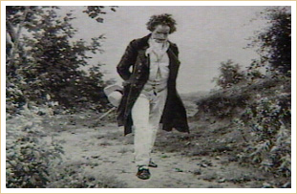
Beethoven Walking in the Woods
Beethoven's hearing loss began in 1802 at the age of 32. By 1815, his increasing deafness made public performance as a pianist or conductor impossible. He was already considered rather eccentric and difficult to get along with; his mounting deafness only made matters worse. By 1817, Beethoven had gone completely deaf. During the last three years of his life, he devoted himself to writing a series of string quartets considered by many to be among his greatest works. At the same time, they are the most difficult to listen to and understand. By the end of his life, he was composing in a personal style unlike anything previously heard until the 20th-century string quartets of Béla Bartók.
Beethoven died on March 26, 1827. His death is surrounded by myth. According to one report, his last words were: “I shall hear in heaven.” Some 20,000 people attended his majestic funeral.
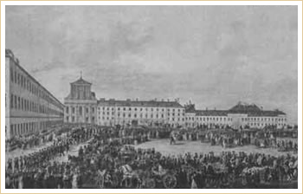
Beethoven's Funeral Procession
Beethoven did much to increase and extend the existing music genres. His incorporation of a chorus into the symphonic form through his Symphony No. 9, the addition of more instruments and different instruments into the standard orchestra ensemble, and the augmentation of the traditional forms through increased length, number of movements, and intricacy of harmony widened the horizons and conceptual ideas for later generations of composers. To his contemporaries, he was sometimes a controversial figure, making heavy demands on listeners both by the length and complexity of his writing as he explored new fields of music.

Beethoven's Works
One of the most important facts to know about Beethoven is that he is considered both a Classical and Romantic composer. His early works were influenced by Haydn and stayed within the Classical tradition of balance and clearly defined forms. His later works, however, were unlike anything heard before. Beethoven took traditional forms and expanded and explored them in unprecedented ways. Many people of his day found his later works almost incomprehensible.

Vocal Music
In common with other composers, Beethoven wrote a number of songs. Of these, the best known are the settings of poems by Goethe, who did not acknowledge their existence. Beethoven also wrote a cycle of six songs known as An die ferne Geliebte (To the Distant Beloved).
Lieder von Goethe: Mit einem gemalten Bande
Beethoven's most impressive choral work is the Missa Solemnis in D major, Op.123, written for the enthronement ceremony of his pupil Archduke Rudolph as Archbishop of Olmutz. Unfortunately, the work was only finished following the occasion.

Opera
Beethoven wrote only one opera, Fidelio, which is considered an escape opera. The heroine, Leonora, under the pseudonym Fidelio, disguises herself as a boy and takes a job at the prison in which her husband Florestan has been wrongly imprisoned. Leonora proves her love and constancy as a wife. Leonora ends with the defeat of the evil prison governor and the rescue of Florestan. Beethoven had considered composing other operas, but only wrote the one, first staged in 1805 and again in a revised performance in 1814. Fidelio was not well received by the public and is rarely performed today.
Fidelio - Aria: Hat man nicht auch Gold beineben

Orchestral Music: Symphonies
Beethoven completed nine symphonies, works that influenced the entire future of music through his development of the traditional classical form. The best known are the Third, Eroica, originally intended to celebrate the achievements of Napoleon; the Fifth; and the Ninth, called Choral Symphony because of the use of chorus in its last movement.
Symphony No. 3 in E-flat major, Op.55, Eroica: I. Allegro con brio
Symphony No. 5 in C minor, Op.67: I. Allegro
Symphony No. 9 in D minor, Op.125, Choral: IV. Finale

Overtures
For the theater and various other occasions, Beethoven wrote a number of overtures, including four for his only opera, Fidelio. Other overtures include Egmont, Coriolan, Prometheus, Consecration of the House, and The Ruins of Athens.

Concertos
Beethoven completed one violin concerto, five piano concertos written for his own use in concert performance, as well as a triple concerto for violin, cello and piano. This genre also includes the Choral Fantasia for solo piano, chorus, and orchestra.
Violin Concerto in D major, Op. 61: II. Larghetto
Piano Concerto No. 5 in E-flat major, Op.73, Emperor: III. Rondo: Allegro ma non troppo

Chamber Music
Beethoven wrote ten sonatas for violin and piano. Even with his first set of quartets, he expanded the musical possibilities of the string quartet. The striking late string quartets offer great challenges to both players and audience, and include the remarkable Grosse Fugue (Great Fugue), a gigantic work. It was originally intended as the final movement of a string quartet, but was published separately. Other chamber music includes a number of trios for violin, cello, and piano. The cello sonatas and sets of Variations for cello and piano are a valuable part of any cellist's repertoire. One set is based on Handel's See Here the Conquering Hero Comes and others on operatic themes from Mozart. Beethoven also wrote chamber music for wind instruments and piano.
Violin Sonata No. 9 in A major, Op.47, Kreutzer: I. Adagio - Presto
String Quartet No. 1 in F major, Op.18 No. 1: III. Scherzo: Allegro molto
Cello Sonata No. 4 in C major, Op. 102, No.1: I. Andante

Solo Piano Music
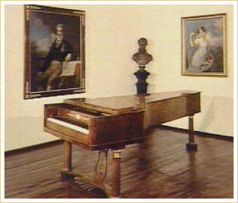
Beethoven's Piano
Photo Courtesy of German Cultural Center
Beethoven's 32 numbered piano sonatas make full use of the developing piano, with its wider range and possibilities of dynamic contrast. The best known of the sonatas are those that have nicknames not always given by the composer, such as the Pathétique, Op. 13 with its Third Movement in Rondo form, and Moonlight, Op. 27 No. 2.
Sonata No. 8 in C minor, Op.13, Pathétique: III. Rondo
Piano Sonata No. 14 in C-sharp minor, Op.27 No.2, Moonlight: I. Adagio sostenuto
Among Beethoven's other important keyboard works are several sets of variations, of which the most significant are the Eroica Variations in E-flat major, Op.35 (1802), the 32 Variations in C minor (1806), and the 33 Variations on a Waltz by Diabelli, Op.120 (1823), commonly known as the Diabelli Variations. There are also other interesting sets of variations, including a set based on God Save the King and another on Rule, Britannia. Less substantial piano pieces include the extemely popular Für Elise (1810), and the Bagatelles, Op.33 (1802).

