Romantic Period (1820-1910)

Painting
Romanticism in the visual arts extended roughly from 1800 to 1850. Whereas the Classical and Neoclassical periods cultivated emotional restraint and clarity of form and expression, Romantic outpouring was reflected in the paintings of Francisco Goya and Ferdinand Delacroix, although it was probably the life and work of Vincent Van Gogh that most aptly exemplified the extremes of Romanticism. In the late 19th century, impressionists such as Edouard Manet, Edgar Degas, and Claude Monet influenced all of the arts, including music. The work of Henri Rousseau, for example, anticipated 20th-century primitivism.

Sculpture
Sculpture in the Romantic era was naturalistic and emotional. Two important pieces, both created around the turn of the century and both called The Kiss, illustrate the contrast between Romanticism and later movements. Whereas Auguste Rodin's 1886 version depicted two nude figures locked in a passionate embrace, Constantin Brâncuşi's, created in 1908 (as Romanticism neared its end), was much more abstract, focusing on the form rather than the emotion or naturalistic detail.
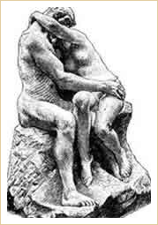
The Kiss
Auguste Rodin (1886)
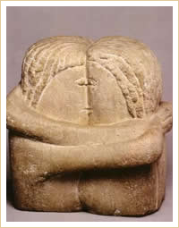
The Kiss
Constantin Brâncuşi (1908)

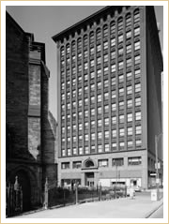
Guaranty Building
The first steel-framed building, pre-cursor to the modern skyscraper
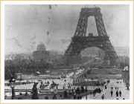
Eiffel Tower
(Under construction in 1888)
The Eiffel Tower was completed in 1889 for the Paris World Exhibition, where the composer Claude Debussy first heard the Javanese gamelan music that would have such a strong impact on him.

Architecture
Architecture was greatly affected by advances made in the Industrial Revolution. Cast iron as structural material transformed the discipline.
One of the great architectural accomplishments of the Romantic era was the Crystal Palace in London. Built by the greenhouse designer Joseph Paxton (1801-1856) for the Great Exhibition of 1851 and sponsored by Prince Albert, the Crystal Palace was the first prefabricated building and a forerunner of the steel and glass architecture of the 20th century. As such, it was a significant step in the history of architecture.
From 1887 to 1889, Gustave Eiffel (1832-1923) erected the Eiffel Tower in Paris, France. Mocked at first as a monstrosity, but soon after that embraced as an emblem of modernity, the Eiffel Tower was constructed of wrought iron on a reinforced concrete base. At its completion, it stood at 984 ft., which made it the tallest building in the world. It held that distinction until 1930, when the Chrysler Building was erected in New York City. The Eiffel Tower remains the tallest structure in Paris to this day.
In the Industrial Age, ornamental architecture gave way to functionality in design. The prime architectural expression of industrial and technical power inevitably became the skyscraper.
In 1894, the American architect Louis Sullivan (1856-1924), mentor of Frank Lloyd Wright (1867-1959) and considered by many the “Father of Modernism,” designed the Guaranty Building in Buffalo, New York. Embodying Sullivan's motto of “form follows function,” this building exemplified structural simplicity made possible by its steel frame, a feature which did away with the limitations of masonry and allowed cities to grow upward for the first time.
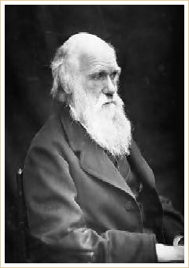
Charles Darwin

Literature
In the early part of the century, writers emerged as some of Romanticism's leading proponents. Novelist Victor Hugo in France and the poets John Keats and Percy Shelley in England and Henry Wadsworth Longfellow in the United States, are among the writers who reflected the Romantic aesthetic in their works. Later, Charles Dickens, Honoré de Balzac, Georges Sand, Edgar Allan Poe, Alexandre Dumas, Henrik Ibsen, Herman Melville, Emily Dickinson, Walt Whitman, Leo Tolstoy, Fyodor Dostoyevsky, and Mark Twain created some of the world's most enduring literary works. Karl Marx, Friedrich Nietzsche, and Soren Kierkegaard wrote philosophical works that sought to change humanity's view of itself.
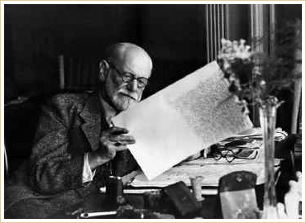
Sigmund Freud
In the mid-1880s, the age of the realistic novel emerged with novelists such as the Bronte sisters and Herman Melville. The new reverence for nature that characterized Romantic thought was illustrated in Ralph Waldo Emerson's works. Edgar Allen Poe's The Raven embodied a fascination with the irrational and the supernatural.

Scientific Progress
The 19th century in Europe was an era of enormous progress, especially in science. Steam engines were invented, and railways began to crisscross the landscape. Biologists developed the germ theory of disease, revolutionizing medicine. In 1859, Charles Darwin (1809-1882) presented to an astonished world his theory of evolution in the groundbreaking work On the Origin of Species.
In 1899, the Viennese neurologist Sigmund Freud (1856-1939) laid the foundation for psychoanalytic theory in his most important work, The Interpretation of Dreams. Freud's work had a profound influence on 20th-century art, especially on the Surrealists, who, in their effort to gain access to the secrets of the unconscious, created new art forms and techniques.
 | Freud's work had a profound influence on 20th century art, especially on the Surrealists who, in their effort to gain access to the secrets of the unconscious, created new art forms and techniques...

