Romantic Period (1820-1910)

The Post-Romantics
Romanticism did not completely disappear at the turn of the century. Despite the alteration of the musical landscape by 1920, some more traditional composers continued to write in well-established harmonic idioms.

Sergei Rachmaninoff
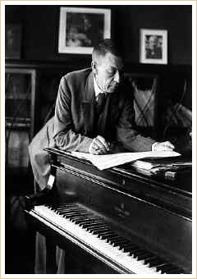
Sergei Rachmaninoff
Piano Concerto No. 2 in C minor: I. Moderato

Sergei Rachmaninoff
Born: 1873
Died: 1943
Period: Romantic
Country: Russia
Rachmaninoff was a Russian composer and pianist who, at the turn of the century, conquered the musical world as a piano virtuoso. His compositions employed a personal brand of Romanticism that, like Tchaikovsky's, contained elements of Russian nationalism. His four piano concertos are among the most demanding in the repertoire, as evidenced by the first movement from his Piano Concerto No. 2 in C minor.

Jean Sibelius
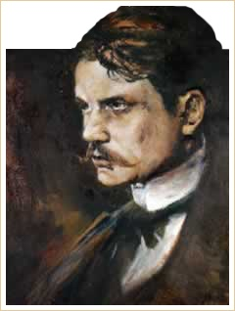
Jean Sibelius
Finlandia

Jean Sibelius
Born: 1865
Died: 1957
Period: Romantic
Country: Finland
Finland’s greatest composer was Jean Sibelius, who worked in the Romantic and neoclassical idioms well into the 20th century. A national Finnish hero, Sibelius was born in Tavastehus, Finland, the son of an army doctor. As intensely nationalistic and patriotic as Smetana, Borodin, and Rimsky-Korsakov before him, his music played a crucial role in the creation of a Finnish national musical identity. In fact, the main theme from the tone poem Finlandia (1899) became the de facto Finnish national anthem.
Although he lived into the late 1950s, some argue that because of his traditional treatment of melody and harmony, Sibelius's music belongs more in the late 19th than the 20th century. While certainly more conservative than his peers—he was strongly influenced by Wagner, Bruckner, and Tchaikovsky—his music did possess a number of modern tendencies. His best known pieces include his seven symphonies, the Violin Concerto in D minor, and Finlandia, which evokes the Finnish struggle for independence from the Russian Empire.

Gustav Holst
Gustav Holst (1874-1934) was an English composer whose music lay between Romanticism and Impressionism. From the orchestral suite The Planets, the movement entitled Jupiter is at times reminiscent of Elgar’s work in its nobility, yet the size of the orchestra owes more to the influence of Mahler.
The Planets: Jupiter

Alexander Scriabin and Charles Ives
Scriabin and Ives were two more composers who defied easy classification. The Russian Alexander Scriabin (1872-1915) experimented with tonality and the relationship of music to the arts in a way that anticipated 20th-century techniques.
Charles Ives (1874-1954) was arguably the first great original American composer. In an effort to re-create a memory from his youth in which several marching bands came into town from separate directions, his music juxtaposed two halves of the orchestra playing different tunes in various keys and rhythms, thus anticipating Stravinsky’s polytonality.

