St. Tammany Parish

Department Of Permits & Inspections
P. O. Box 628
Covington, LA 70434
Phone: (985) 898-2574
June 24, 2021

St Tammany Parish is currently following the 2015 IRC chapter 9 for roof assemblies. All assemblies must be designed for 130 mph wind speeds. Listed below are some of the most overlooked sections.

R905 Roof coverings shall be applied in accordance with this code and the manufacturer’s installation instructions. Including but not limited to fastening, starter strips, hips, valleys
and ridges.

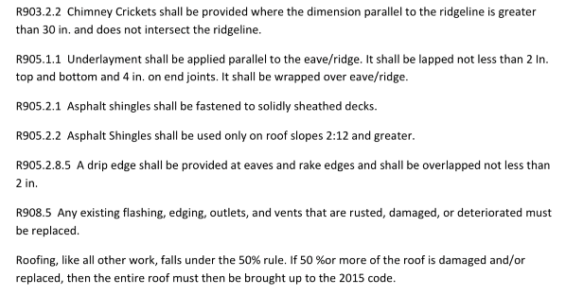

Kenny Wortmann
Director, CBO, CFM
Department of Permits & Inspections
St Tammany Parish Government

