
554 Old Spanish Trail
Slidell, LA 70458
Phone: 985-649-5832
dammonengineering.com
info@dammonengineering.com

February 11, 2025

Wayne Collier

Re: 38183 Commercial Ct.

Mr. Prasad,

Thank you for considering Dammon Engineering. We are pleased to propose our services for 38183 Commercial Ct.
Our understanding is that this agreement is for the design & drafting of the existing building as it currently exists today, approximately 8,000 s.f. Then additionally, the owner wants to improve some of the building for “The Hidden Vault”; It is also understood that no Mechanical, Electrical or Plumbing design for the remainder of the building is not included.
We propose a fee of $10,000.00. A $1,000 deposit will be required to start the project. You will be invoiced $5,000 after the design/drafting for the existing building is completed. The remaining fee will be invoiced once the project is approved by the State Fire Marshal and ready for permit.
A recent survey of the property and all existing improvements and landscape is required. This survey needs to be provided to Dammon Engineering in CAD format.
Our fee does not include the cost of project management, the cost of designing sprinkler or fire alarm systems, drainage studies, wetlands determination, or other engineering studies that may be required by government agencies nor does it include the cost of plan review or permit fees by the municipality. These items, if provided by Dammon Engineering, will be billed at a "cost plus" fee.
We look forward to working with you on this project. Please indicate your acceptance of the above fee by signing below. If you have any questions, or require any further information, please feel free to call.
Sincerely,

If you have any questions, please contact me.

Thank You,

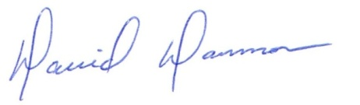
David Dammon __________________________________
President Wayne Collier

