
554 Old Spanish Trail
Slidell, LA 70458
Phone: 985-649-5832
www.dammonengineering.com
info@dammonengineering.com

February 24, 2017

Daniel Latournerie
Continuous Improvement Manger
Textron Marine & Land Systems
1010 Gause Blvd.
Slidell, LA 70458

RE: New Orleans Facility Roof Tie-Offs for Fall Protection on Bldgs 1 & 2

Mr. Latournerie,

Dammon Engineering is pleased to propose our services for the Fall Protection system.

We propose to furnish a letter and drawings that cover the requirements of the Fall Protection Support System on buildings 1 & 2 at the New Orleans Facility.

We propose a flat fee of $1,400.00.

We appreciate the opportunity to propose our services and we look forward to working with you on this project. If you have any questions, or require any further information, please feel free to call.

Sincerely,

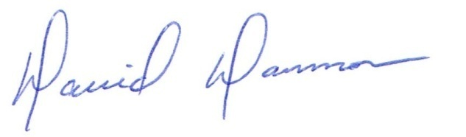
David Dammon, VP
Dammon Engineering, Inc.

Accepted For Design: _______________________________ Date:__________________
Daniel Latournerie

